Name: ______________________________________ Date: ________________________
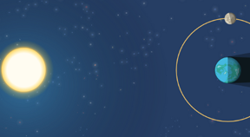

Student Exploration: 2D Eclipse

Vocabulary: corona, eclipse, lunar eclipse, penumbra, solar eclipse, umbra

Prior Knowledge Questions (Do these BEFORE using the Gizmo.)

- The image below shows a flashlight shining on a ball. Draw the shadow cast by the ball.

- In the image, draw a golf ball that is in the shadow of the soccer ball. Label this ball “1.” Then, draw a second golf ball that will cast a shadow on the soccer ball. Label this ball “2.”

Gizmo Warm-up
An eclipse occurs when the shadow of one celestial body falls on another celestial body. The 2D Eclipse Gizmo allows you to explore two types of eclipses: a lunar eclipse and a solar eclipse. Notice that the objects in the Gizmo are not drawn to scale. If they were, the Sun would be located over 150 meters to the left and would be over a meter tall!

- Next to Views, select Both shadows. Why do the Moon and Earth have shadows?

_________________________________________________________________________

_________________________________________________________________________

- Notice there are two parts to each shadow. The darkest part is the umbra. The lighter part surrounding the umbra is the penumbra.

  - How much of the Sun would you see if you were standing in the umbra? __________

___________________________________________________________________

  - How much of the Sun would you see if you were standing in the penumbra? _______

___________________________________________________________________

Activity A:  Solar eclipse | Get the Gizmo ready:  - Select Moon shadow. | 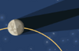

Question: What causes a solar eclipse?

- Predict: During a solar eclipse, our view of the Sun is blocked by the Moon. In the diagram, draw where you think the Moon is located when the observer on the left side of Earth is experiencing a solar eclipse.

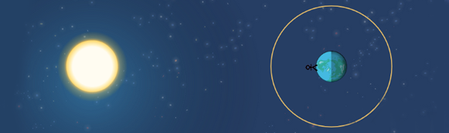

- Observe: Move the Moon slowly around Earth in a counterclockwise direction. As you do this, pay attention to the Moon’s shadow and the Sun view in the upper right corner.

What do you notice? ________________________________________________________

_________________________________________________________________________

- Record: Position the Moon so that the Sun is completely blocked. Draw the Moon, the Moon’s umbra, and the Moon’s penumbra in the image below. This is a total solar eclipse.

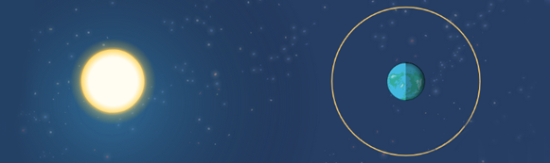

- Record: Position the Moon so that the Sun is partially blocked. Draw the Moon, the Moon’s umbra, and the Moon’s penumbra in the image. This is a partial solar eclipse.

(Activity A continued on next page)
Activity A (continued from previous page)

- Analyze: Slowly move the Moon forward and back in its orbit. As you do this, look at the Moon view and the Sun view.

    - What do you notice about the apparent sizes of the Moon and Sun? _____________

___________________________________________________________________

    - The Sun is a much larger object than the Moon. Why do they appear to be about the same size from Earth? _________________________________________________
___________________________________________________________________
    - What do you see around the Sun during a total solar eclipse? __________________

___________________________________________________________________

This fuzzy “cloud” is a part of the Sun’s atmosphere called the corona. It is only visible from Earth during a total solar eclipse.

    - What is the phase of the Moon during a solar eclipse? (Circle the phase below.)

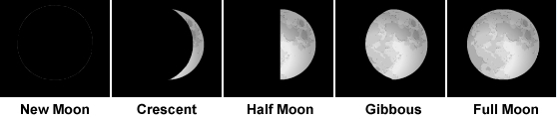

- Explore: Experiment with changing the Moon diameter, Sun diameter, and Earth-Moon distance. Describe your findings below.

_________________________________________________________________________

_________________________________________________________________________

_________________________________________________________________________

_________________________________________________________________________

_________________________________________________________________________

_________________________________________________________________________

_________________________________________________________________________

Activity B:  Lunar eclipse | Get the Gizmo ready:  - Click Reset.  - Select Earth shadow. | 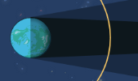

Question: What causes a lunar eclipse?

- Predict: During a lunar eclipse, the Moon is darkened by Earth’s shadow. In the diagram, draw where you think the Moon is located when the observer can see a lunar eclipse.

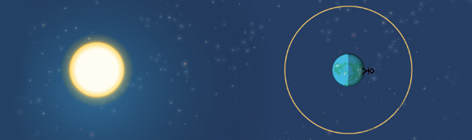

- Observe: Move the Moon slowly around Earth in a counterclockwise direction. As you do this, pay attention to Earth’s shadow and the Moon view above.

What do you notice? ________________________________________________________

_________________________________________________________________________

- Record: Position the Moon so that it is in Earth’s penumbra. Draw Earth’s umbra, Earth’s penumbra, and the Moon. This is a penumbral lunar eclipse.

- Record: Position the Moon so that it is partially in Earth’s umbra. In the left diagram, draw Earth’s umbra, Earth’s penumbra, and the Moon. This is a partial lunar eclipse. Then position the Moon so that it is completely in Earth’s umbra. Draw Earth’s umbra, Earth’s penumbra, and the Moon in the right diagram. This is a total lunar eclipse.

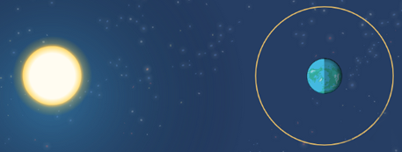

(Activity B continued on next page)
Activity B (continued from previous page)

- Analyze: What is the phase of the Moon during a lunar eclipse? (Hint: Imagine what the Moon would look like if it were not in Earth’s shadow.) Circle your choice.

- Explore: Experiment with changing the Earth diameter, Sun diameter, and Earth-Moon distance. Describe your findings below.

_________________________________________________________________________

_________________________________________________________________________

_________________________________________________________________________

_________________________________________________________________________

_________________________________________________________________________

- Compare: How is a lunar eclipse similar to a solar eclipse? How are they different?

_________________________________________________________________________

_________________________________________________________________________

_________________________________________________________________________

_________________________________________________________________________

- Think and discuss: The Moon takes about one month to orbit Earth. Based on what you have seen in the Gizmo, there would be two eclipses (one lunar and one solar) every month. Do you think this is realistic? Explain why or why not.

_________________________________________________________________________

_________________________________________________________________________

In reality, the Moon’s orbit is tilted relative to the orbit of Earth. Therefore, the Moon usually passes above or below Earth’s shadow, and the Moon’s shadow usually passes above or below Earth’s surface. Solar and lunar eclipses occur once or twice a year on average.

