Name: ______________________________________ Date: ________________________

Student Exploration: 3D Eclipse

Vocabulary: eclipse, lunar eclipse, path of totality, penumbra, solar eclipse, umbra

Prior Knowledge Questions (Do these BEFORE using the Gizmo.)

- Have you ever seen an eclipse? If so, describe what you saw. _______________________

_________________________________________________________________________

_________________________________________________________________________

- About how often do you think eclipses happen? ___________________________________

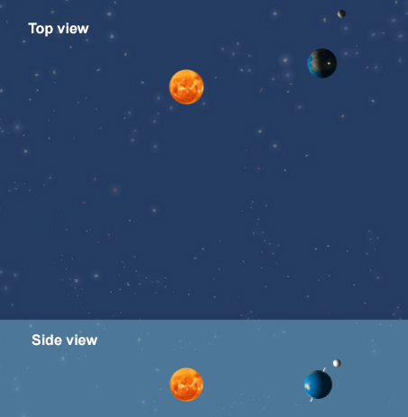
Gizmo Warm-up
If you see a two-dimensional image of the Earth, Moon, and Sun, you might predict that an eclipse occurs every time the Moon passes in front of or behind Earth, or about twice a month. However, eclipses occur much more rarely.

The 3D Eclipse Gizmo shows two views of the Earth, Moon, and Sun: a top view (above) and a side view (below). The sizes of the Earth, Moon, and Sun are not to scale. (If they were, the Earth and Moon would be microscopic!)

- Set the Simulation speed slider to a middle value, and click Play (). Based on the top view on the SIMULATION pane, describe the motions of the Sun, Earth, and Moon.

_________________________________________________________________________

_________________________________________________________________________

_________________________________________________________________________

- Click Reset (), and then click Play again. This time, focus on the side view at the bottom of the SIMULATION pane. What do you notice about the Moon’s orbit?

_________________________________________________________________________

_________________________________________________________________________

_________________________________________________________________________

Activity A:  Solar eclipse | Get the Gizmo ready:  - Click Reset.  - Under Shadows, select Moon.  - Set the Moon angle to 0.0°. | 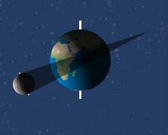

Introduction: There are two parts to the Moon’s shadow. The umbra is the central, darkest portion of the shadow. An observer standing in the umbra cannot see the Sun. The penumbra surrounds the umbra. An observer in the penumbra sees part of the Sun. Only the umbra is shown in the 3D Eclipse Gizmo.

Question: What controls whether a solar eclipse will occur?

- Observe: Click Play and then Pause () when the Moon is directly between the Earth and Sun. (If you go too far, you can click the Back button to step back.)

    - What do you notice about the Moon’s shadow? _____________________________

___________________________________________________________________

    - Under Views, select Earth. What do you see? ______________________________

___________________________________________________________________

Any person standing in the Moon’s shadow will experience a solar eclipse. During a total solar eclipse, the entire disk of the Sun is blocked by the Moon.

- Observe: Set the Simulation speed to a lower setting and click the Back button until just before the Moon’s shadow crosses Earth’s surface. Click Play and observe.

    - What do you notice? __________________________________________________

___________________________________________________________________

    - The path the Moon’s umbra traces across Earth’s surface is called the path of totality. What would you see if you were standing in the path of totality?

___________________________________________________________________

- Record: Click Reset. Set the speed to a higher setting and click Play. Use the Gizmo to determine the dates of the first six solar eclipses of the year. Record these dates below.

_________________________________________________________________________

Do you think solar eclipses really happen this often? Explain. ________________________

_________________________________________________________________________

(Activity A continued on next page)
Activity A (continued from previous page)

- Explore: Click Reset. A solar eclipse does not occur every month because the Moon’s orbit is tilted 5.14° relative to Earth’s orbit.

To model this, set the Moon angle to 5.1°. Play the simulation until January 9. Click Pause, reduce the speed, and click Play. What do you notice about the path of totality now?

_________________________________________________________________________

_________________________________________________________________________

- Explore: Advance the simulation to February 8, and again play the simulation at a low speed. Does the umbra cross Earth’s surface this time? ____________________________
In this situation, a total solar eclipse will not be visible from any location on Earth’s surface.

- Record: Use the Gizmo to find the dates of the next three solar eclipses. Be sure to check carefully whether the Moon’s umbra crosses Earth’s surface. Record these dates below.

_________________________________________________________________________

Do you think this frequency of solar eclipses is more realistic? Explain. _________________

_________________________________________________________________________

_________________________________________________________________________

- On your own: Experiment with different Moon angle values. How does the angle of the Moon’s orbit affect the number of solar eclipses that occur in a year?

_________________________________________________________________________

_________________________________________________________________________

_________________________________________________________________________

- On your own: Return the Moon angle to 5.1°, and increase the Moon distance to 1.50. How does increasing the Earth-Moon distance affect the occurrence of total solar eclipses?

_________________________________________________________________________

_________________________________________________________________________

_________________________________________________________________________

Activity B:  Lunar eclipse | Get the Gizmo ready:  - Click Reset. Under Shadows, select Earth.  - Set the Moon distance to 1.00 and the Moon angle to 0.0°. | 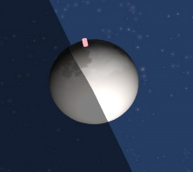

Introduction: A lunar eclipse occurs when the Moon goes into Earth’s shadow. If the Moon goes into Earth’s penumbra, it is called a penumbral lunar eclipse. If the Moon goes into Earth’s umbra, it is a total lunar eclipse. A partial lunar eclipse occurs when only part of the Moon goes into Earth’s umbra. (Note: Earth’s penumbra is not shown in the Gizmo.)

Question: What controls whether a lunar eclipse will occur?

- Observe: Set the Moon angle to 0.0°. Click Play, and then click Pause when the Moon is in Earth’s shadow. Select the Moon view. What do you see? __________________________
_________________________________________________________________________

- Observe: Set the speed to a lower setting and click the Back button until just before Earth’s shadow crosses the Moon. Click Play and describe what you see.

_________________________________________________________________________

_________________________________________________________________________

- Infer: Select the Earth view. Who on Earth would be able to see the lunar eclipse? Explain your answer. ______________________________________________________________
_________________________________________________________________________

_________________________________________________________________________

- Record: Click Reset and select the Moon view. Set the speed to a higher setting and click Play. Use the Gizmo to determine the dates of the first six lunar eclipses, and record below.

_________________________________________________________________________

Do you think lunar eclipses really happen this often? Explain. ________________________

_________________________________________________________________________

_________________________________________________________________________

_________________________________________________________________________

(Activity B continued on next page)
Activity B (continued from previous page)

- Explore: Click Reset. Set the Moon angle to 5.1°. Play the simulation until January 24. Click Pause, set the speed to a low value, and click Play.

    - Is there a lunar eclipse this time? ________________________________________

    - Why not? (Hint: Look at the side view on the bottom of the SIMULATION pane.)

___________________________________________________________________

___________________________________________________________________

- Record: Use the Gizmo to find the dates of the lunar eclipses in one year. Be sure the Moon is actually darkened by Earth’s shadow for each eclipse. Label each eclipse a total eclipse (moon is completely darkened) or a partial eclipse (only part of the moon is darkened).

_________________________________________________________________________

_________________________________________________________________________

Do you think this frequency of lunar eclipses is more realistic? Explain. ________________

_________________________________________________________________________

_________________________________________________________________________

- Think and discuss: A person living in North America can see 15 lunar eclipses in the 2010–2020 decade. In the same time period, only two solar eclipses can be observed in North America.

Why will more lunar eclipses than solar eclipses be visible from North America in this decade? If possible, discuss your answer with your classmates and teacher.

_________________________________________________________________________

_________________________________________________________________________

_________________________________________________________________________

_________________________________________________________________________

_________________________________________________________________________

_________________________________________________________________________

