Name: Date:

**Student Exploration:** **3D and Orthographic Views**

Josieleaning

**Vocabulary:** orthographic projection

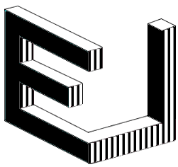

**Prior Knowledge Questions** (Do this BEFORE using the Gizmo.)

Josie sees an interesting sculpture, shown to the right. She decides to look at the sculpture from three different angles.

JosieJosieIn the boxes below, try to sketch the shapes Josie would see if she sees only the black side of the sculpture, if she sees only the striped side of the sculpture, and if she sees only the white side of the sculpture.

**Black** **Striped** **White**

**Gizmo Warm-up**

Like a view of one side of a sculpture, an **orthographic projection** is a flat, two-dimensional image of a three-dimensional object. In the *3D and Orthographic Views* Gizmo, your challenge is to build a 3-D object that matches a given set of orthographic projections.

1. You will build your object on the draggable game board on the right side of the Gizmo. Below the board, check that **add blocks** is selected. Click to add blocks in various ways.

How can you add a block to stack on another block?

1. Select **delete blocks** and click on blocks to remove them. What happens if you remove a block from the middle of a stack?

**Shape on each face of a block**

1. Click **Clear**, select **add blocks**, and add one block. Drag the board to see different sides of the block. In the boxes at right, sketch the shape that appears on each face of the block.

**Front Back Top Left Right**

|  |  |  |
| --- | --- | --- |
| **Activity:**  **Matching orthographic views** | Get the Gizmo ready:   * Check that the first challenge is showing (see image at right). If not, restart the Gizmo by clicking **Refresh** or **Reload** on your browser. * Click **Clear**. |  |

1. Check that **Show goal** is selected. Look at the three orthographic projections on the left side of the Gizmo. How many blocks do you think are needed to match these views?
2. In the Gizmo, click to place two blocks on the board to match the **Top** view. Select the **Show current** view, and compare to the **Show goal** view. If necessary, delete blocks and add blocks until the views match. When you are confident your board matches the goal, click **Check**.
3. Sketch your blocks on the board at right.
4. How many blocks did you use?
5. Did you use the **minimum number of blocks** (shown above **Check**)?

If not, see if you can complete the figure with the minimum number of blocks.

1. Click **New game** and try to solve the new challenge in the Gizmo. After you have solved it, sketch your blocks on the board below.
2. How many blocks did you use?
3. Did you use the minimum number of blocks?

If not, see if you can complete the figure with the minimum number of blocks.

1. Solve at least five more challenges in the Gizmo. Try to find the solution using the fewest blocks. (The first few challenges will be easy to solve with the minimum number of blocks. As the challenges get more complex, this will be more difficult. In fact, for some challenges, it may be easier to start by clicking **Fill** and then deleting blocks.)

Each time you find a solution with the minimal number of blocks, select **Screen shot** from the **Tools** palette in the bottom right corner of the Gizmo. Paste each image into a blank document, and turn in the document with this worksheet when you are done.

**(Activity continued on next page)**

**Activity (continued from previous page)**

1. 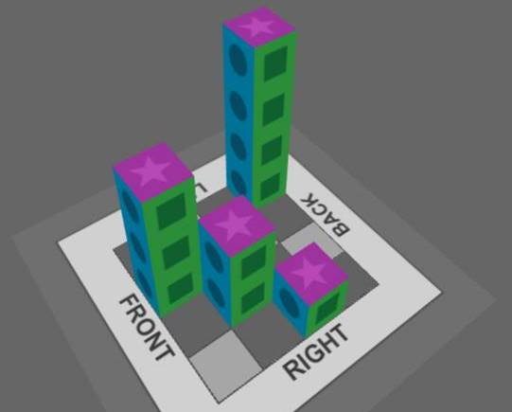Without using the Gizmo, sketch the top, front, and right orthographic projections for the figure shown to the right. When you are done, check your answer using the Gizmo.



1. cameraChallenge: Using just 7 blocks, construct a figure to match the projections shown at left below. When you are done, sketch your figure. Or, click the camera icon ( ) to take a snapshot of your figure, paste it into a document, and hand it in with this sheet.

