Name: Date:

**Student Exploration: Absolute Value with Linear Functions**

**Vocabulary:** absolute value, linear function

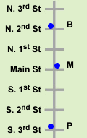**Prior Knowledge Questions** (Do these BEFORE using the Gizmo.)

1. Brad (B), Maria (M), and Pam (P) all live on the same street. Their locations are shown to the right. Distances are measured in blocks.
   1. How far does Brad live from Maria?
   2. How far does Pam live from Maria?

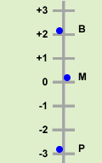

1. Suppose the street is represented as a number line, as shown to the right.
2. Do you think Pam would say she lives –3 blocks from Maria?
3. The **absolute value** of a number is the distance of that number from 0 on the number line. The expression |*x*| means the absolute value of *x*. How does absolute value relate to your answer above?

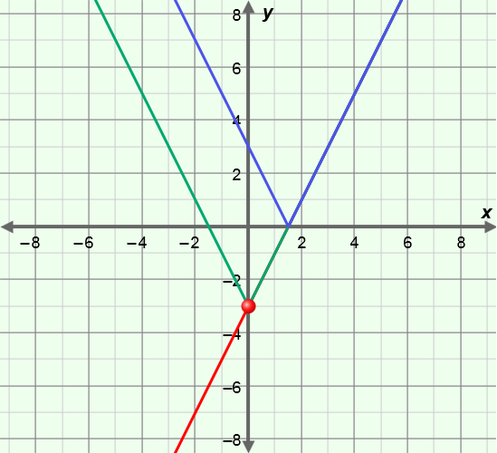

**Gizmo Warm-up**

In the *Absolute Value with Linear Functions* Gizmo, you can graph two types of functions – **linear functions** of the form *y* = *ax* + *b*, and absolute value functions of the form *y* = *a*|*x*|+ *b* and *y* = |*ax* + *b*|.

Turn on **Show *y* = *ax* + *b***, **Show *y* = *a*|*x*| + *b***, and **Show *y* = |*ax* + *b*|**. Change the value of ***a***to 2.0 and ***b*** to –3.0. (You can quickly set a slider by typing a value in the box to the right of the slider and pressing **Enter**.)

Turn on **Show probe**. Look at the table under the graph to see the *y*-values of each graph for the *x*-value where the probe is located.

1. Drag the probe until *x* = 3. What do you notice about the values of the three functions?

1. Drag the probe until *x* = –3. What do you notice about the values of the three functions?

|  |  |  |
| --- | --- | --- |
| **Activity A:**  **Absolute value functions** | Get the Gizmo ready:   * Be sure **Show *y* = *ax* + *b***, **Show *y* = *a*|*x*| + *b***, and **Show probe** are turned on. * Turn off **Show *y* = |*ax* + *b*|**. | 94SE2 |

|  |  |  |
| --- | --- | --- |
| ***x*** | ***y* = *x*** | ***y* = |*x*|** |
| –3 |  |  |
| –2 |  |  |
| –1 |  |  |
| 0 |  |  |
| 1 |  |  |
| 2 |  |  |
| 3 |  |  |

1. In the Gizmo, set ***a*** to 1.0 and ***b*** to 0.0.
   1. Substitute the *x*-values shown to the right into *y* = *x* and *y* = |*x*| to find several points on their graphs. Use the probe to check your work.
   2. 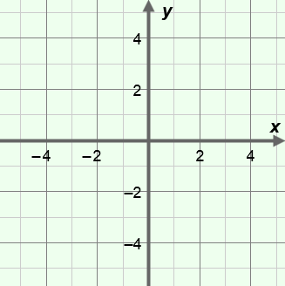When are the *y*-values the same? When are they different?
   3. Plot the points on the grid and graph *y* = *x* and *y* = |*x*|.
   4. When are the graphs of *y* = *x* and *y* = |*x*|the same and when are they different?

* 1. Drag the probe through negative *x*-values. How do the *y*-values differ here?
  2. Explain why the graph of *y* = |*x*| looks like it does.

1. With **Show *y* = *a*|*x*| + *b*** still selected, turn on **Show *y* = |*ax* + *b*|**. Turn off **Show *y* = *ax* + *b*** and **Show probe**. With ***b*** set to 0.0, vary the value of ***a***.
2. Are the graphs of *y* = *a*|*x*| and *y* = |*ax*| the same when *a* is positive?

Why?

1. Are the graphs of *y* = *a*|*x*| and *y* = |*ax*| the same when *a* is negative?

Why?

1. In which of the two functions is it possible to have negative output?

**(Activity A continued on next page)**

**Activity A (continued from previous page)**

1. With just **Show *y* = *ax* + *b*** turned on, graph *y* = 2*x* + 4.
2. What are the intercepts of the line? *x*-intercept: *y*-intercept:
3. Turn on **Show *y* = *a*|*x*| + *b*** and **Show *y* = |*ax* + *b*|**. Compare the vertex (point at the bottom or top of the “V”) of each absolute value graph to the intercepts of the line. What do you notice?

1. Vary the value of ***b***. What happens to the absolute value graphs?

1. Vary the value of ***a***. What happens to the absolute value graphs?

1. In general, how does the equation *y* = *a*|*x*| + *b* change when the values of *a* and *b* are varied?
2. In general, how does the equation *y* = |*ax* + *b*| change when the values of *a* and *b* are varied?
3. Use either *y* = *a*|*x*| + *b*, *y* = |*ax* + *b*|, *both*, or *neither* to answer each of the following questions. Check your answers in the Gizmo.
4. Which function is always symmetrical about the *y*-axis?
5. In which function is *b* always the *y*-intercept?
6. In which function can the vertex to be the maximum point?
7. Which function always has exactly one *x*-intercept?

|  |  |  |
| --- | --- | --- |
| **Activity B:**  **Using absolute value functions** | Get the Gizmo ready:   * Be sure **Show *y* = *ax* + *b***, **Show *y* = *a*|*x*| + *b***, and **Show probe** are turned on. * Turn off **Show *y* = |*ax* + *b*|**. | 94SE4 |

1. Graph each pair of equations by hand, below. To do so, graph the first equation, and then use what you know about absolute value functions to graph the second one. Then use the Gizmo to check your answers.
2. *y* = |*x*| + 5 and *y* = |*x*| – 5
3. *y* = |2*x* + 1| and *y* = |–2*x* – 1|

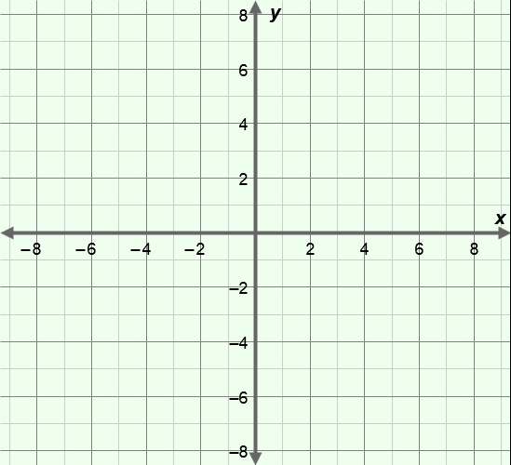

1. What is true about the graphs of the functions in question B above?

Why do you think this is true?

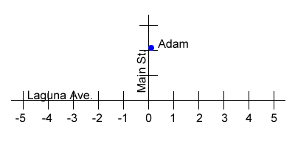

1. Adam lives on Main St., as shown to the right. His friends all live on Laguna Ave. To get to their houses, Adam walks 100 meters down Main St., and then turns left or right on Laguna Ave.

Write an absolute value function to express the walking distance from Adam’s house to any of the houses (represented by numbers on the number line) on Laguna Ave.

Assume there are 50 meters between house locations. (Hint: Let *x* represent the location of a friend’s house on Laguna Ave.)

*d* =