Name: Date:

Student Exploration: Addition of Polynomials

Vocabulary: coefficient, constant, like terms, monomial, polynomial, zero pair

Prior Knowledge Questions (Do these BEFORE using the Gizmo.)

- Mark has 2 dogs and 4 cats. Jane has 1 dog and 8 fish.

- How many of each type of pet do they have, total?
- Suppose d = number of dogs, c = number of cats, and f = number of fish. Fill in the blanks below to write an equation for this problem.

d + c + d + f = d + c + f

- Fill in the blanks below to show the sum of (2x² + 4x) and (x² + 8).

(2x² + 4x) + (x² + 8) = x² + x +

Gizmo Overview
When you simplified the expression (2x² + 4x) + (x² + 8) above, you added like terms, or monomials that contain the same variables raised to the same exponents. In the Addition of Polynomials Gizmo, you will use tiles to add like terms and find the sum of polynomials of the form ax² + bx + c.

Here’s how the Gizmo works:
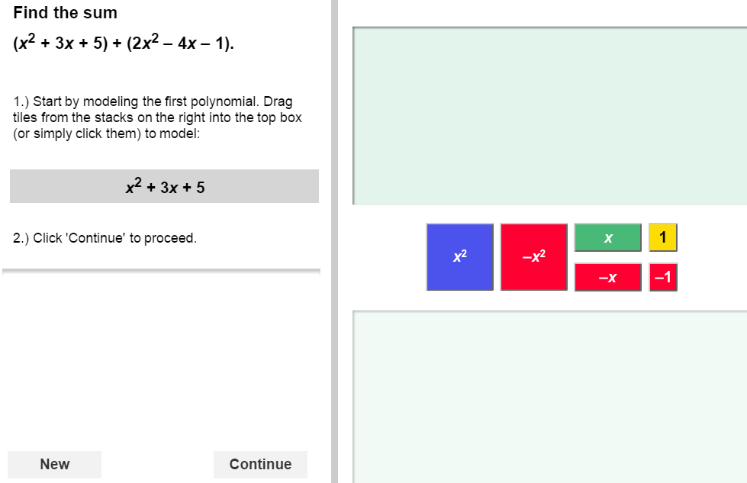
You will model the first polynomial by dragging or clicking to place the colored tiles here.
After you click Continue, model the second polynomial here.

Then you will combine the two groups of tiles to model the sum.

The sum for you to find is here.

Feedback will appear here.

Activity A:  Modeling polynomial addition | Get the Gizmo ready:  - You should see (x² + 3x + 5) + (2x² – 4x – 1) at the top of the Gizmo. If you do not, click Refresh in your browser. | 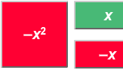

- In this question, you will use tiles to model the sum (x² + 3x + 5) + (2x² – 4x – 1).

- Model x² + 3x + 5 in the Gizmo by dragging or clicking blue x²-tiles, green x-tiles, and yellow 1-tiles into the top bin. How many of each type of tile did you use?

x²-tile(s) x-tiles(s) 1-tile(s)

- Click Continue. Model 2x² – 4x – 1 by dragging or clicking blue x²-tiles, red –x-tiles, and red –1-tiles into the bottom bin. How many of each type of tile did you use?

x²-tile(s) –x-tiles(s) –1-tile(s)

- Click Continue. All of the tiles from both bins will be combined into a single bin to represent the sum of the two polynomials.

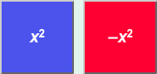
To simplify the sum, you need to remove all zero pairs of tiles like the pairs shown to the right.
A zero pair is two quantities that add to zero.

How many of each type of zero pairs do you see in your model in the Gizmo?

x² and –x² x and –x 1 and –1

- Removing zero pairs simplifies the sum without changing its value. Why does removing zero pairs not change the value of the sum?
- To remove a zero pair, drag a box around the pair and click Remove. Remove all of the zero pairs. What is the sum in simplest form?
- You can add polynomials algebraically, without tiles. Add the numbers in front of the variables, called coefficients, of like terms. Then add the constant terms, 5 and 1.

Fill in the blanks below to find the sum (x² + 3x + 5) + (2x² – 4x – 1).

( + )x² + ( + )x + ( + ) =

(Activity A continued on next page)
Activity A (continued from previous page)

- Click New. You should see the sum (–2x² – 3x + 2) + (2x² + x + 5).

- Model the polynomials and find the sum. What is the sum?

- Now use algebra to find the sum. Show your work below.

- How can you tell by just looking at the coefficients of –2x² and 2x² that the terms will add to zero?

- Click New. Work through more problems in the Gizmo. After you have completed at least 5 problems, choose two sums from the Gizmo to find yourself.

First model the sum of the polynomials, crossing out any zero pairs. Then use algebra to find the sum. Show your work below. Check your answers in the Gizmo.

- When two polynomials are added, what happens to any like terms that are opposites?

Activity B:  Adding polynomials | Get the Gizmo ready:  - Click New if you need more practice adding polynomials similar to those in this activity.

Sketch a model to find each sum. Then use algebra to find the sum and check your work.

- (x² + 3x + 2) + (3x² – x + 1)

- (x² + 2x – 4) + (–x² – 6x + 3)

- (2x² – 4x – 5) + (3x² + 4x – 1)

- (–3x² + 5x – 4) + (2x² – x + 4)

