Name: Date:

**Student Exploration: Adding on the Number Line**

**Vocabulary:** addend, commutative property of addition, sum

**Prior Knowledge Questions** (Do these BEFORE using the Gizmo.)

Julia is saving money for a new bike. At the start of the month, she has $100. During the month, she spends $10 on snacks and $14 on a new book, and earns $42 babysitting.

1. How much does Julia have at the end of the month?

Show your calculation in the space to the right.

1. Can you determine how much money Julia has saved using only addition?

Explain. (Hint: You can use negative numbers.)

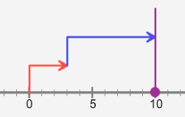**Gizmo Warm-up**

One way to think about Julia’s money is to imagine adding numbers to the balance of her savings account. Earning money (making a deposit) adds a positive number to her balance. Spending money (making a withdrawal) adds a negative number. In the *Adding on the Number Line* Gizmo, you will model **sums** of numbers, positive and negative, with arrows on a number line.

1. To begin, set ***a*** to 3 (3.0) and ***b*** to 7 (7.0). (To quickly set the value of a slider, click on the number in the text field next to the slider, type a new value, and hit **Enter**.)
2. What is the length of the red arrow that represents ***a***?
3. What is the length of the blue arrow that represents ***b***?
4. In what direction do both arrows point?
5. How does the Gizmo model the sum of 3 and 7?

1. Click **Reset**. Move the ***a*** slider back and forth to model both positive and negative numbers.

What is the direction of the arrow when ***a*** is negative?

|  |  |  |
| --- | --- | --- |
| **Activity:**  **Adding positive and negative numbers** | Get the Gizmo ready:   * Click **Reset**. | 95SE2 |

1. Suppose you were modeling the sum 10 + (–7) on a number line. Before doing it with the Gizmo, see if you can figure it out on your own.
2. 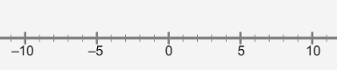On the first number line to the right, draw an arrow to represent 10.
3. On the second number line, draw an arrow to represent –7.
4. On the third number line, put the arrows together to represent the sum 10 + (–7).



What does this sum equal?

1. Check your model and result using the Gizmo. Were you correct?
2. What subtraction expression is equivalent to 10 + (–7)?

Any time you add a negative number, it is the equivalent of subtracting a positive number. The opposite is also true.

1. On the number line at right, use arrows to show the sum (–5) + 9.



1. What is (–5) + 9?
2. Check your model and your answer with the Gizmo. Were you correct?
3. On the left number line below, model (–2.6) + 1.2. On the right number line, model   
   1.2 + (–2.6). Check your work in the Gizmo.

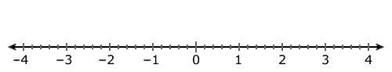

1. What is (–2.6) + 1.2? What is 1.2 + (–2.6)?
2. Each number that is added in a sum is called an **addend**. In this case, does changing the order of the addends change the answer?

**(Activity continued on next page)**

**Activity (continued from previous page)**

1. Use the Gizmo to try switching the order with several other examples. Does changing the order of addends ever affect the result?

The **commutative property of addition** states that the order in which numbers are added does not change the sum.

1. Fred and David both go for a run along an east-west river path. Fred runs to the west (left)   
   8 miles, and then runs to the east 5 miles. David runs 5 miles east and then 8 miles west. Model each run with arrows on the number lines below, and find each sum.



Fred’s run: David’s run:

Compared to the start, where do Fred and David both end up?

1. Click **Reset**. Select **Add three numbers**. Use the Gizmo to model 2.1 + (–7.5) + 3.6. Then find 3.6 + 2.1 + (–7.5) and (–7.5) + 2.1 + 3.6. Check your answers in the Gizmo.

2.1 + (–7.5) + 3.6 = 3.6 + 2.1 + (–7.5) = (–7.5) + 2.1 + 3.6 =

Does the commutative property of addition seem to apply to sums of three numbers?

Explain.

Model other sums of three numbers in the Gizmo to confirm your answer.

1. State the sum that is modeled on each number line. (Only whole numbers are used.)

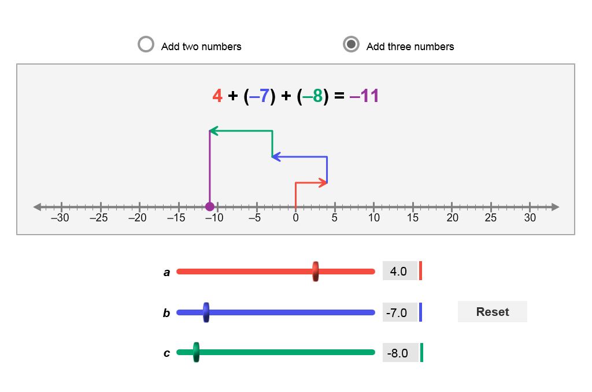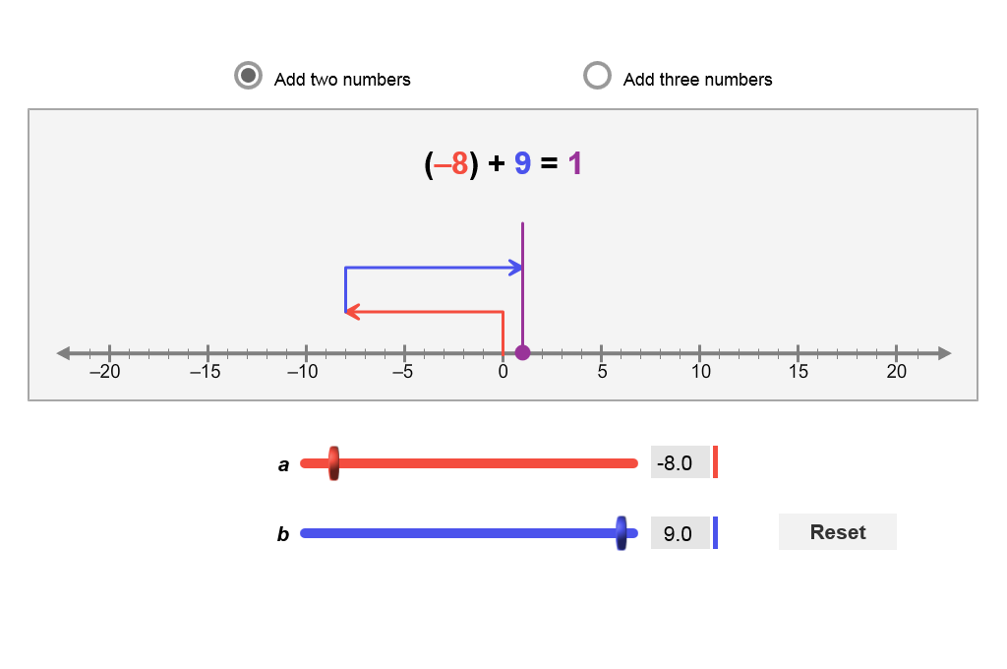

Sum: Sum:

1. Find the following sums. Use mental math if you can. Check your answers with the Gizmo.
2. 9 + (–7) + (–3) =
3. (–1.3) + 6.1 =
4. 5.3 + 6.7 + (–9.5) =
5. (–8.1) + (–5.0) + (–7.7) =