Name: ______________________________________ Date: ________________________

Student Exploration: Additive Colors

Vocabulary: additive color, cyan, magenta, primary colors, RGB value, secondary color, visible spectrum

Prior Knowledge Questions (Do these BEFORE using the Gizmo.)
When white light passes through a prism, it splits into a rainbow of colors. These colors make up the visible spectrum shown below.

- What is the order of colors in the visible spectrum? ________________________________

_________________________________________________________________________

- What do you think would happen if all of the colors of light in the visible spectrum were blended together? __________________________________________________________
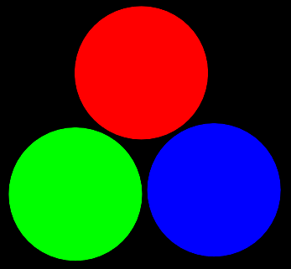
Gizmo Warm-up
On a computer or TV screen, all the colors you see are mixtures of only three primary colors of light. In the Additive Colors Gizmo, you will explore how the primary colors can be mixed to make any color.

- The primary colors are listed on the left side of the Gizmo.

What are they? ___________________________________

- Check each box to turn each color on. Notice that the intensity of each color can be adjusted with the slider. What happens to the color if you move the slider to the left?

_________________________________________________________________________

- Turn on Show RGB values at the mouse location, and move each slider to the right. The RGB value gives how much red, green, and blue light is in a given color. Move the cursor over each colored circle. List the RGB values of each pure color below.

Red: _____, _____, _____ Green: _____, _____, _____ Blue: _____, _____, _____

Activity A:  Mixing light | Get the Gizmo ready:  - Set the Red, Green, and Blue values to 255. | 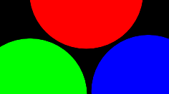

Question: What happens when red, blue, and green light are mixed?

- Predict: What color do you expect to be produced from each of the following light combinations?

Red and green light: ______________

Red and blue light: ______________

Green and blue light: ______________

Red, green, and blue light: ____________

- Observe: Drag the red circle so that it overlaps with the green circle. What color is made by mixing red and green light? ___________________________________________________

- Gather data: Try the remaining color combinations. Describe the resulting colors below.

Red and blue light: _______________________________________________________

Green and blue light: _____________________________________________________

Red, green, and blue light: _________________________________________________

- Identify: A secondary color is produced when two primary colors are mixed. The names of the secondary colors are yellow, cyan (blue-green), and magenta (pinkish purple).
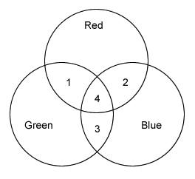
Without using the Gizmo, name the numbered colors in the diagram at right, and predict the RGB value of each.

Area | Color | RGB value
1
2
3
4

After completing the table, check your answers by using the Gizmo.

- Analyze: Colored lights are called additive colors. Why do you think this is so? _________

_________________________________________________________________________

_________________________________________________________________________

Activity B:  Creating colors | Get the Gizmo ready:  - Move the red, green, and blue circles so they completely overlap.  - Check that the Red, Green, and Blue values are all set to 255.

Question: How can any color be made from a combination of red, blue, and green light?

- Predict: How do you think you could use the Gizmo to make the color gray? _____________

_________________________________________________________________________

- Observe: Change the Red, Green, and Blue values to 90. What color does this produce?

_________________________________________________________________________

- Create: Using the Gizmo, try to create a color that matches each description below. Write the RGB value of each color that you create. In the last row of the table, describe your own object or color and give its RGB value.

Description | RGB value
A pale blue sky
A brown dog
A delicate pink rose
An orange pumpkin
A royal purple robe

- Calculate: Describe the RGB value and color you would obtain with each combination described below. Use the Gizmo to check your answers.
RGB value Color
  - Yellow (255, 255, 0) and blue (0, 0, 255) ______________ ______________

  - Plum (120, 0, 120) and dark green (0, 120, 0) ______________ ______________

  - Teal (0, 90, 90) and bronze (185, 150, 0) ______________ ______________

- Summarize: If you know the RGB values of two colors of light, how could you calculate the RGB value of a mixture of the two colors? _______________________________________
_________________________________________________________________________

