Vocabulary: Air Track

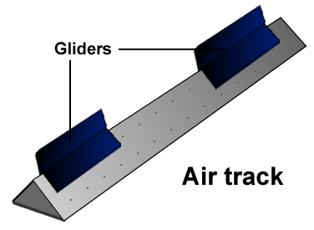

Vocabulary

- Air track – a triangular track that is perforated with holes that emit air.
  - One or more gliders can float on a cushion of air as they move over the air track.
  - An air track is used to study motion with minimal friction.

- Approach velocity – the rate at which two objects are approaching one another.
  - For objects moving on the same track, the approach velocity is equal to the difference in the objects’ velocities: approach velocity = v₁ – v₂.

- Conservation of energy – the principle that the total energy in a closed system remains constant.

- Conservation of momentum – the principle that the total momentum in a closed system remains constant.

- Elasticity – a measure of how much kinetic energy is preserved in a collision.
  - The symbol for elasticity is k.

- Kinetic energy – energy of motion.
  - Kinetic energy is represented by the symbol KE or simply K.
  - The formula for kinetic energy is KE = mv² / 2.

- Momentum – a measure of how difficult it is to stop a moving object.
  - Momentum is represented by the symbol p.
  - Momentum is the product of an object’s mass and velocity: p = mv.
  - If mass is measured in kilograms (kg) and velocity is measured in meters per second (m/s), the units of momentum are kilograms-meters per second (kg•m/s).

- Separation velocity – the rate at which two objects are moving away from one another.
  - For objects moving on the same track, the separation velocity is equal to the difference in the object’s velocities: separation velocity = v₂ – v₁.

- Velocity – the speed and direction of a moving object.
  - Motion to the right is considered positive and motion to the left is negative.

