Name: Date:

Student Exploration: Area of Parallelograms

Vocabulary: area, height (of a triangle or quadrilateral), parallelogram

Prior Knowledge Questions (Do these BEFORE using the Gizmo.)

- Ken is using tiles to cover a 6-foot by 3-foot section of a floor.

- If he uses 1-foot square tiles, how many will be in each row of tiles?

- How many rows of tiles will he use?

- How many tiles will he use to cover the whole section?

- The number of tiles needed represents the area of that section of Ken’s floor, in square feet. How can Ken use the dimensions of the section (6 feet by 3 feet) to calculate its area?

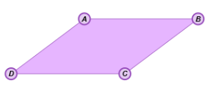
Gizmo Warm-up
The Area of Parallelograms Gizmo gives you a dynamic parallelogram, which is a quadrilateral with parallel opposite sides. You can manipulate the figure, and see an animation that shows how parallelograms are related to rectangles.

- In the Gizmo, drag the vertices of the parallelogram. Then click Animate. In the space to the right, sketch the figures from the Gizmo, before and after the animation.

- What was done to turn the parallelogram into a rectangle?

The length of the segment the figure was cut along is the height of the parallelogram.

- Turn on Show base and height. Reshape the parallelogram and click Animate again. How is the height of the parallelogram always shown in the Gizmo? (Fill in the blanks below.)

The height comes from one and is to the base.

Activity A:  Area of parallelograms | Get the Gizmo ready:  - Be sure Show base and height is selected.  - Turn on Show grid. | 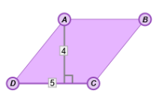

- In the Gizmo, drag the vertices to create a variety of parallelograms. Then click Align grid (under Show grid) to align the grid with the lower left vertex of your parallelogram.

- How can you use the grid to find the area of a parallelogram?

- Explain why finding area by “counting squares” can be tricky or inexact.

- Turn off Show grid. Be sure Show base and height is still selected. In the Gizmo, create a parallelogram of your choice. Click Animate.

- Sketch your “pre-animation” parallelogram and your “post-animation” rectangle to the right. Label each figure’s dimensions.

- What is the area of the rectangle?

- Explain how the area of the parallelogram relates to the area of the rectangle.

- In general, how can you find the area of a parallelogram?

Turn on Show area to check your answer. Experiment with other parallelograms to confirm that this is always true.
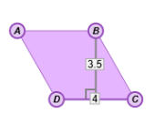
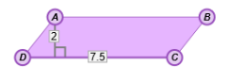

- Find the areas of the parallelograms to the right. Show your work in the space below each parallelogram. Then check your answers in the Gizmo.

Activity B:  Using area of parallelograms | Get the Gizmo ready:  - Be sure Show base and height is selected. | 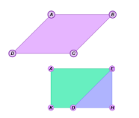

Solve each problem. Show all of your work in the space below each. Then, if possible, check your answers in the Gizmo. (Note: The last two problems cannot be checked in the Gizmo.)

- What is the area of the parallelogram shown below?
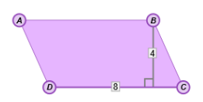

- A parallelogram with a height of 2.5 cm has an area of 30 cm². What is the base?

- If the area of a parallelogram is 25.2 square units and the base is 5.6 units, what is the height to that base?

- The area of the parallelogram shown below is 99 square feet. What is the base of the parallelogram?
11.5 ft
11 ft

- The height of a parallelogram is 15 units and the base is (x + 8) units. The area of the parallelogram is 180 square units. What must be the value of x?

