Vocabulary: Area of Triangles

Vocabulary
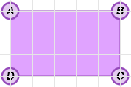
- Area – the number of square units inside a plane figure.
  - For example, the area of the figure to the right is 15 square units.

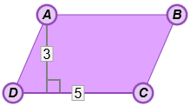
- Height (of a quadrilateral or triangle) – the perpendicular distance from a vertex to the opposite side.
- In parallelogram ABCD shown to the right, the height is 3 units.
- The side that forms a right angle with the height is called the base.
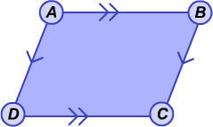

- Parallelogram – a quadrilateral with two pairs of parallel sides.

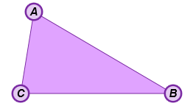

- Triangle – a polygon with three sides.

