Vocabulary: Balancing Blocks

Vocabulary

- Area – the size of a flat figure or object.
  - Area describes only two-dimensional figures.
  - Area is measured in square units such as square centimeters (cm²) or square inches (in²).
  - The area of a rectangle is equal to the product of its length and width.

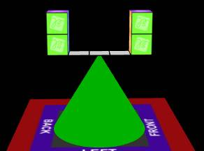
- Balance – stability produced by equal weights on either side of a point or line.
  - In the image at right, the blocks are balanced on a platform that sits on the tip of a cone.

- Dimension – a measurement in one direction.
  - A rectangular prism can be described by three dimensions: length, width, and height.
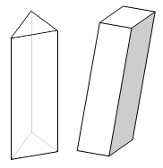
Triangular prism (left) and rectangular prism (right)

- Prism – a regular solid with the following characteristics:
  - The top and bottom faces, called bases, are the same size and shape.
  - The faces on the sides of the prism are all either rectangles or parallelograms.
  - The edges that connect the bases are all parallel to each other.

- Product – the result of multiplying numbers.
  - For example, the product of and 3 and 4 is 12 because 3 × 4 = 12.

- Rectangular prism – a prism with rectangular bases.
  - Boxes and bricks are examples of rectangular prisms.

- Volume – the amount of space taken up by an object.
  - Volume is similar to area, but is measured in three dimensions.
  - Volume of solids is measured in cubic units such as cubic centimeters (cm³) or cubic inches (in³).

