Vocabulary: Basic Prism

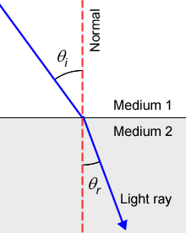
Vocabulary

- Angle of incidence – the angle between a light ray moving through a medium and the normal.
  - The normal is an imaginary line that runs perpendicular to the border between two media.
  - The symbol for angle of incidence is θ_{i}.

- Angle of refraction – the angle between the light ray moving through a second medium and the normal.
  - The symbol for angle of incidence is θ_{r}.

- Critical angle – the minimum angle of incidence that results in total internal reflection.

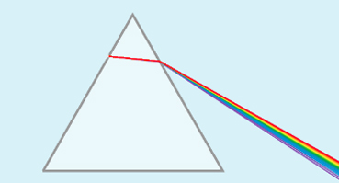
- Dispersion – the separation of light into its constituent colors.
  - The separation of light depends on its wavelength. Therefore, as white light passes from one medium to another, different colors are refracted at slightly different angles.
  - When white light passes through a prism, it is dispersed into a spectrum of colors.

- Index of refraction – a ratio of the speed of light in a vacuum to its speed in a given medium.
  - The higher the index of refraction of a medium, the slower light will travel through that medium.
  - The symbol for index of refraction is n.
  - Air has a refractive index of 1.0003, glass has a refractive index of 1.52, and diamond has a refractive index of 2.419.

- Medium – a substance through which a wave can travel.
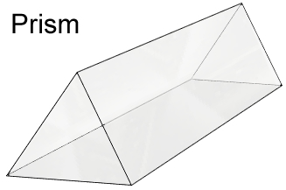
  - The plural of medium is media.

- Prism – an optical device made of clear glass or plastic that is used to divide white light into a spectrum of colors.
  - Prisms often have triangular bases and rectangular sides.

- Refract – to bend or change direction as a result of entering a different medium.
  - During refraction, the speed and wavelength of a wave changes, but not its frequency.

- Snell’s law – a law stating that the product of the first medium’s index of refraction and the sine of the angle of incidence is equal to the product of the second medium’s index of refraction and the sine of the angle of refraction:

n₁·sin(θ_{i}) = n₁·sin(θ_{r})

- Total internal reflection – a phenomenon in which light is reflected from the boundary between two substances rather than refracting through the boundary.
  - Total internal reflection occurs when the refractive index of the first medium is greater than the refractive index of the second medium.
  - The minimum angle of incidence that results in total internal reflection is the critical angle.

- Visible spectrum – the band of colors produced when white light is passed through a prism or similar device.
  - The sequence of colors in the visible spectrum is red, orange, yellow, green, blue, and violet. Red light has the longest wavelength, and violet light has the shortest wavelength.
  - Visible light has wavelengths that range from 0.38 μm to 0.73 μm (380–730 nm).

- Wavelength – the distance between consecutive crests or troughs of a wave.
  - Different forms of electromagnetic radiation are distinguished by their wavelengths.
  - Visible light has wavelengths between 380 and 730 nanometers (nm).

