Name: Date:

Student Exploration: Beam to Moon

Vocabulary: proportion, proportional, ratio

Prior Knowledge Questions (Do these BEFORE using the Gizmo.)
At Frugal Foods a loaf of bread cost about $1 in 1980. In 2013, the loaf of bread cost $2.50.

- A ratio is a comparison of two amounts by division. What is the ratio of the cost of a loaf of bread in 2013 to the cost in 1980?

- Assuming the price of clothing increased at the same rate, if the cost of jeans at Cobb’s Corner was $15 in 1980, what would the cost of the jeans be in 2013?
Explain.

Two quantities that change at the same rate, so they keep equal ratios, are proportional.

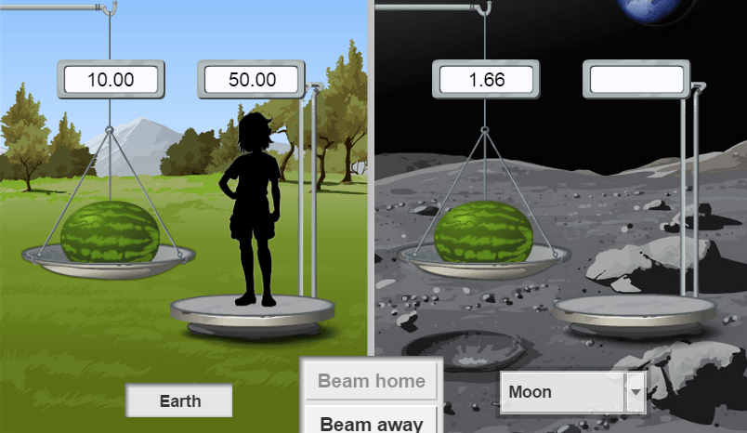
Gizmo Warm-up
If you could travel to the Moon, you would weigh less there. So would a baseball, or a car, or anything. Like the prices above, the weights of any two objects would change proportionally.

In the Beam to Moon Gizmo, you can find what your weight would be on the Moon with ratios and proportions. A proportion is an equation of two equal ratios.

- In the Gizmo, be sure Pounds is selected at the bottom right, and be sure the Moon is selected. Drag the flower onto the first scale, on Earth, and then onto the scale on the Moon.

What is the flower’s Earth weight? What is its Moon weight?

- Type your weight at the top left corner of the Gizmo and hit Enter. Then select Newtons.

  - What is your weight in pounds? In Newtons?

  - How many Newtons equal one pound? Explain.

Activity A:  Weight on the Moon | Get the Gizmo ready:  - Select Pounds in the bottom right.  - Select Moon from the menu. | 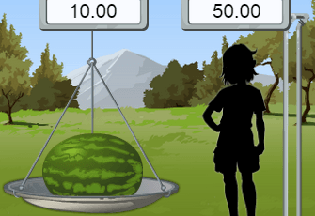

- In the Gizmo, place the watermelon on the scale on Earth, and on the Moon.

- How much does the watermelon weigh in each location? (Use units on the answers.)

Earth weight: Moon weight:

- What is the ratio of Moon weight to Earth weight of the watermelon? Write this as a fraction and as a decimal.
=
_________
≈

- Find the same ratio (Moon weight to Earth weight) of the flower and the baseball.

What do you notice?

- How much do you weigh on Earth? How do you think you could figure out your Moon weight?

- In the space to the right, set up a proportion. One fraction should include the Moon weight and Earth weight of the baseball, flower, or watermelon. The other fraction should be for your weights. (Use x for your Moon weight.)

Then solve the proportion to find what your weight would be on the Moon.

- Using the Gizmo, check your answer. (To do this, first type in your weight at the top left corner of the Gizmo. Then weigh the baseball, flower, or watermelon on the Moon and on Earth. When all three weights are entered, click Beam Away.)

- An object weighs 30 pounds on Earth. How much will it weigh on the Moon?

Explain.

- An object weights 30 pounds on the Moon. How much will it weigh on Earth?

Explain.

Activity B:  Exploring other planets | Get the Gizmo ready:  - Select Pounds in the bottom right.  - Select Pluto from the menu. | 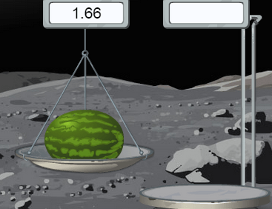

- Using the Gizmo, place the flower on the scale on Earth, and on Pluto.

- How much does the flower weigh in each location? (Use units on your answers.)

Earth weight: Pluto weight:

- What is the ratio of Pluto weight to Earth weight of the flower? Write this as a fraction and as a decimal.
=
≈
_________

- Find the same ratio (Pluto weight to Earth weight) of the baseball and watermelon.
What do you notice?
- How much do you weigh on Earth? Enter your weight at the top left corner of the Gizmo.

- In the space to the right, set up a proportion to find what your weight would be on Pluto. Then solve the proportion.

- Check your answer in the Gizmo. Weigh an object on Earth and on Pluto. When all three weights are entered, click Beam Away.)

The weights on Earth and Pluto are proportional since the ratio of any object’s weights on Earth and Pluto is always the same. Earth weight is about 17 times the Pluto weight, or Pluto weight is about one-seventeenth (about 5.8%) of Earth weight.

- In the Gizmo, select Venus from the menu. Select an object and use the scales to weigh the object on Earth and Venus. In the space to the right, write a proportion to find your weight on Venus. Then solve for your weight (including units). Use the Gizmo to check your answer.

Object:

Object’s Earth weight:

Object’s Venus weight:

Your Venus weight:

(Activity B continued on next page)
Activity B (continued from previous page)

- In the Gizmo, select an object (baseball, flower, or watermelon) and weigh it on Earth and on Mars, Jupiter, and Saturn. For each planet, use a proportion to calculate how much you would weigh there. Show your work in the space provided below.

Your weight on: Mars: Jupiter: Saturn:

Check each of your answers in the Gizmo by clicking Beam Away.

- Your weight depends on the mass and the force of gravity pulling you down. The stronger the force of gravity, the more you weigh. From planets in the Gizmo as well as the Moon, which has the strongest force of gravity? Which has the weakest?

Strongest gravity: Weakest gravity:

Explain.

- Answer each problem without using the Gizmo. Then check your answer to part A in the Gizmo. (Part B uses a fictitious planet.) Make corrections if needed.

- Using what you have found earlier, write a proportion to find how much a 60-pound dog weighs on Pluto.

- Suppose a 20-pound sledgehammer weighs 8 pounds on the planet Quintron. If a man weighs 58 pounds on Quintron, find his weight on Earth.

Dog’s Pluto weight:
Man’s Earth weight:

