Name: Date:

Student Exploration: Biconditional Statements

Vocabulary: biconditional statement, conclusion, conditional statement, converse, hypothesis

Prior Knowledge Questions (Do these BEFORE using the Gizmo.)

- Kara said, “A cheeseburger is a type of food.”

- Is this true?

- Is this a good definition of a cheeseburger? Why or why not?

- What is a better definition of “cheeseburger”?

Gizmo Overview
In the Biconditional Statements Gizmo, you’ll work with a conditional statement (an if-then statement) and its converse (formed by switching the hypothesis, the “if” part of a conditional, and the conclusion, the “then” part). You’ll use the conditional and converse to write two-way biconditional statements (if-and-only-if statements).

Here’s how the Gizmo looks at first:

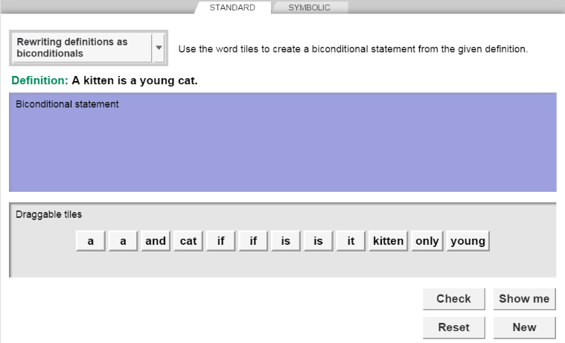
At the top, click the tabs to select a “mode”: STANDARD (words) or SYMBOLIC (with symbols).
Click Check to check your answer.
Click Reset to start over.
Click Show me for the answer.
Click New to try a new problem.

You can choose three different problem types from this menu:
- Rewriting definitions as biconditionals
- Writing biconditionals
- Rewriting biconditionals as two conditionals

Your job is to put these word tiles in the correct order in the bin above.

(Note that the bin(s) may be different depending on which problem type you’ve selected.)

Activity A:  Rewriting definitions | Get the Gizmo ready:  - Be sure the STANDARD tab is selected.  - Select Rewriting definitions as biconditionals. | 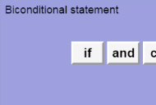
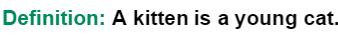
- You should see the definition to the right at the top.

- Are there any kittens that are not young cats? How can you express that as a true conditional statement? Fill in the blanks below to do so.

If a cat , then it

- Are there any young cats that are not kittens? Express this as a conditional statement below. (This should be the converse of the above conditional.)

If a cat , then it

- When a conditional statement and its converse are both true, you can combine them into one true biconditional (“if and only if”) statement. Fill in the blanks below with the hypothesis and conclusion to form this statement.

if and only if

In the Gizmo, drag these tiles into the Biconditional statement bin. Click Check. Adjust your tiles if needed.

- Switch the hypothesis and conclusion. Click Check. What do you find?

- With Rewriting definitions as biconditionals still chosen, click the SYMBOLIC tab. You should still see the definition, “A kitten is a young cat.”

  - The symbolic statement p ↔ q is read, “p if and only if q.” Drag the word tiles into the bins to form p and q. Then click Check to check your answers. What are p and q?

p:

q:

  - How does your answer for this statement on the SYMBOLIC tab compare to your answer on the STANDARD tab?

- Click New. Work through more Rewriting definitions as biconditionals problems.

(Activity A continued on next page)
Activity A (continued from previous page)

- A good definition can be written as a biconditional statement. Write two biconditionals that mean the same thing as each definition below. For the first statement, use only words. For the second one, use words and the ↔ symbol, and reverse the hypothesis and conclusion.

- A hurricane is a tropical storm with winds of at least 74 mph.

if and only if

↔

- Independence Day in the United States is the fourth of July.

- Noon is 12:00 P.M.

- A right triangle has one right angle.

- A quadrilateral is a polygon with four sides.

- Two perpendicular lines intersect at a 90-degree angle.

- An obtuse angle measures greater than 90 degrees.

Activity B:  Conditionals and biconditionals | Get the Gizmo ready:  - Click on the STANDARD tab.  - Choose Writing biconditionals. | 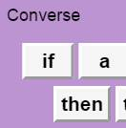
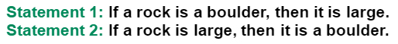
- You should see the statements at the right.

  - Are both statements true?

  - Fill in the blank below to describe how Statement 2 relates to Statement 1.

Statement 2 is the of Statement 1.

  - Write a true biconditional that combines Statement 1 and Statement 2.

Form the biconditional by dragging word tiles into the Biconditional statement bin. Click Check to see if your answer is correct. If not, make some changes and click Check again.

  - Write a different (reversed) biconditional that combines the two given statements.

Rearrange the tiles to form this statement. Click Check to check your answer.

- With Writing biconditionals chosen, click the SYMBOLIC tab. You should see the statements below in the Gizmo.

- Write two true biconditionals for these statements in symbolic form.

↔

↔

- Drag the tiles into the bin to form one of the biconditionals from above. How does this biconditional compare with the ones you formed on the STANDARD tab?

- Click New. Work through more Writing biconditionals problems in the Gizmo, in both STANDARD and SYMBOLIC form.

(Activity B continued on next page)
Activity B (continued from previous page)

- Choose Rewriting biconditionals as two conditionals from the dropdown menu. Click on the STANDARD tab. You should see the biconditional below at the top of the Gizmo.

- What conditional and converse were combined to make the given biconditional?

Conditional:

Converse:

Drag the tiles into the bins to form the conditional and converse. Click Check.

- If you switch the answers in the bins, are the statements still true?

Explain:

Rearrange the tiles to check your answer.

- With Rewriting biconditionals as two conditionals still chosen, click the SYMBOLIC tab. You should see the biconditional below at the top of the Gizmo.

Write the conditional and converse in symbolic form below. Then, form them in the Gizmo.

→

→

- Click New. Work through more Rewriting biconditionals as two conditionals problems in the Gizmo, in both STANDARD and SYMBOLIC form.

- Rewrite each biconditional statement as a conditional and a converse.

- A quadrilateral is a rhombus if and only if it has four congruent sides.

Conditional:

Converse:

- The time is midnight if and only if it is 12:00 A.M.

Conditional:

Converse:

