Name: Date:

Student Exploration: Box-and-Whisker Plots

Vocabulary: box-and-whisker plot, interquartile range, maximum, median, minimum, quartile

Prior Knowledge Questions (Do these BEFORE using the Gizmo.)
Holly and Brian’s social studies teacher gives them quizzes worth up to 20 points. Holly received the following scores: 5, 11, 17, 18, and 20. Brian’s scores were 16, 16, 17, 19, and 19.

- The median is the middle value of a data set. What is the median of each set of scores?

Holly’s median: Brian’s median:

- Aside from having the same median, are the data sets very similar?

Explain.

Gizmo Warm-up
Both Brian and Holly had the same median score, but in other ways their scores were very different. While Brian’s scores were very consistent, Holly’s scores were all over the place.

One way to visualize the “spread” of a data set is to use a box-and-whisker plot. You can explore these graphs with the Box-and-Whisker Plot Gizmo. To begin, check that Link plots is selected. The data set shown in the dot plot should be 2, 7, 10, 13, and 18.
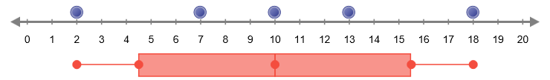

- The minimum, or lowest value, of the data set is 2. Move the leftmost blue dot back and forth. How does this relate to the position of the leftmost point of the box-and-whisker plot?

- How does the position of the maximum (highest value) of the data set affect the box-and-whisker plot?

- Move the middle blue point (the median) back and forth. How does this affect the box-and-whisker plot?

Activity A:  Creating box-and-whisker plots | Get the Gizmo ready:  - Check that Link plots is selected. Click Clear.  - Drag points to 2, 6, 9, 11, 14, and 18 on the line plot above the box-and-whisker plot. | 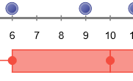

- A box-and-whisker plot of a data set contains five key values. So far, you know what three of these points represent: the minimum, the median, and the maximum.
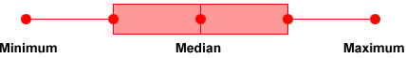

- What is the median of the data set, 2, 6, 9, 11, 14, 18?

(Hint: When there is an even number of values in the data set, the median is the mean of the two middle values. To find the mean, add the values and divide by 2.)

- What are the set’s minimum and maximum values? Min. Max.

- A box-and-whisker plot divides the data into four quarters. The boundaries of these segments are called quartiles. The first quartile (Q₁) is greater than about 25%, or one quarter of the data. The median is the second quartile (Q₂), and is greater than about 50% of the data. The third quartile (Q₃) is greater than about 75% of the data.

- In the data set given above, how many data points are to the left of Q₂?

- What are the values of these points?

- What is the median of these values?

This is the first quartile, Q₁. Notice that it forms the left side of the “box.”

- How many data points are to the right of Q₂?

- What are the values of these points?

- What is the median of these values?

This is the third quartile, Q₃. It forms the right side of the “box.”

- Add a point at 10. The data set should now be 2, 6, 9, 10, 11, 14, and 18.

Do the positions of Q₁ or Q₃ change?

The new point, which is on Q₂, does not affect the other quartile values because only the points to the left and right of Q₂ are used to find Q₁ and Q₃.

(Activity A continued on next page)
Activity A (continued from previous page)

- Deselect Link plots and click New. In this setting, the box-and-whisker plot is not automatically linked to the line plot. This allows you to manipulate the points in the
box-and-whisker plot to match the data.

- What is the new data set?

- What are the minimum and maximum of this set? Min. Max.

- What is the median of this data set?

- What is the median of the terms to the left of Q₂?

- What is the median of the terms to the right of Q₂?

- In the Gizmo, create a box-and-whisker plot for the data set by dragging the five red points to the correct values. When you are done, select Check plots. If necessary, adjust your plot until your box-and-whisker plot matches the line plot.

- In the space below the number line, draw the box-and-whisker plot for this data set. Label the values of the five key values: Min., Q₁, Q₂, Q₃, and Max.

- The interquartile range (IQR) is the difference between the first and third quartiles: IQR = Q₃ – Q₁. In other words, it is the width of the box in the box-and-whisker plot.

What is the interquartile range of this data set?

- Deselect Check plots, and click New. In the space below, record the data set and create a corresponding box-and-whisker plot. Use the Gizmo to check your work.

Data set:

Plot:

Activity B:  Interpreting box-and-whisker plots | Get the Gizmo ready:  - Click Clear.  - Check that Link plots is not selected. | 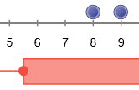

- Use the Gizmo to create the box-and-whisker plot shown below. Then, create a data set that matches the plot. The data set should have 10 values. Use the Gizmo to check your work.

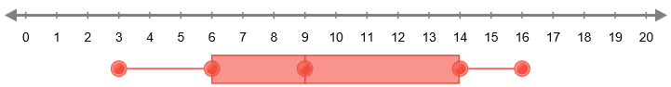

Data set:

Challenge: Create a second data set that also matches the given box-and-whisker plot. This data set should have 13 values. Use the Gizmo to check your work.

Data set:

- Two box-and-whisker plots are shown below. Each plot represents a data set with 6 items.
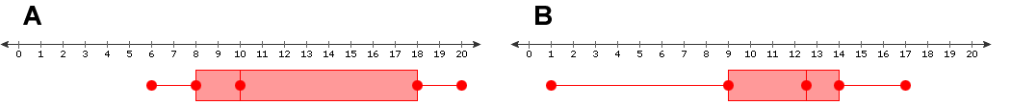

- Which plot shows data with a greater range?

- Which plot shows a greater interquartile range?

- In your opinion, which plot shows data that is more spread out?

Explain your answer.

- Challenge: The mean of a data set is equal to the sum of all the values in the data set divided by the number of values.

Which plot shows data in which the mean is likely greater than the median?

Explain why you think so.

