Name: Date:

Student Exploration: Cargo Captain

Vocabulary: base-10 system, difference, regrouping, subtract

Prior Knowledge Questions (Do these BEFORE using the Gizmo.)
Joey is selling his DVD player to Jill for $172. Jill pays for it with 2 hundred-dollar bills.

- How much change should Jill get? ______________

- Jill asks for her change in ten-dollar bills and one-dollar bills. Joey has 20 one-dollar bills but only 1 ten-dollar bill. Can he give Jill her change? If so, how would he do it?

_____________________________________________________________________

_____________________________________________________________________

Gizmo Warm-up
In the Cargo Captain Gizmo, you have been hired to command a spaceship that transports important supplies from Earth to faraway planets.
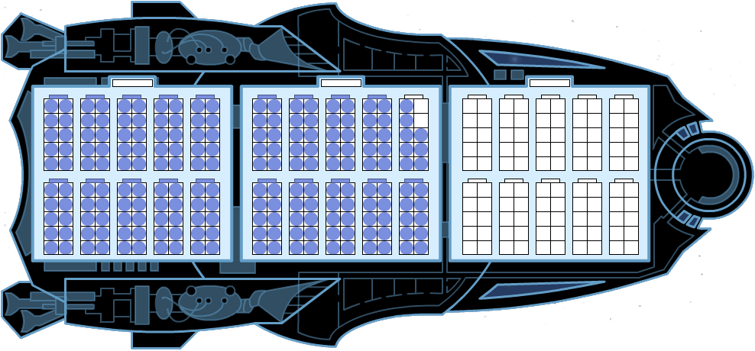
Your control panel includes a diagram of your ship. The blue dots on the diagram represent barrels of cargo.

- You can adjust the number of barrels by dragging the slider.

What is the maximum number of barrels your ship can hold? _________

- Use the slider to load 198 barrels onto your ship. Click Seal all to group your barrels into containers. Check that Containers is selected, and write your Cargo status below:

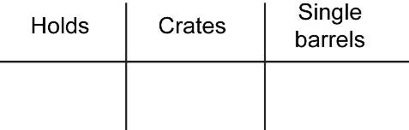

- Click Done to fly to Planet Pythagoras. This planet needs 7 barrels of cargo. Set the slider to 7 and click Done. How much cargo do you think you will have once you unload 7 barrels?

_____________________________________________________________________

- Select 7 barrels by clicking on them. Click Done to unload them. Were you correct? ______ The people of Planet Pythagoras thank you for your delivery!

Activity A:  Captain training | Get the Gizmo ready:  - Be sure that your ship is located on Earth. (If the button is visible, click Back to Earth.)  - Set the slider to 0 barrels of cargo. | 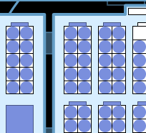

- To earn your Captain’s license, you need to know your ship. Your spaceship is organized like the base-10 system, the system we use to write numbers.

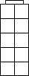
    - Cargo barrels are stored in crates like the one shown to the right.

How many barrels does one crate hold? _________

    - Crates are stored in rooms called “cargo holds.”

How many crates are in one hold? _________

- There are several ways that the cargo can be organized. Use the slider to load 100 barrels onto your ship. Make sure the display is set to Containers. Check the Cargo status.

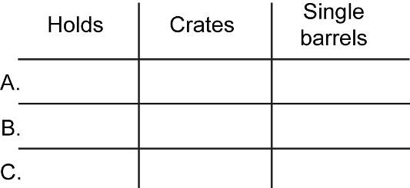
  - Fill in line A of the table at right.

  - A full crate can be sealed by clicking the blue rectangle at its top. Seal all the full crates. Fill in line B.

  - A full hold can also be sealed by clicking the blue rectangle at its top. Seal the hold, and then fill in line C.

  - Regrouping is changing how a number is grouped into ones, tens, and so on. How did you use regrouping here? ___________________________________________
___________________________________________________________________

- In the table, write three different ways for organizing 140 barrels on your ship.

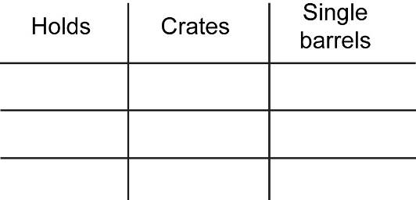

Use the Gizmo the check your answers. Congratulations, you’ve earned your Cargo Captain License!
Activity B:  First mission | Get the Gizmo ready:  - If the button is visible, click Back to Earth.  - Be sure the display is set to Containers.  - Load 92 barrels onto your ship and click Seal all. | 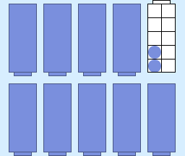

It’s time for your first cargo mission, Captain! You must transport 92 barrels of pickles from Earth to the outer planets. At each planet, you will subtract some barrels.

- With 92 barrels on board, click Done to fly to Pythagoras. Here you will drop off 8 barrels.

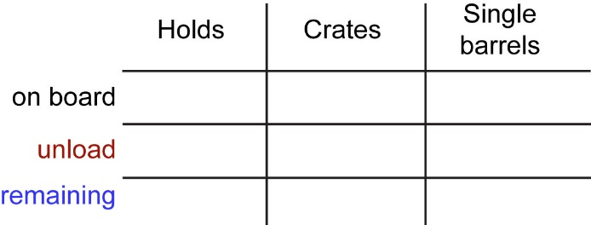
- Set the slider to 8 and click Done.

- Select 8 barrels to unload. Fill in the first two lines of the table.

- What did you have to do to get exactly 8 barrels selected?

___________________________________________________________________

- Click Done and fill in the last line of the table. How many barrels are left? _________

This number is the difference between 92 and 8.

- Click Next planet. Euclid needs 19 barrels of pickles. Set the slider to 19 and click Done.
- Fill in the first two lines of the table. Then select 19 barrels to unload.

- How many barrels will remain after you unload 19 barrels? _________
- Click Done and check your answer. Then fill in the last line of the table.

- Click Next planet. Newton needs 37 barrels of pickles. Set the slider to 37 and click Done.

- Select 37 barrels and click Done. Record the Cargo status at right.

- Changing how your cargo is organized is called regrouping. For example, one full crate can be regrouped into ten single barrels.

How did you use regrouping in this case? __________________________________

___________________________________________________________________

Activity C:  Advanced mission | Get the Gizmo ready:  - If the button is visible, click Back to Earth.  - Be sure the display is set to Containers.  - Load 300 barrels onto your ship. Click Seal all.

The outer planets are experiencing a severe shortage of sardines. Delivering these 300 barrels will require skill (and regrouping). Good luck! Click Done to fly to the first planet, Pythagoras.

- Planet Pythagoras needs 40 barrels. After you arrive, set the slider to 40 and click Done.
  - Unload the 40 barrels by selecting 4 crates. What did you have to do to select 4 crates?

___________________________

  - Click Done and fill in the table.

- Click Next planet. Euclid needs 87 barrels of sardines. Set the slider to 87 and click Done. Fill in the first two lines of your Cargo status below.

- First, find a way to select 7 barrels. Update the first line of your table.

- Now select 8 crates. Update the first line of your table.

- How many barrels will remain after you unload 87 barrels? __________
- Click Done to check your answer, and then fill in the last line in the table.

3. Click Next planet. Newton needs 95 barrels of sardines. Set the slider to 95 and click Done.
- Find a way to select 95 barrels. Fill in the first two lines of the table.

- How many barrels will remain after you unload 95 barrels? _________
- Click Done to check your answer, and then fill in the last line in the table.

- Explain how you used regrouping to unload the 95 barrels. Mission accomplished!

___________________________________________________________________

___________________________________________________________________

