Name: Date:

Student Exploration: Cat and Mouse
(Modeling with Linear Systems)

Vocabulary: slope, y-intercept

Prior Knowledge Questions (Do these BEFORE using the Gizmo.)

- Kristin is driving on the highway at 100 kilometers per hour. How long will it take Kristin to reach a rest area 150 kilometers away?

- Kristin is 20 kilometers behind a truck that is driving 90 kilometers per hour. How long will it take her to catch up to the truck? How far will she go in that time?

Time to catch up to truck: Distance traveled in that time:

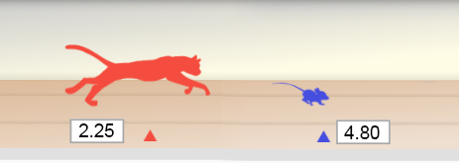
Gizmo Warm-up
A small mouse plays on the floor, unaware of the cat creeping up on it from behind. The cat springs and the mouse desperately runs away. Will the mouse reach its hole in time to escape the cat?

The Cat and Mouse (Modeling Linear Systems) Gizmo models this situation. In the Gizmo, you can drag the sliders to adjust the speeds of the cat and mouse, as well as the head start of the mouse. (To quickly set a slider to a given value, enter the value in the text box to the right of the slider and hit Enter.) The time and distance of the cat and mouse are shown on the graph.

- On the CONTROLS tab, drag the Mouse’s head start (meters) slider. What changes about the graph?
The y-value of the point where the line crosses the y-axis is the y-intercept of the line.

- Drag the Mouse’s speed (meters per second) slider. What changes about the graph?
The steepness of the line is called the slope of the line.

- Click Simulate. Does the cat catch the mouse?

Activity A:  Graph sense: Slope and  y-intercept | Get the Gizmo ready:  - Click Refresh in your browser. | 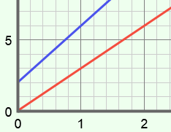

- Experiment with a variety of settings for the mouse head start, mouse speed, and cat speed. For each simulation, write down the settings you used, whether the cat captured the mouse, and when the capture occurred. (If the mouse escaped, leave the last column blank.)

To find the time of the capture, turn on Show whether cat catches mouse.

Mouse head start (meters) | Mouse speed (meters/second) | Cat speed (meters/second) | Mouse captured? | Time of capture

- What is represented by the y-intercept of the blue line?

- What does the slope of the blue line represent?

- What does the slope of the red line represent?

- What do the blue and red dots represent?

- In each situation where the cat catches the mouse, what is true about the graph?

- In each situation where the cat does not catch the mouse, what is true about the graph?
- What do the coordinates of the green dot (the intersection point) tell you?

- If the cat runs faster than the mouse, will it always catch the mouse?

Explain your answer.

(Activity A continued on next page)
Activity A (continued from previous page)
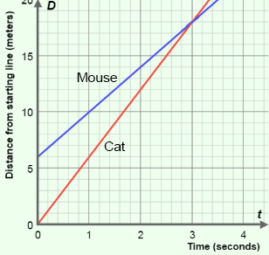
- The graph at right depicts a cat chasing a mouse. The lines show the positions of the animals (or, distance from the cat’s starting point) over time. The mouse is trying to reach its hole, at 20 meters.

Answer the questions below based on the graph.

- The cat always starts at a position of 0 meters. Where does the mouse start?
- Where is each animal after 1 second? Mouse: Cat:

- What is the speed of each animal? Be sure to include units on your answers. (Hint: don’t forget to factor in the mouse’s starting position.)

Mouse speed: Cat speed:

- The slope of a line is equal to the change in y over change in x (or, “rise over run”). What are the slopes of the two lines shown in the graph?

Slope of mouse’s line: Slope of cat’s line:

Notice that the slope of each line gives you the speed of each animal.

- Did the cat catch the mouse? If so, at what time?

Check all of your answers using the Gizmo.

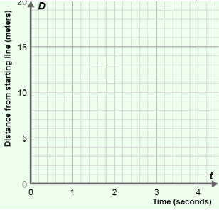
- A mouse is 5 meters in front of a cat and 15 meters from its hole. The mouse runs at a speed of 4 meters per second, while the cat runs 5 meters per second.

Graph this scenario to the right. Then answer the questions below.

- Will the cat catch the mouse?

- How do you know?

Check your graph and answers with the Gizmo.

- Challenge: If the mouse hole were much farther away, when and where would the cat catch the mouse?
Activity B:  Interpreting tables | Get the Gizmo ready:  - Set the Mouse’s head start to 9 m, Mouse’s speed to 5 m/s, and Cat’s speed to 11 m/s. | 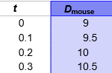

- Using the settings given above, take a look at the graph of the cat-and-mouse chase. Place your cursor on the green point where the lines intersect. What does that point tell you?

The cat catches the mouse after seconds, after running meters.

- You can also find (or estimate) that solution using the table. Select the TABLE tab. In the table, D_{mouse} represents the distance of the mouse from the starting point, and D_{cat} represents the distance of the cat. Below the table, check that the STEP is set to 0.10.

  - What must be true about D_{mouse} and D_{cat} at the moment the cat catches the mouse?

  - Scroll down through the table. When did the cat catch the mouse?

  - According to the table, at what position did the cat catch the mouse?

Click SIimulate to see the chase and check your answers.

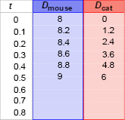
- You can also use the table to measure the position and speed of the mouse and cat. The table at right is missing a few values. Use the table to answer the following questions.

- What is the head start of the mouse?

- How far does each animal move every 0.1 seconds?

Mouse: Cat:

- What are their speeds meters per second? Mouse: Cat:

- When and where will the cat catch the mouse?

Use the Gizmo to check your answers.

t (hrs) | D_{Blonde} | D_{Malhomme}
0
1
2
3
4

- Jim Blonde and the evil Professor Malhomme are in a car chase. Blonde has a 24-km lead and travels 148 km/h. Malhomme is going 156 km/h.

Fill in the table to determine when and where Malhomme will catch up to Blonde.

Time: Distance:

Extension:  Using algebra | Get the Gizmo ready:  - Set the Mouse’s head start to 10 m, Mouse’s speed to 3 m/s, and Cat’s speed to 10 m/s.  - Turn off Show whether cat catches mouse. | 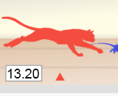

- After entering the values above, select the TABLE tab. Click Simulate to see the chase.

- What is true at the moment the cat catches the mouse?

- Scroll through the table. What is the best estimate you can make for when the cat catches the mouse?

- To find the exact coordinates of that intersection point, you need algebra. In general, the position of the mouse is described by the equation D_{mouse} = mt + b where m is the speed of the mouse, t is the time, and b is the head start of the mouse.

  - Write a general equation for the cat’s position, using c for cat speed. D_{cat} =

  - At the time of the catch, D_{mouse} = D_{cat}. Set the expressions for D_{mouse} and D_{cat} equal, and solve for the time that the cat catches the mouse, t. Show your work to the right.

- Is it possible to determine the time of capture if all you know is the head start and the difference between the two speeds? Explain.

- In each problem below, use your equation to solve for t. Then substitute this value into the D_{cat} equation to find the distance. Show your work. If possible, check with the Gizmo.

  - A cat is chasing a mouse. The mouse has a head start of 9 meters and is going 5 m/s. The cat is going 12 m/s. How long will it take for the cat to catch the mouse, and how far will the cat go?

  - A cheetah is chasing an antelope. The antelope starts 30 meters ahead, going 21 meters per second (m/s). The cheetah is going 25 m/s. When will the cheetah catch the antelope, and how far will the cheetah go?

