Name: Date:

**Student Exploration: Cat and Mouse   
(Modeling with Linear Systems)**

**Vocabulary:** slope, *y*-intercept

**Prior Knowledge Questions** (Do these BEFORE using the Gizmo.)

1. Kristin is driving on the highway at 60 miles per hour. How long will it take Kristin to reach a rest area 90 miles away?
2. Kristin is 20 miles behind a truck that is driving 50 miles per hour. How long will it take her to catch up to the truck? How far will she go in that time?

Time to catch up to truck: Distance traveled in that time:

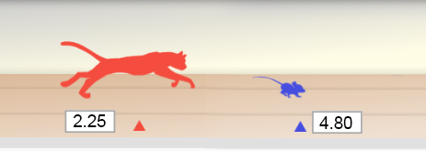

**Gizmo Warm-up**

A small mouse plays on the floor, unaware of the cat creeping up on it from behind. The cat springs and the mouse desperately runs away. Will the mouse reach its hole in time to escape the cat?

The *Cat and Mouse (Modeling with Linear Systems)* Gizmo models this situation. In the Gizmo, you can drag the sliders to adjust the speeds of the cat and mouse, as well as the head start of the mouse. (To quickly set a slider to a given value, click the text field, type the new value, and hit **Enter**.) The time and distance of the cat and mouse are shown on the graph.

1. On the **CONTROLS** tab, drag the **Mouse: head start (feet)** slider. What changes about the graph?

The *y*-value of the point where the line crosses the *y*-axis is the ***y*-intercept** of the line.

1. Drag the **Mouse: average speed (feet per second)** slider. What changes about the graph?

The steepness of the line is called the **slope** of the line.

1. Click **Simulate**. Does the cat catch the mouse?

|  |  |  |
| --- | --- | --- |
| **Activity A:**  **Graph sense: Slope and  *y*-intercept** | Get the Gizmo ready:   * Click **Refresh** in your browser. | 108SE2 |

1. Experiment with a variety of settings for the mouse head start, mouse speed, and cat speed. For each simulation, write down the settings you used, whether the cat captured the mouse, and when the capture occurred. (If the mouse escaped, leave the last column blank.)

To find the time of the capture, turn on **Show whether cat catches mouse**.

|  |  |  |  |  |
| --- | --- | --- | --- | --- |
| **Mouse: head start (feet)** | **Mouse: speed (feet/second)** | **Cat: speed (feet/second)** | **Mouse captured?** | **Time of capture** |
|  |  |  |  |  |
|  |  |  |  |  |
|  |  |  |  |  |
|  |  |  |  |  |
|  |  |  |  |  |

1. What is represented by the *y*-intercept of the blue line?
2. What does the slope of the blue line represent?
3. What does the slope of the red line represent?
4. What do the blue and red dots represent?
5. In each situation where the cat catches the mouse, what is true about the graph?

1. In each situation where the cat does not catch the mouse, what is true about the graph?
2. What do the coordinates of the green dot (the intersection point) tell you?

1. If the cat runs faster than the mouse, will it always catch the mouse?

Explain your answer.

**(Activity A continued on next page)**

**Activity A (continued from previous page)**

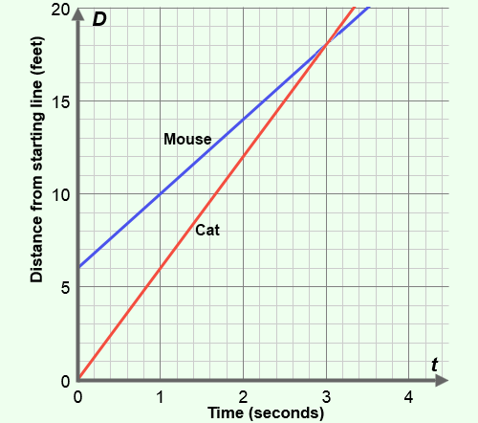

1. The graph at right depicts a cat chasing a mouse. The lines show the positions of the animals (or, distance from the cat’s starting point) over time. The mouse is trying to reach its hole, at 20 feet.

Answer the questions below based on the graph.

1. The cat always starts at a position of 0 feet. Where does the mouse start?
2. Where is each animal after 1 second? Mouse: Cat:
3. What is the speed of each animal? Be sure to include units on your answers. (Hint: don’t forget to factor in the mouse’s starting position.)

Mouse speed: Cat speed:

1. The slope of a line is equal to the change in *y* over change in *x* (or, “rise over run”). What are the slopes of the two lines shown in the graph?

Slope of mouse’s line: Slope of cat’s line:

Notice that the slope of each line gives you the speed of each animal.

1. Did the cat catch the mouse? If so, at what time?

Check all of your answers using the Gizmo.

1. 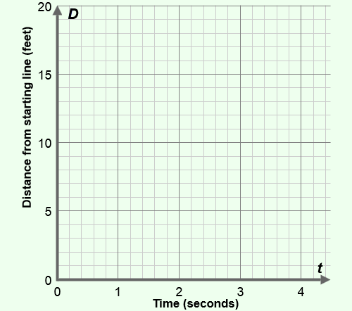A mouse is 5 feet in front of a cat and 15 feet from its hole. The mouse runs at a speed of 4 feet per second, while the cat runs 5 feet per second.

Graph this scenario to the right. Then answer the questions below.

1. Will the cat catch the mouse?
2. How do you know?

Check your graph and answers with the Gizmo.

1. Challenge: If the mouse hole were much farther away, when and where would the cat catch the mouse?

|  |  |  |
| --- | --- | --- |
| **Activity B:**  **Interpreting tables** | Get the Gizmo ready:   * Set **Mouse: head start** to 9 feet, **Mouse: speed** to 5 ft/s, and **Cat: speed** to 11 ft/s. | 108SE5 |

1. Using the settings given above, take a look at the graph of the cat-and-mouse chase. Place your cursor on the green point where the lines intersect. What does that point tell you?

The cat catches the mouse after seconds, after running feet.

1. You can also find (or estimate) that solution using the table. Select the **TABLE** tab. In the table, ***D*mouse** represents the distance of the mouse from the starting point, and ***D*cat** represents the distance of the cat. Below the table, check that the **STEP** is set to 0.10.
   1. What must be true about ***D*mouse** and ***D*cat** at the moment the cat catches the mouse?

* 1. Scroll down through the table. When did the cat catch the mouse?
  2. According to the table, at what position did the cat catch the mouse?

Click **Simulate** to see the chase and check your answers.

1. You can also use the table to measure the position and speed of the mouse and cat. The table at right is missing a few values. Use the table to answer the following questions.
2. What is the head start of the mouse?
3. How far does each animal move every 0.1 seconds?

Mouse: Cat:

1. What are their speeds in feet/second? Mouse: Cat:
2. When and where will the cat catch the mouse?

Use the Gizmo to check your answers.

|  |  |  |
| --- | --- | --- |
| ***t* (hrs)** | ***D*Blonde** | ***D*Malhomme** |
| 0 |  |  |
| 1 |  |  |
| 2 |  |  |
| 3 |  |  |
| 4 |  |  |

1. Jim Blonde and the evil Professor Malhomme are in a car chase. Blonde has a 24-mile lead and travels 89 miles per hour. Malhomme is going 97 miles per hour.

Fill in the table to determine when and where Malhomme will catch up to Blonde.

Time: Distance:

|  |  |  |
| --- | --- | --- |
| **Extension:**  **Using algebra** | Get the Gizmo ready:   * Set **Mouse: head start** to 10 feet, **Mouse: speed** to 6 ft/s, and **Cat: speed** to 13 ft/s. * Turn off **Show whether cat catches mouse**. | 108SE7 |

1. After entering the values above, select the **TABLE** tab. Click **Simulate** to see the chase.
2. What is true at the moment the cat catches the mouse?

1. Scroll through the table. What is the best estimate you can make for when the cat catches the mouse?
2. To find the exact coordinates of that intersection point, you need algebra. In general, the position of the mouse is described by the equation *D*mouse = *mt* + *b* where *m* is the speed of the mouse, *t* is the time, and *b* is the head start of the mouse.
   1. Write a general equation for the cat’s position, using *c* for cat speed. *D*cat=
   2. At the time of the catch, *D*mouse = *D*cat. Set the expressions for *D*mouse and *D*cat equal, and solve for the time that the cat catches the mouse, *t*. Show your work to the right.
3. Is it possible to determine the time of capture if all you know is the head start and the difference between the two speeds? Explain.

1. In each problem below, use your equation to solve for *t*. Then, substitute this value into the *Dcat* equation to find the distance. Show your work. If possible, check with the Gizmo.
2. A cat is chasing a mouse. The mouse has a head start of 9 feet and is going 5 ft/s. The cat is going 12 ft/s. How long will it take for the cat to catch the mouse, and how far will the cat go?
3. A cheetah is chasing an antelope. The antelope starts 30 meters ahead, going 21 meters per second (m/s). The cheetah is going 25 m/s. When will the cheetah catch the antelope, and how far will the cheetah go?