Name: ______________________________________ Date: ________________________

Student Exploration: Cell Division

Vocabulary: cell division, centriole, centromere, chromatid, chromatin, chromosome, cytokinesis, DNA, interphase, mitosis

Prior Knowledge Questions (Do these BEFORE using the Gizmo.)

- Cells reproduce by splitting in half, a process called cell division. What do cells need to do between divisions to make sure that they don’t just get smaller and smaller?

_________________________________________________________________________

- The genetic information of a cell is carried in its DNA (short for deoxyribonucleic acid). What do cells need to do between divisions to make sure that a full set of DNA gets passed on to each daughter cell?

_________________________________________________________________________

_________________________________________________________________________

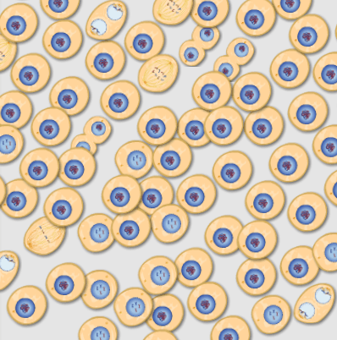

Gizmo Warm-up
On the SIMULATION pane of the Cell Division Gizmo, check that the Cycle Length is set to 12 hours. Click Play (), observe until the maximum number of cells is shown, and then click Pause ().

- Look at the cells. Do they all look the same? _______________

- Cells that are in the process of dividing are said to be in mitosis or cytokinesis. Cells that are not dividing are in interphase.

Check the Magnify box and move the cursor over the cells.

  - Of the 100 cells shown, how many are in the process of dividing? _______________

  - Select the BAR CHART tab, and turn on Show numerical values. How many cells are in the interphase stage of their life cycle? ______________________________
  - Based on these two observations, would you say that a cell spends most of its life cycle in interphase or in mitosis/cytokinesis? _______________________________

Activity A:  Phases of the cell cycle | Get the Gizmo ready:  - Click Reset ().  - Select the DESCRIPTION tab.  - Click on the right arrow once so that Interphase is shown. | 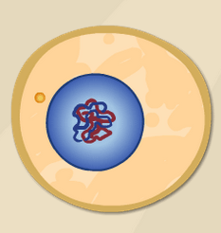

Question: What are the stages of the cell cycle?

- Observe: Click Play and hold the cursor over the cell. Observe the cell as it divides several times. (This happens quickly!) What do you notice happening during this process?

_________________________________________________________________________

_________________________________________________________________________

- Summarize: On the DESCRIPTION pane, read about each phase in the cell cycle. In the spaces below, sketch the cell in each phase and summarize what occurs in your own words.

Phase | Sketch | Summary
Interphase
Prophase
Metaphase
Anaphase
Telophase
Cytokinesis

(Activity A continued on next page)
Activity A (continued from previous page)

- Analyze: Use your summaries and the Gizmo to answer the following questions:

    - What are the four phases of mitosis? _____________________,

_____________________, _____________________, _____________________

    - During which phase is the DNA duplicated? _____________________

    - What is the relationship between chromatin and chromosomes? ______________

___________________________________________________________________

    - In which phase are chromatids pulled apart? _____________________

    - What is the role of the centrioles? _______________________________________

    - In which phase does a new nuclear membrane develop? _____________________

    - A cell has a single line of chromosomes. What is the phase? ___________________

    - During which three phases are individual chromosomes no longer visible?

_____________________, _____________________, _____________________

- Think and discuss: Why is it important that the cell’s DNA is duplicated before cell division?

_________________________________________________________________________

_________________________________________________________________________

_________________________________________________________________________

- Challenge: Human cells have 46 chromosomes. Each chromosome consists of a pair of identical chromatids attached together by a structure called a centromere. Once the chromosome has split, each chromatid is called a daughter chromosome. At the end of cytokinesis, how many daughter chromosomes will be found in each cell? Explain.

_________________________________________________________________________

_________________________________________________________________________

_________________________________________________________________________

Activity B:  Duration of phases | Get the Gizmo ready:  - Click Reset.  - Select the TABLE tab. | 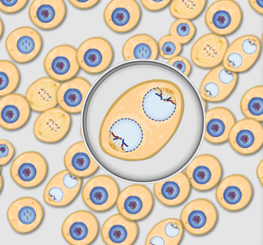

Question: What is the relative duration of each phase of the cell cycle?

- Collect data: Set the Cycle Length to 10 hours and click Play. Click Pause when the maximum number of cells has been reached. On the TABLE tab, click Record data.

Record the number of cells in each phase of the cell cycle in the table below. Then click Play, wait for a while, and click Record data again. Repeat this process until you have recorded four sets of results, and then find the average number of cells in each phase.

Trial | Interphase | Prophase | Metaphase | Anaphase | Telophase | Cytokinesis
1
2
3
4

Avg.

- Analyze: Which phase of the cell cycle is longest? ____________ Shortest? ____________
Explain your answers: _______________________________________________________
_________________________________________________________________________

- Calculate: You can use your data to estimate the duration of each phase of the cell cycle. For example, if 8% of the cells were in prophase and the cell cycle was 10 hours long, then prophase would last 8% of 10 hours, or 0.8 hours (48 minutes).

Use percentages to estimate the duration of each phase of the cell cycle. Show your work.

Interphase: __________________________________________________________

Prophase: __________________________________________________________

Metaphase: __________________________________________________________

Anaphase: __________________________________________________________

Telophase: __________________________________________________________

Cytokinesis: __________________________________________________________

Extension:  Cell populations | Get the Gizmo ready:  - Click Reset.  - Select the GRAPH tab.  - Set the Cycle Length to 5 hours. | 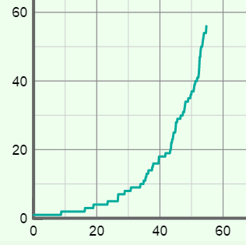

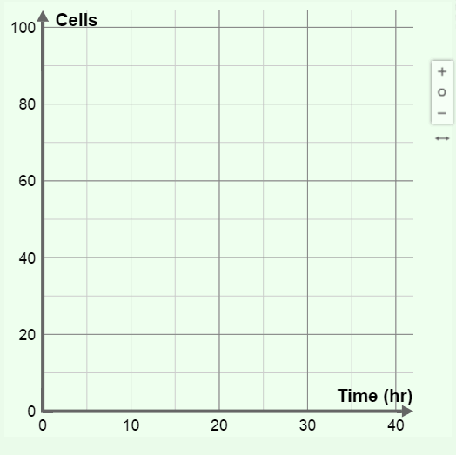
Question: How quickly do cells multiply?

- Collect data: Click Play to start a new simulation. Click Pause when the maximum number of cells is reached. View the total number of cells on the GRAPH tab. (Click the “–” button until the whole graph is visible.)

Draw a sketch of this graph here.

What is the general shape of the graph?

____________________________________

____________________________________

____________________________________

- Analyze: Look closely at the graph.

  - About how long did it take to grow the first 20 cells? __________________________

  - About how long did it take to grow the last 20 cells? __________________________

  - Would you say the rate of cell growth is increasing or decreasing? Explain.

___________________________________________________________________

___________________________________________________________________

- Extend your thinking: In living organisms, the cell cycle is closely regulated. What do you think will happen if cell division is not controlled?

_________________________________________________________________________

_________________________________________________________________________

_________________________________________________________________________

_________________________________________________________________________

_________________________________________________________________________

