Name: Date:

Student Exploration: Cell Types

Vocabulary: ATP, bacteria, carbon dioxide (CO₂), cell, cellular respiration, compound light microscope, eukaryote, multicellular, muscle cell, neuron, organelle, photosynthesis, prokaryote, protist, red blood cell, root hair cell, tissue, unicellular, white blood cell

Prior Knowledge Questions (Do these BEFORE using the Gizmo.)

- How do you know if something is alive? Describe some of the characteristics of living things.

- Humans, plants and mushrooms are all alive. What do these organisms have in common?

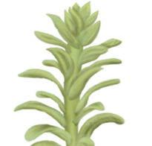

Gizmo Warm-up
In the Cell Types Gizmo, you will use a light microscope to compare and contrast different samples. On the LANDSCAPE tab, click on the Elodea leaf. (Turn on Show all samples if you can’t find it.) Switch to the MICROSCOPE tab to observe the sample as it would appear under the microscope. By default, this microscope is using 40x magnification.

- Drag the Coarse focus slider until the sample is focused as well as possible. Then, improve the focus with the Fine focus slider. What do you see?

- Select the 400x magnification. If necessary, adjust the fine focus. Now, what do you see?

The individual chambers you see are cells, the smallest functional unit of an organism.
Activity A:  Observing cells | Get the Gizmo ready:  - On the LANDSCAPE tab, click on the woman’s right arm to choose the Human skin sample.  - Select the MICROSCOPE tab. | 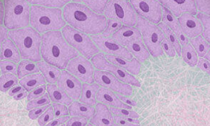

Introduction: Complex organisms are made up of smaller units, called cells. Most cells are too small to be seen by the naked eye. Microscopes are used to magnify small objects, so here you will use a compound light microscope to observe the cells of different organisms.

Question: What are similarities and differences between cells from different organisms?

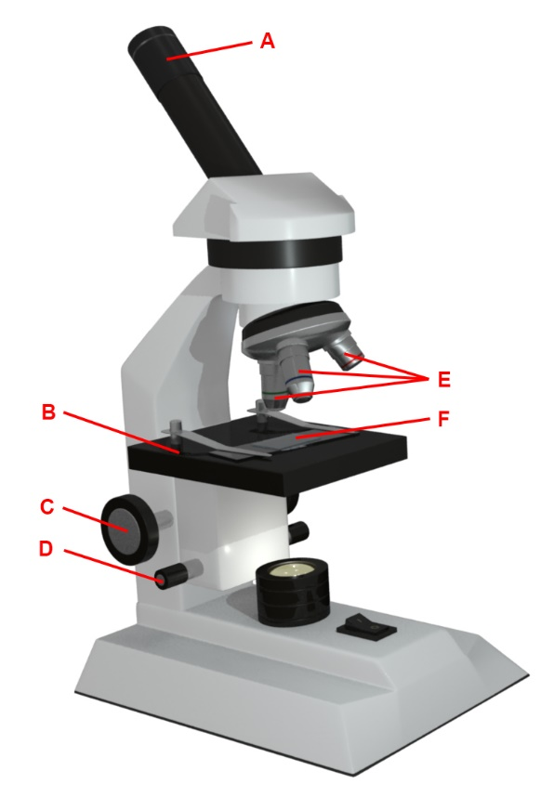
- Match: Read about each microscope part. Match the description to the part on the diagram.

Stage: Platform where a slide is placed.

Eye piece: Lens at the top of the microscope that the user looks though. This lens most commonly magnifies a sample by 10x.

Coarse focus knob: Large knob that moves the stage up and down to focus the sample.

Fine focus knob: Small knob that moves the stage over a short distance to refine the focus.

Objective lens: A second lens that further magnifies the sample. Microscopes usually have several objective lenses with different magnifications. The total magnification is the product of the eyepiece magnification and the objective lens magnification.

Slide: A rectangular piece of glass upon which a sample is mounted for viewing under a microscope.

- Manipulate: With 40x selected, use the Coarse and Fine focus sliders to focus on the sample. Then, choose 400x and focus on the sample using the Fine focus slider.

- Which focus knob is easier to use at 40x? 400x?

- Turn on Show labels. What structures can you see in human skin cells?

- Turn off Show labels and turn on Show scale bars. The scale bar has a width of 20 micrometers, or 20 μm. (There are 1,000 micrometers in a millimeter.)

Using the scale bar, about how wide is a human skin cell?

(Activity A continued on next page)
Activity A (continued from previous page)

- Observe: An organelle is a cell structure that performs a specific function. Observe the samples below under the highest magnification. Click the Show labels checkbox to label the organelles. List the organelles and approximate size of the cells in each sample.

Sample | Organelles | Estimated size (μm)
Mouse skin
Fly muscle
Maple leaf
Elodea
Fungus

What do all of these samples have in common?

In eukaryotic cells, genetic material is contained inside a distinct, membrane-bound nucleus. Plant and animal cells are classified as eukaryotes.

- Observe: Click on the cow and observe E. coli under the highest magnification. Notice the microscope magnification is larger for this organism, and notice the scale bar is smaller.

- What is the approximate size of E. coli?

- What organelles are present in E. coli?

- What organelle is missing from E. coli?

E. coli is an example of a bacteria. Bacteria are classified as prokaryotic cells because their DNA is not contained in a membrane-bound nucleus.

- Compare: Look at the Sand/silt sample under the microscope.

- Turn on Show labels. Does sand/silt have any internal structures?

- Do you think sand or silt is alive? Explain.

Activity B:  Specialized cells | Get the Gizmo ready:  - On the LANDSCAPE tab, click on the woman’s head to choose the human neuron sample. | 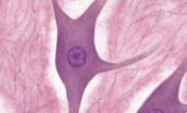

Question: How do a cell’s specialized structures relate to its function?

- Collect data: Use the microscope to observe the samples listed in the table below. For each sample, estimate the cell size and check off the organelles that are present. If there is no column for an organelle, list it in the Special structure(s) column.

Sample | Estimated size (μm) | Nucleus | Cell membrane | Cytoplasm | Special structure(s)
Human neuron
Human skin
Human muscle
Human blood

- Observe: Select the human skin sample. On the MICROSCOPE tab, choose the 400x magnification, focus on the sample, and turn on Show labels. Click on the Nucleus label. If necessary, adjust the Stage sliders to see the full description.

- What is the function of the nucleus?

- What is the function of the cytoplasm?

- What is the function of the cell membrane?

- Observe: Select the human neuron sample. Focus the cells at 400x. Turn on Show labels.

- Click on the axon label to read the description. What is its function?

- What is the function of a dendrite?

Neurons transmit messages in the form of electrical and chemical signals, through axons and dendrites, from one part of the body to another.

(Activity B continued on next page)
Activity B (continued from previous page)
- Compare: Select to the human muscle sample. Observe the sample at 400x.
- What do muscle cells have that other cell types do not?

- What is a striation and how does it help muscle cells function?

- Compare: Select the human blood sample. Observe at 400x. Look under Show information on the right-hand side of the Gizmo.

- What is the function of red blood cells?

- What is the function of white blood cells?

- What organelle is missing from the red blood cells?

- Compare: Compare the human and animal samples (human and mouse skin; human and worm neurons; human and fly muscle; human and frog blood).

- In general, are there any major differences that you can see? Explain.

- What organelle do frog RBCs have that human RBCs do not?

Most mammalian red blood cells have no nucleus. This allows the red blood cell to use all of its volume to transport oxygen.

- Extend your thinking: Many types of cells, such as the ones in this activity, live together in groups, called tissues. A tissue is a group of similar cells that together carry out a specific function. Describe how the skin cells, neurons, muscle cells, and blood cells you have observed relate to the functions of skin, nerve, muscle, and blood tissue.

You can write your answer on another sheet of paper.

Activity C:  Plants and unicellular life | Get the Gizmo ready:  - On the LANDSCAPE tab, select the Microalgae sample. | 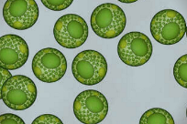

Introduction: Most of the animals and plants we are familiar with are multicellular, they are made up of many cells. However, many living things only consist of a single cell. These microscopic organisms are unicellular.

Question: How are unicellular organisms similar to multicellular organisms?

- Observe: Compare the microalgae, the Elodea leaf cells, the maple leaf cells, and the root hair cells at 400x. Sketch each below:

Microalgae Elodea Maple leaf Root hair

- What structures do all of these cells have in common?

- What structures are missing from the root hair cells?

- What is the purpose of this structure, and why do you think it is missing from the root hair cells?

Photosynthesis is the ability of some organisms to generate food from sunlight. Cells that are not exposed to sunlight will not take part in photosynthesis.

- How are the algae cells different from the other cells?

Microalgae are examples of unicellular organisms. Each cell is a single organism.

- Explore: Which other samples in the Gizmo do you think represent unicellular organisms?

(Activity C continued on next page)
Activity C (continued from previous page)
- Observe: Switch to the Protist sample. Protists are unicellular organisms common in ponds On the MICROSCOPE tab, select the 100x radio button and focus the image.

- Watch the motion of the protists at 100X and 400X. What structures allow each protist to move?

Amoeba: Euglena: Paramecium:

- In the table below, draw the structures that allow the protists to move on their images on the left and describe the structures in the spaces on the right:
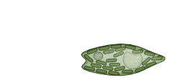
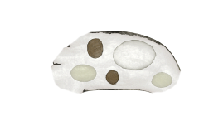
 | Amoeba
 | Euglena
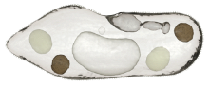 | Paramecium

- Which protist is photosynthetic? How do you know?

- Compare: On the LANDSCAPE tab, click on the cow to switch to the E. coli sample. On the MICROSCOPE tab, select 2500x, focus the image and turn on Show labels.

- Find two structures that help E. coli move and describe them below:

Name: Description:

Name: Description:

- Do protists (amoeba, Euglena, Paramecium) use similar structures to move?

Explain.

Activity D:  Are cells alive? | Get the Gizmo ready:  - On the LANDSCAPE tab, select the worm to choose the Worm neuron sample.  - Select the TEST FOR LIFE tab. | 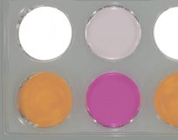

Introduction: All organisms need energy from food to function. During cellular respiration, cells use glucose from food to produce ATP, a molecule that stores energy for the cell, and carbon dioxide (CO₂). You can test for the products of respiration to see if your sample is alive.

Question: How can you test if cells are alive?

- Observe: The first row of the dish contains an ATP reagent that will glow if ATP is in the liquid. The second row of the dish contains phenol red, a reagent that turns orange when the liquid is acidic. Each row of the dish contains an example of a positive test (positive control), an example of a negative test (negative control), and the sample.

- Click Play (). What happens?

- Does the worm neuron sample produce ATP? How do you know?

- What happens to the phenol red?

- When CO₂ combines with water it forms carbonic acid. How does this explain the phenol red result?

- Based on the test results, are the worm neurons alive?

- On the LANDSCAPE tab, select the Maple leaf sample. Return to the TEST FOR LIFE tab.

- Click Play. Does the maple leaf sample produce ATP?

- What happens to the phenol red?

In the light, plant leaves undergo photosynthesis, using CO₂, water, and light energy to produce food. In the dark, plants cannot perform photosynthesis.

- Click Reset (), then click on the light switch to turn off the lights. Click Play to run the experiment in the dark. What happens?
- Based on the test results, are maple leaves alive?
(Activity D continued on next page)
Activity D (continued from previous page)
- Collect data: Using the table below, select the sample on the LANDSCAPE tab. Perform the experiment in the light on the TEST FOR LIFE tab. Turn off the light by clicking on the light switch and perform the experiment again in the dark. Record the results below.

Sample | Light - ATP | Light Respiration | Dark - ATP | Dark - Respiration
E. coli
Fungus
Human skin
Maple leaf
Root hair
Protists
Sand/silt

- Analyze: Which of the samples in the above table are alive?

How do you know?

- Discuss: Based on the results of the experiment, which samples from the table above are likely to undergo photosynthesis?
How do you know?

- Analyze: Small particles of silt are about the same size and shape as a cell.

- Is silt alive?

- How do you know?

