Name: ______________________________________ Date: ________________________

Student Exploration: Charge Launcher

Vocabulary: attract, electrostatic force, negative charge, positive charge, repel

Prior Knowledge Questions (Do these BEFORE using the Gizmo.)

- Suppose you rolled a metal ball across a perfectly flat table. What kind of path would the ball take, straight or curved?

_________________________________________________________________________

- Suppose you held a magnet near the ball as it was rolling. How would the magnet affect the path of the ball?

_________________________________________________________________________

Gizmo Warm-up
The Charge Launcher Gizmo shows how charged particles interact. Like magnets, tiny charged particles can either attract (pull together) or repel (push apart) each other.

- The red particles have positive charge. Click Launch to launch a red (positively charged) particle. Describe the path of the particle.

_________________________________________________________________________

- The blue particles have negative charge. Drag one of these onto the grid. This particle is fixed, which means it is attached to the grid. Click Launch. What happens now?

_________________________________________________________________________

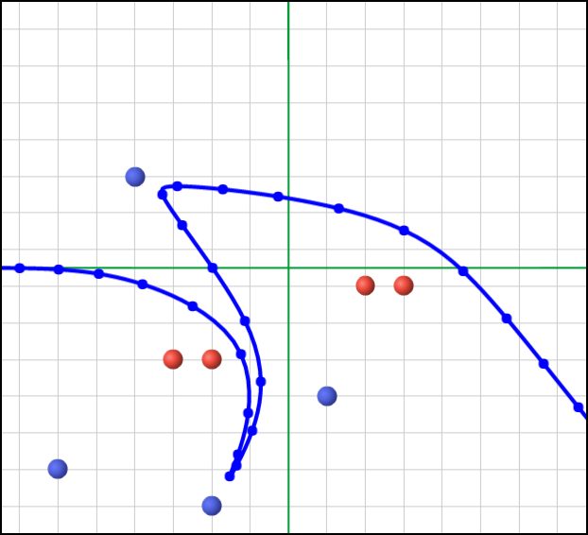
- Drag several particles onto the grid. Try to make the most interesting path you can.
- Change the speed of the particle with the Launch speed menu.
- You can drag either a red particle or a blue particle into the launcher.

To take a snapshot of an interesting path, click the camera icon () at the upper right. Right-click the image, select “Copy,” and then paste the image into a blank document.

Activity A:  Attract or repel? | Get the Gizmo ready:  - Remove all the particles from the grid.  - Drag a positively charged (red) particle into the launcher.  - Set Launch speed to Medium. | 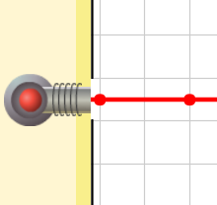

Question: Charges can cause electrostatic forces. How do these forces affect the paths of launched particles?

- Observe: Experiment with the Gizmo to determine the answer to the above question.

- Form hypothesis: Answer the following questions based on your observations:

    - How does a fixed red particle affect the path of a moving red particle?

________________________________________________________________

    - How does a fixed blue particle affect the path of a moving red particle?

________________________________________________________________

- Predict: Based on your hypothesis, predict the path of the launched particle on each grid below. Draw your predicted paths using dashed lines. Label each path “Predicted” or “P”.

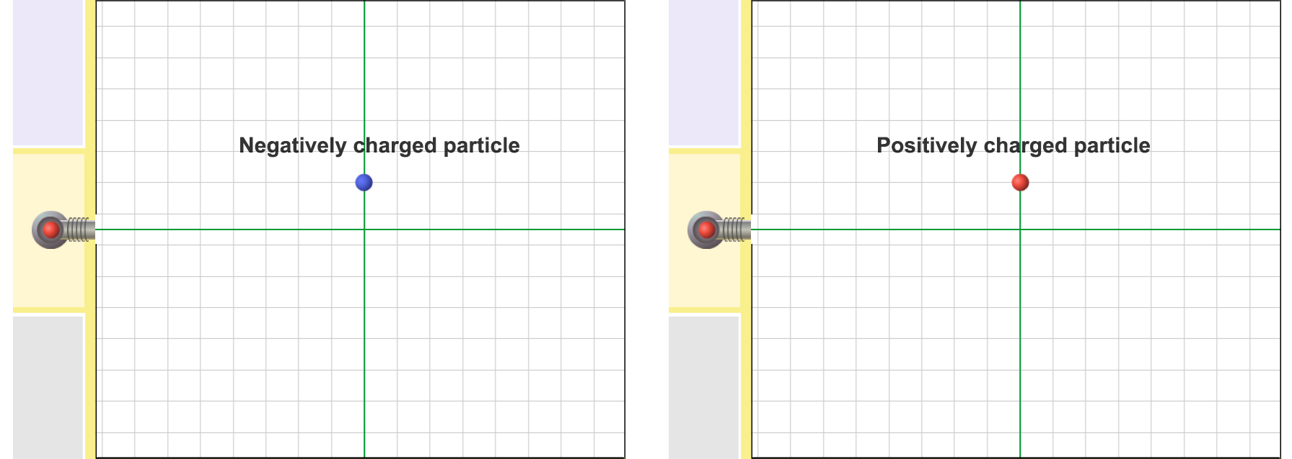

- Run Gizmo: Test your predictions using the Gizmo. Record the actual path on each grid with a solid line. Label these paths “Actual” or “A”.

- Draw conclusions: Fill in each blank below with either “repelled by” or “attracted to.”

    - Positively charged objects are ____________________ negatively charged objects.

    - Positively charged objects are ____________________ positively charged objects.

Activity B:  Match that path! | Get the Gizmo ready:  - Remove all the particles from the grid.  - If needed, drag a red particle into the launcher.  - Set Launch speed to Slow.  - Turn on Show challenge. | 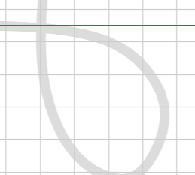

Goal: Use fixed particles to make a launched particle follow a given path.

- Run Gizmo: Your goal is to match the gray path. In this challenge you are allowed to use one red particle. Place this particle where you think it should go and press Launch.

- Observe: Were you close? ___________________________________________________

- Revise: Change the position of the particle on the grid, and click Launch again. Keep trying until you match the path perfectly. Take a snapshot and paste it into a document.

- Apply: Click New challenge for new paths. Do your best to match them.
- The challenges get harder as you go. You may need to try different launch speeds.
- Some challenges require three or more fixed particles. These are almost impossible to match exactly. Just get as close as you can.
- Take a snapshot at the end of each challenge. Paste these into your document.

- Challenge yourself: Press Reload or Refresh on your browser to restart the Gizmo. Turn on Show challenge and drag a negatively charged (blue) particle into the launcher. Complete the challenges while launching blue particles, and paste snapshots into your document.

- Analyze: How do the grids you made while launching red particles compare to the grids you made while launching blue particles? Explain why this makes sense.

_________________________________________________________________________

_________________________________________________________________________

- Extend your thinking: Forces between charged particles can be compared to magnetic forces. The north pole of one magnet is attracted to the south pole of another magnet. North poles are repelled by other north poles, and south poles are repelled by south poles.

How are charged particles similar to the poles of magnets? __________________________

_________________________________________________________________________

_________________________________________________________________________

