Name: Date:

Student Exploration: Chemical Changes

Vocabulary: acid, base, catalyst, chemical change, coefficient, conservation of matter, decomposition, dissolve, double replacement, endothermic, exothermic, indicator, ion, physical change, product, reactant, single replacement, subscript, synthesis

Prior Knowledge Questions (Do these BEFORE using the Gizmo.)

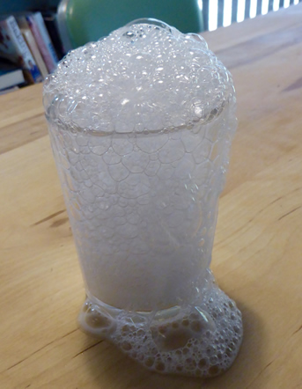
- A student mixes baking soda and vinegar in a glass. The results are shown at left. Do you think any new substances are being created in this mixture? If so, how do you know?

- Suppose this was done on top of a balance. Do you think the mass would change as the reaction proceeded?

- What do you think would happen to the mass if the reaction took place inside a sealed plastic bag?
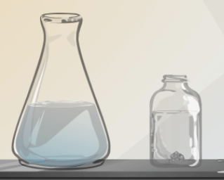
Gizmo Warm-up
A chemical change, (or chemical reaction) occurs when one or more substances, called reactants, are transformed into different substances, or products. In the Chemical Changes Gizmo, you will look for evidence of chemical changes by looking at changes you can see, touch, or smell.

To begin, check that Reactant 1 is Sodium and Reactant 2 is Water. Sodium is a metal so soft you can cut it with a knife.

- Click Play (). What do you observe?

- Do you think a chemical reaction has taken place? Explain.

Activity A:  Observing chemical changes | Get the Gizmo ready:  - Click Reset (). Check that the reactants are still Sodium and Water.  - Turn on the Label reactants checkbox.

Introduction: It is important to distinguish chemical changes, in which new substances are formed, from physical changes, which do not create new substances. In this activity, you will look at many kinds of evidence that chemists use to see if a chemical change has taken place.

Question: What kinds of evidence indicate a chemical change has taken place?

- Observe: Some chemical reactions release heat, and others absorb heat. In an exothermic reaction, heat is released and the temperature of the system rises. In an endothermic reaction, heat is absorbed and the temperature of the system decreases.

In the Gizmo, drag the Thermometer into the flask of water.

- What is the starting temperature?

- Click Play, and wait for the reaction to end. What is the final temperature?

- Was this reaction exothermic or endothermic?

- Observe: Two families of chemicals are acids and bases. Acids and bases can be detected by an indicator, which is a substance that changes color in the presence of an acid or a base. Phenol red is an indicator that is yellow in an acid, orange in a neutral solution, and pink in a base.

- Click Reset. Drag the Phenol red next to the flask of water. What does the indicator show?
- Click Play, and wait for the reaction to end. What does the indicator show now?

- Observe: Click Reset. Select the Gas collection setup. Chemists use this apparatus to collect any gases produced in the reaction. From the reaction flask, gases travel through a long tube and into a cylinder of water. As gases bubble into the cylinder, the water is displaced (removed) until the cylinder is filled with gas.

Click Play and observe the cylinder. Was any gas produced in the reaction?

How do you know?

(Activity A continued on next page)
Activity A (continued from previous page)

- Analyze: One way to test what kind of gas is in the cylinder is to use a splint test. A glowing splint is a wooden stick that has been lit on fire and then blown out, resulting in a glowing, red-hot tip. A burning splint is a splint that has a burning tip.

The table shows how a splint reacts to some common gases:

Gas | Carbon dioxide (CO₂)  or ammonia (NH₃) | Oxygen (O₂) | Hydrogen (H₂)
Glowing splint | Goes out | Ignites (burns) | Does not ignite
Burning splint | Goes out | Continues to burn | Small explosion and “pop” sound

- Drag the glowing splint next to the cylinder, and observe. What do you see?

- Click Reset and click Play, and then bring the burning splint to the cylinder.

What happens now?

- Based on the table above, what gas do you think was produced in this reaction?

- Interpret: Turn on Show chemical equation. A chemical equation is a shorthand way to describe a chemical reaction. Symbols represent the elements: H for hydrogen, O for oxygen, and Na for sodium. The reactants are to the left of the arrow, and the products are to the right. For example, the equation H₂ + O₂ → H₂O shows that the reactants hydrogen and oxygen combine to form the product H₂O, or water.

- Look at the reaction shown in the Gizmo. What are the reactants in this reaction?

- What are the products in this reaction?

These symbols represent sodium hydroxide and hydrogen gas. Sodium hydroxide is a strong base. (Chemicals that contain the hydroxide ion (OH–) are bases.)

- How do the products of the reaction relate to the phenol red test and the splint test?

Activity B:  Conservation of matter | Get the Gizmo ready:  - Click Reset. Select Hydrogen peroxide for Reactant 1 and Potassium iodide for Reactant 2. | 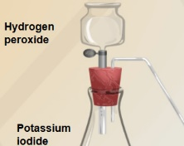

Goal: How does the mass change (or not change) during a chemical reaction?

- Review: In this reaction, hydrogen peroxide is added to a potassium iodide solution. Click Play and observe the reaction.

- What do you observe?

- What evidence do you see that a chemical reaction is taking place?

- Replay the reaction and use the available tools (Thermometer, Phenol red, Glowing splint, Burning splint.) What do these tools indicate? (Note: You will need to switch to the Gas collection setup to use the splint.)

Thermometer:

Phenol red:

Glowing splint: Burning splint:

- Record: Click Reset, and change back to the Normal setup. Notice the mass shown on the electronic balance.

- What is the starting mass for this reaction?

- Click Play. What is the mass when the reaction has finished?

- How does the mass change in this reaction?

- Record: Click Reset, and select the Gas collection setup. Notice that this setup is heavier than the normal setup, but the amounts of reactants is the same.

- What is the starting mass for this reaction?

- How do you think the mass will change during the reaction?

- Click Play. What is the mass when the reaction has finished?

(Activity B continued on next page)
Activity B (continued from previous page)

- Explain: Why do you think that mass was lost when the reaction was done in the normal setup, but stayed the same when the reaction was done in the gas collection setup?

A fundamental law of chemistry is conservation of matter. This law states that, in a chemical reaction, matter can neither be created nor destroyed. That means that, as long as nothing escapes from the system, the total mass measured at the start of the reaction will be the same as the total mass at the end of the reaction.

- Compare: Turn on Show chemical equation. The small numbers, called subscripts, show how many of each atom there are in the molecule. For example, the molecule H₂O contains two hydrogen atoms and one oxygen atom. (Notice that, in this reaction, the potassium iodide (KI) acts as a catalyst. A catalyst is a substance that helps a reaction happen but does not change during the reaction.)

Count the total number of hydrogen and oxygen atoms on the left and right sides of the equation:

Left side: H _____ O _____ Right side: H _____ O _____

What do you notice?

- Turn on Show balanced equation. A balanced equation shows how many molecules of each substance take part in the reaction. The coefficients are the big numbers that tell you how many molecules there are. For example, “2H₂O” means there are two water molecules and a total of four hydrogen and two oxygen atoms.

Carefully count the total number of hydrogen and oxygen atoms on the left and right sides of the balanced equation:

Left side: H _____ O _____ Right side: H _____ O _____

- What do you notice?

- How does the balanced equation relate to the law of conservation of matter?

Activity C:  Types of reactions | Get the Gizmo ready:  - Click Reset. Select Normal setup.  - Select Sodium for Reactant 1 and Chlorine for Reactant 2. | 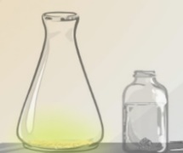

Goal: Explore, observe, and classify a variety of chemical reactions.

- Observe: In this reaction, a small piece of sodium is added to a flask containing poisonous chlorine gas which has a yellowish color, and sand. Water is added to start the reaction.

- Click Play. What happens?

- Try the experiment with the Thermometer. Is the reaction exothermic or endothermic?
- Run the experiment one more time, this time watching the mass. What do you notice?
- Repeat the experiment, this time in the Closed system. How does the mass change during the reaction now?

- Challenge: Turn on Show chemical equation. In this reaction, solid sodium reacts with chlorine gas to form solid sodium chloride (NaCl), also known as table salt.

How does this explain the normal setup increase in mass during the reaction?

- Observe: Select Ammonium nitrate for Reactant 1 and Water for Reactant 2. Add the Thermometer to the flask and click Play.

- What do you observe?

- Is this process exothermic or endothermic?

- What is the equation for this process?

In this example, ammonium nitrate (NH₄NO₃) dissolves in water, producing ammonium (NH₄⁺) and nitrate (NO₃–) ions. Chemists do not all agree about whether this is an example of a physical change or a chemical change.

(Activity C continued on next page)
Activity C (continued from previous page)

- Classify: There are many types of chemical reactions. Four are described below:
- Synthesis: Two or more reactants combine to form a single product. For example, 2H₂ + O₂ → 2H₂O. (Synthesis reactions are also called combination reactions.)
- Decomposition: One reactant breaks down to form two or more products. For example, 2KCl → 2K + Cl₂.
- Single replacement: An element reacts with a compound to form another element and compound. For example, Zn + 2HCl → ZnCl₂ + H₂.
- Double replacement: Two compounds react to form two different compounds. For example, FeS + 2HCl → FeCl₂ + H₂S.

Using the Gizmo, find an example of each type of reaction.

Synthesis: Decomposition:

Single replacement:

Double replacement:

- Explore: Find an example of each of the following in the Gizmo:

- An example of no chemical reaction occurring:

- A reaction that produces an acid:

- A reaction that produces a base:

- A reaction that uses a catalyst:

- Demonstrate learning: Choose an interesting reaction in the Gizmo. Use the available tools to make observations, and use what you have learned so far to draw conclusions about the reaction. Describe your findings below. (If necessary, continue on a second sheet of paper.)

Reaction:

Findings:

