Name: Date:

Student Exploration: Chocomatic

Vocabulary: area, array, dimensions, factor, multiplication, product

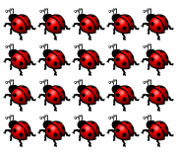
Prior Knowledge Questions (Do these BEFORE using the Gizmo.)

- How many ladybugs are in the picture to the right? _______

- How could you find the number of ladybugs without counting them one-by-one?

_________________________________________________________________________

_________________________________________________________________________

Gizmo Warm-up

In the Chocomatic Gizmo, the Gizmolicious Chocolate Company has invented a machine called the Chocomatic. The Chocomatic is used to design, fill, and wrap chocolate bars.

Notice there is already an empty chocolate bar mold (no chocolate yet) in the Chocomatic.

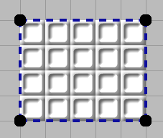
- The length and width of a rectangle are its dimensions. What are the dimensions of the mold in the Gizmo? Write your answer on the mold to the right. Then click Show dimensions to check.

- How many squares are in the chocolate bar mold? ________

Set the Chocomatic to Fill. Enter the number of squares in the box labeled Use enough to fill ____ squares. Then click the mold to pour the chocolate in.

- Set the Chocomatic to Wrap. Click the filled bar to wrap it. Select Show wrapper labels.

What does the wrapper label say? ________ × ________ = ________

- Set the Chocomatic back to Design molds. Create your own candy bar mold – just click and drag. Then pour chocolate into the mold and wrap it up! (Note: In this mode, you can drag any candy bars around, or drag them to the trash.)

Activity A:  Chocomatic training | Get the Gizmo ready:  - Click the Clear button.  - Make sure that the Use auto-filler checkbox is off. | 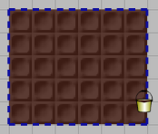

You are the Chief Chocolate Officer for the Gizmolicious Chocolate Company. You’ve just had the new Chocomatic machine installed in the factory. Now it’s time to train your employees on it.

- Select Design molds mode. Create a mold for a 2 × 5 chocolate bar.

  - How many squares of chocolate will this candy bar have? _________

  - Fill the mold with chocolate. Was your number of squares correct? _________

  - How many rows of chocolate squares does the candy bar have? _________

  - How many squares are in each row? _________

  - How can you find the total number of squares without counting them all, one-by-one?

___________________________________________________________________

___________________________________________________________________

- Knowing a shortcut for finding the number of chocolate squares helps more for bigger bars because counting would take too long. Create a mold for a 7 × 10 candy bar.

  - How many rows of chocolate squares will this candy bar have? _________

  - How many squares will be in each row? _________

  - How many squares of chocolate do you think this candy bar will have? _________

  - Fill and wrap the bar. Was your shortcut for counting squares correct? _________

Every candy bar that the Chocomatic makes is a rectangle. When you find the number of squares in a bar, you are also finding the area of that rectangle (in square units).

- Quinn in Quality Control has some questions about the chocolate bars.

  - If a 2 × 5 bar and a 5 × 2 bar were unwrapped, could you tell them apart? ________

  - Explain why or why not. ________________________________________________

___________________________________________________________________

___________________________________________________________________

Activity B:  Bar Collections | Get the Gizmo ready:  - Click the Clear button.  - Make sure that the Use auto-filler checkbox is off. | 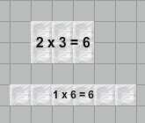

The Gizmolicious Chocolate Co. is introducing “Bar Collections.” Each collection is made of bars that all have the same number of squares. As Chief of Chocolate, you design the collections!

- The first Collection will be the “12 Collection,” available in dark, milk, or white chocolate.
- Use the Chocomatic to design different bars made of 12 squares of chocolate.
- Make sure your molds are the right size – select Pour Chocolate and enter 12 in the Use enough to fill ____ squares box. Then click the molds to fill them.
- Sketch your bars below. Label the dimensions (length and width) of each.

- Click Clear. Follow the same steps for the exciting (and slightly bigger) “16 Collection.” Sketch and label the candy bars in this collection below.

- One candy bar you might have in the “10 Collection” is a 2 × 5 bar. A 2 × 5 bar has 10 squares of chocolate because 2 × 5 = 10. This means that both 2 and 5 are factors of 10.

  - Look at the “12 Collection” you made above. What numbers are factors of 12?

___________________________________________________________________

  - What numbers are factors of 16? ________________________________________

  - What numbers are factors of 24? (Hint: Explore the Chocomatic “24 Collection”!)

___________________________________________________________________

- What shape of bar is in the “16 Collection” but not the other two collections? ____________

Why? ____________________________________________________________________

Activity C:  Math Munches | Get the Gizmo ready:  - Click the Clear button.  - Turn the Use Auto-filler checkbox on. | 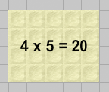

The Gizmolicious Chocolate Company has a new hit – Math Munch candy bars. They are really two bars wrapped together to be one. As a bonus, they help students learn multiplication facts!

- One of the more popular new candy bars is the 8 × 7 Math Munch.

- Make an 8 × 5 mold. Fill it with dark chocolate. How many squares are in it? ______

- Make an 8 × 2 mold. Fill it with milk chocolate. How many squares are in it? ______

- Select Design molds and move the bars together to form one big rectangle.

What are its dimensions? _________ How many squares does it have? ________

- Select Wrap and click one of the bars. You have just made the 8 × 7 Math Munch! Fill in the blanks in the diagram below.
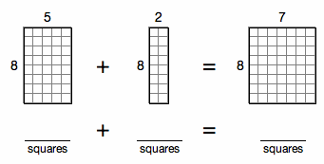

- If you had trouble recalling what 8 × 7 equals, how could this Math Munch bar help?

___________________________________________________________________

___________________________________________________________________

___________________________________________________________________

- Now create your own two-flavor Math Munch. Sketch and explain your Math Munch below.

Sketch (label dimensions) | Explanation of multiplication fact

