Name: Date:

**Student Exploration: Chords and Arcs**

**Vocabulary:** arc, central angle, chord

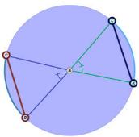

***C***

***A***

***D***

***L***

***K***

**Prior Knowledge Questions** (Do these BEFORE using the Gizmo.)

In **circle** *A* to the right, ∠*CAD* and ∠*LAK* are **central angles** because their vertices are at the center of the circle. These angles define two curved parts of the circle, called **arcs** ($\overset{⏜}{\text{CD}}$ and $\overset{⏜}{\text{LK}}$). They also define two **chords** ( and ) which are line segments with endpoints on the circle.

1. Based on congruency marks, which angles do you know are congruent?
2. What segments are radii of this circle?
3. What is true about the lengths of the radii of a circle?

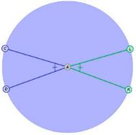**Gizmo Warm-up**

In the *Chords and Arcs* Gizmo, you will explore the relationships among the measures of chords, arcs, and central angles. To begin, be sure **One circle** is selected under **Figure type**. Under **Conditions**, select **Congruent central angles**.

1. Select **Show angle measure tool** to open a Gizmo protractor. Attach the “donuts” to points on ∠*CAD*.

What is the measure of ∠*CAD*?

1. Select **Show ruler** to open a Gizmo ruler. Attach the “donuts” to the endpoints of . How long is ?
2. Select **Show arc measure tool** and attach the “donuts” to the endpoints of $\overset{⏜}{\text{CD}}$.
3. What is the measure of $\overset{⏜}{\text{CD}}$? Notice that the arc measure is in degrees.
4. How do the measures of $\overset{⏜}{\text{CD}}$ and ∠*CAD* compare?

|  |  |  |
| --- | --- | --- |
| **Activity A:**  **Central angles, chords, and arcs** | Get the Gizmo ready:   * Be sure **One circle** is selected under **Figure type** and **Congruent central angles** is selected under **Conditions**. | 175SE3 |

1. Look at the congruent central angles, ∠*CAD* and ∠*LAK*.
   1. What appears to be true about the arcs these angles intercept, and ?

* 1. What appears to be true about the chords these angles intercept,  and ?

Check with the Gizmo arc measure and length rulers. With the rulers in place, drag points *C*, *D*, *K*, and *L* around to see if these relationships are true for all congruent central angles and their intercepted arcs and chords.

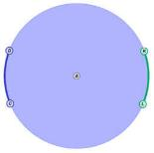

***A***

***C***

***D***

***K***

***L***

1. Under **Conditions**, select **Congruent arcs**. On the figure to the right, sketch the central angles that intercept these arcs. How do you think these central angles are related?

Use the Gizmo protractors to check. With the Gizmo protractors in place, drag the points on the circle to see if this is true for all congruent arcs and their corresponding central angles.

1. Complete the if-and-only-if statement to describe how central angles and the arcs they intercept are related.

Central angles of a circle are congruent if and only if

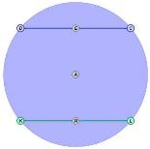

***K***

***L***

***C***

***D***

***A***

1. Select **Congruent chords**. On the figure to the right, sketch the central angles that intercept these chords. How do you think these central angles are related?

Use the Gizmo protractors to check. With the Gizmo protractors in place, drag the points on the circle to see if this is true for all congruent chords and their corresponding central angles.

**(Activity A continued on next page)**

**Activity A (continued from previous page)**

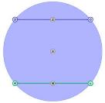

***K***

***L***

***C***

***D***

***A***

1. On the figure to the right, chords  and  are congruent.
2. How do you know that , , , and  are congruent?
3. How do you know that Δ*CAD* and Δ*LAK* are congruent?
4. How does this prove that the central angles are congruent?

1. Select **Congruent central angles**. On the figure below, sketch  and .
2. How do you know that Δ*CAD* and Δ*LAK* are congruent?

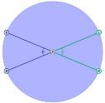

***K***

***L***

***A***

***C***

***D***

1. How does this prove that chords  and are congruent?
2. Write an if-and-only-if statement to about central angles and their intercepted chords.

1. Suppose a circle has two congruent arcs. Answer the questions about the central angles and chords that intercept the arcs. Then verify your answers in the Gizmo.
2. What is true about the central angles that intercept these arcs?

Explain.

1. What is true about the chords that intercept these arcs?

Explain.

1. Under **Figure type**, select **Two congruent circles**. Do you think everything you have discovered about central angles, arcs, and chords is true for congruent circles?

Explain.

Use the same conditions you used for one circle and the Gizmo measuring tools to check.

|  |  |  |
| --- | --- | --- |
| **Activity B:**  **Equidistant chords** | Get the Gizmo ready:   * Select **One circle** under **Figure type**. * Select **Chords equidistant from center** under **Conditions**. | 175SE8 |

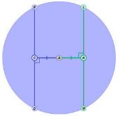

***E***

***C***

***D***

***A***

***L***

***K***

***M***

1. In the figure to the right, chords  and  are equidistant from the center of circle *A*. So,  and  are congruent. What do you think is true about  and ?

Use the Gizmo rulers to check your answer. With the rulers in place, drag points *C* and *K* around to see if this relationship is always true for chords that are equidistant from the center of the circle.

1. Under **Figure type**, select **Two congruent circles**. Check that everything you discovered about chords equidistant from the center is true for congruent circles. Then complete the if-and-only-if statement to describe the relationship between equidistant chords.

Two chords of a circle or congruent circles are congruent if and only if

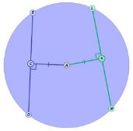

***L***

***E***

***D***

***A***

***C***

***K***

***M***

1. Challenge: Given  ≅ ,  ⊥ , and  ⊥ , prove  ≅ . (Hint: Start by proving that Δ*ACE*, Δ*ACD*, Δ*AKL*, and Δ*AKM* are all congruent.)

|  |  |  |
| --- | --- | --- |
| **Activity C:**  **Using central angles, chords, and arcs** | Get the Gizmo ready:   * Be sure **One circle** is selected under **Figure type**. | 175SE11 |

1. Find the value of *x* for each of the following circles. Show your work.

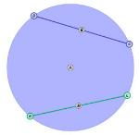

***L***

***K***

***C***

***D***

***A***

**35**

**35**

**100°**

**(*x* + 16)°**

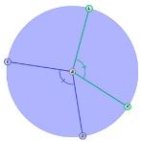

***L***

***K***

***A***

***C***

***D***

**48**

**2*x* – 8**

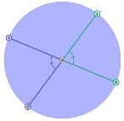

***L***

***K***

***C***

***D***

***A***

**80°**

**(*x* + 19)°**

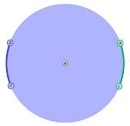

**45°**

**45°**

**17**

**3*x* – 4**

***A***

***K***

***L***

***C***

***D***

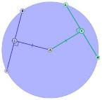

***K***

***C***

***E***

***A***

***D***

***L***

***M***

1. In the circle to the right, *LM* = 5*x* – 5 and *ED* = 3*x* + 9. Find the value of *x*. Show your work in the space below.