Vocabulary: Circles

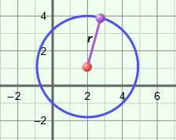
Vocabulary

- Circle – the set of all points the same distance from a given point, called the center of the circle.
- For example, all (x, y) points on the circle shown to the right are r units from the center (2, 1).

- Conic section – a curve formed by the intersection of a plane, and one or two right circular cones.
Circle
- For example, the intersection of the plane and the cone shown to the right is a circle.

- Distance formula – a formula that can be used to find the distance, d, between two points with coordinates (x₁, y₁) and (x₂, y₂).
  - The distance formula is d = .

- Pythagorean Theorem – a theorem stating that, for any right triangle, a² + b² = c², where a and b are the lengths of the legs of the triangle and c is the length of the hypotenuse.
a
c
b

- Radius – a line segment with one endpoint at the center of a circle and the other endpoint on the circle.
- The radius, r, of the circle shown above has a length of 3 units: r = 3.

- Standard form of the equation of a circle – the equation representing the set of points in the coordinate plane that are all the same distance, r, from a given point (h, k).
- The standard form of the equation of a circle is (x – h)² + (y – k)² = r².
- For example, a circle with center (2, 1) and a radius of 3 units has the equation
(x – 2)² + (y – 1)² = 3².

