Name: ______________________________________ Date: ________________________

Student Exploration: Circuits

Vocabulary: ammeter, circuit, current, electron, ohmmeter, Ohm’s law, parallel circuit, resistance, resistor, series circuit, voltage

Prior Knowledge Questions (Do these BEFORE using the Gizmo.)
Strings of holiday lights can be designed in one of two ways. In some strings of lights, each light is connected to the others along a single wire (in series). In others, each light is attached to its own wire (in parallel).

- Suppose a single light bulb burns out. How do you think this will affect lights that are strung along a single wire? _________________________________________________________

- How will a single burned-out bulb affect the string of lights if each light is attached to its own wire? ________________________________________________________________
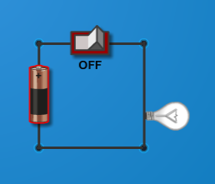
Gizmo Warm-up
The Circuits Gizmo shows a circuit board and a variety of components. Create a circuit with a battery, a light switch, a wire, and a light bulb, as shown. (Click the light switch to turn it to OFF.)

- Click the light switch to turn it to ON. What happens? ________
__________________________________________________

- Turn on Show current and select Electron flow. The moving dots represent a current of electrons—tiny, negatively charged particles—moving through the wire. Voltage is a measure of how much more potential energy an electron at one end of a battery has than an electron at the other end of the battery.

  - How does changing the battery’s voltage affect the current? __________________

___________________________________________________________________

  - How does changing the battery’s voltage affect the brightness of the light? _______

___________________________________________________________________

- Remove the wire. What happens? _____________________________________________

Activity A:  Ohm’s law | Get the Gizmo ready:  - Click Clear. Create the circuit shown at right. (Use the 10-ohm resistor.)  - Click on the battery. Set the Selected battery voltage to 10 volts. | 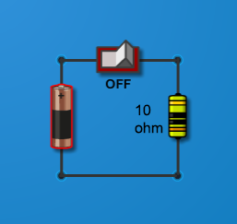

Introduction: Resistors are devices that slow the flow of current in a wire. The resistance of the circuit to current is measured in units called ohms.

Question: What is the relationship between voltage, current, and resistance?

- Form hypothesis: How do you think increasing the resistance in a circuit will affect the current in the wire? _________________________________________________________

- Observe: Turn the light switch On to start the flow of current. An ammeter is a device that measures current in Amperes (A). Drag the Ammeter () to various parts of the circuit.

    - Is the current the same throughout, or does it change? _______________________

    - What is the current in the wire now? _______________________

- Collect data: Measure the current in the circuit using the resistor and voltage combinations given below.

Voltage | Resistance | Current
10 volts | 10 ohms
20 volts | 10 ohms
30 volts | 10 ohms

Voltage | Resistance | Current
50 volts | 20 ohms
50 volts | 100 ohms
50 volts | 200 ohms

- Analyze: What is the mathematical relationship between voltage (V), resistance (R), and current (I)? Express your answer as an equation: __________________________________
This equation is known as Ohm’s law.

- Test: Test your equation with other combinations of voltage and resistance. Modify the equation if necessary.

- Apply: The light bulb is also a resistor. Place the light bulb in the circuit, then use Ohm’s law to find the resistance of the light bulb. What is it? _______________

Activity B:  Series circuits | Get the Gizmo ready:  - Click Clear.  - Create a circuit as shown.  - Click the battery to select it. Set the Selected battery voltage to 10 volts. | 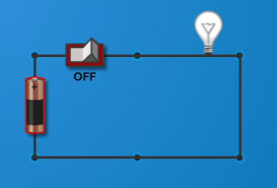

Question: In a series circuit, there is only one path for charge to flow. What are the properties of series circuits?

- Observe: Turn the light switch ON and observe the light bulb. Then start replacing the wire segments with new light bulbs.

- How does each new light bulb affect the others? ____________________________

- Use the Ammeter to measure the current in various parts of the circuit. Is the current the same throughout, or does it change? __________________________________

- Form hypothesis: How do you think the total resistance of a series circuit is calculated?

_________________________________________________________________________

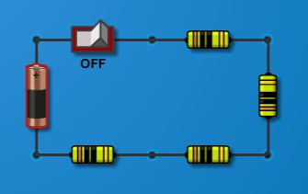
- Experiment: Create a series circuit with a 10-volt battery and four 10-ohm resistors, as shown. Measure the current.

- Based on the voltage and current, what is the resistance of the circuit? (Hint: Use Ohm’s law.) _______________
- Ohmmeters measure resistance. Remove the battery and attach the terminals of the Ohmmeter () to the ends of the circuit, where the battery used to be attached.

What is the resistance? __________

- Make a rule: How do you calculate the total resistance of a series circuit? ______________

_________________________________________________________________________

Test your rule using the Gizmo. If necessary, modify your rule.

- Extend your thinking: Replace the battery. Turn on Show current, and remove one resistor. Why would it be a problem if your household appliances were connected in a series circuit?

_________________________________________________________________________

_________________________________________________________________________

Activity C:  Parallel circuits | Get the Gizmo ready:  - Click Clear.  - Create a circuit as shown.  - Click the battery to select it. Set the Selected battery voltage to 15 volts. | 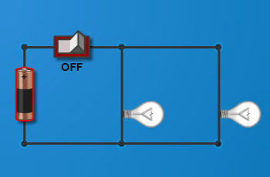

Question: In a parallel circuit, there is more than one path along which charges can flow. What are the properties of parallel circuits?

- Observe: Turn the light switch ON and observe the light bulb. Then add two more light bulbs to the circuit, parallel to the first two.

- How does each new light bulb affect the others? ____________________________

- Use the Ammeter to measure the current in various parts of the circuit. Is the current the same throughout, or does it change? Explain: ___________________________
___________________________________________________________________

- Form hypothesis: How do you think the total resistance of a parallel circuit is calculated?

_________________________________________________________________________

- Experiment: With the battery voltage set to 15 volts, measure the current in a parallel circuit with 1, 2, 3, and 4 light bulbs. (In each case, place the ammeter next to the battery.) Use Ohm’s law to calculate the total resistance of the circuit. Record results below.

Number of light bulbs | 1 | 2 | 3 | 4
Voltage | 15 volts | 15 volts | 15 volts | 15 volts
Current
Total resistance

- Make a rule: How would you find the resistance of a parallel circuit with n identical resistors?

_________________________________________________________________________

- Apply: What will be the total resistance and current in a parallel circuit with a 15-volt battery and three 10-ohm resistors? Test your answers with the Gizmo.

Total resistance: ______________________ Current: ______________________

(Activity C continued on next page)
Activity C (continued from previous page)

- Extend your thinking: Household appliances are usually connected in a parallel circuit. Why do you think it might be a problem if too many appliances are turned on at once? (Hint: current in a wire also produces heat.)

_________________________________________________________________________

_________________________________________________________________________

- Calculate: Determining the total resistance of a parallel circuit when there is a variety of resistors is more complex.
  - The total current in the circuit (I) is equal to the sum of currents in each branch:
  - Ohm’s law (V = IR) can be rewritten as I = V / R. Substituting this expression into the equation above:
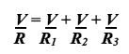
  - (Note: Since each branch of the circuit might have a different resistance, we write R₁, R₂, and so forth. But the voltage is the same across each branch, so V is used for each term.)
  - Divide each side of the equation by V, and you get an expression for the total resistance of the circuit:
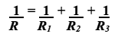

- Practice: Determine the total resistance of each of the following parallel circuits. Then use the Gizmo to check your answer. (You can calculate the total resistance from the current and voltage using Ohm’s law, or use the Ohmmeter to measure the resistance directly.)

- A parallel circuit with a 20-ohm resistor and a 10-ohm resistor. _________

- A parallel circuit with two 20-ohm resistors and a 10-ohm resistor. _________

- A parallel circuit with a 15-ohm light bulb and a 20-ohm resistor. _________

- A parallel circuit with two 100-ohm resistors and a 20-ohm resistor. _________

- A parallel circuit with a 10-ohm, 20-ohm, 100-ohm and 200-ohm resistor. _________

