Name: ______________________________________ Date: ________________________

Student Exploration: Circulatory System

Vocabulary: artery, atrium, blood vessel, capillary, circulatory system, heart, heart valves, platelet, pulmonary artery, pulmonary vein, red blood cell, urea, ventricle, vein, white blood cell

Prior Knowledge Questions (Do these BEFORE using the Gizmo.)

- Why do you need blood? _____________________________________________________

_________________________________________________________________________

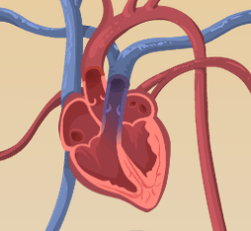
- What organ pushes blood through your body? _______________

Gizmo Warm-up
The Circulatory System Gizmo shows the heart and blood vessels that make up the circulatory system. Look at the heart.

- How many chambers does the heart have? _______________

- Turn on Show labels. What are the names of the chambers? _______________________,

_______________________, _______________________, _______________________

- Do you see tiny “doors” that open and close as blood is pumped through the heart? ______

These are heart valves. Heart valves control the flow of blood through the heart.

- Click Heartbeat sound and listen for the two parts of the heartbeat, nicknamed “lub” and “dub.” Observe the heart. (Note: The recording is not in sync with the heart animation.)

What do you think causes heartbeat sounds?

In fact, the “lub” sound is caused by valves from the atria to the ventricles closing, and the “dub” sound is caused by the valves from the ventricles to the blood vessels closing.

- Challenge: Why do you think the left atrium and left ventricle are shown on the right side of the diagram? ______________________________________________________________

Activity A:  Blood flow | Get the Gizmo ready:  - Turn off Show labels.  - Turn on Show blood flow. | 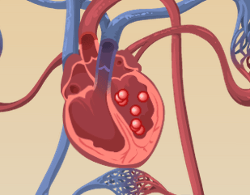
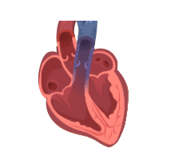

Question: How does blood flow through the heart?

- Observe: Blood in each chamber of the heart is represented by little balls. Click Play () and observe the balls as they move through the heart and lungs.

- Label: Click Pause () and turn on Show labels. Label the four chambers of the heart on the diagram. Then draw arrows to show the direction that blood flows through the heart.

Starting at the right atrium, in what order does blood flow through the four chambers?

Right atrium, ____________________, ____________________, ____________________

- Analyze: Click Play. Observe the path of blood that leaves each ventricle.

    - Where does blood from the right ventricle go? ______________________________

    - Where does blood from the left ventricle go? _______________________________

- Collect data: Use the syringe to collect a blood sample from the right ventricle (on the left side of the heart diagram). Look at the Data from blood sample numbers.

    - What is the concentration of oxygen in this sample? ____________________

    - What is the concentration of carbon dioxide in this sample? ____________________

- Collect data: Now collect a blood sample from the left atrium.

    - What is the concentration of oxygen in this sample? ____________________

    - What is the concentration of carbon dioxide in this sample? ____________________

- Draw conclusions: Between the right ventricle and the left atrium, blood goes through the lungs. Based on the data you have collected, what happens in the lungs?

_________________________________________________________________________

_________________________________________________________________________

Activity B:  Blood circulation | Get the Gizmo ready:  - Check that Show labels is on.  - Turn on Show blood flow. | 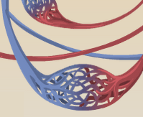

Question: How is blood carried to different parts of the body?

- Observe: Click Play and watch the blood after it leaves the left ventricle. What are some places that blood goes after leaving the heart? ____________________________________
_________________________________________________________________________

- Compare: The Gizmo shows three types of blood vessels. Arteries carry blood away from the heart, capillaries are small vessels that carry blood to body cells, and veins carry blood back to the heart. Locate examples of arteries, veins, and capillaries.

Use the syringe to take blood samples from several different veins and arteries.

    - Which type of blood vessel usually carries oxygen-rich blood? __________________

    - Which type of blood vessel usually carries oxygen-poor blood? _________________

    - In which type of blood vessel is oxygen released into body cells? _______________

- Challenge: The pulmonary arteries carry blood from the right ventricle to the right and left lungs. The pulmonary veins carry blood from the lungs back to the left atrium. Locate these blood vessels, and use the syringe to take a blood sample from each.

    - How is the blood in the pulmonary arteries different from blood in other arteries?

___________________________________________________________________

    - How is the blood in the pulmonary veins different from blood in other veins?

___________________________________________________________________

- Extend your thinking: How is the circulatory system similar to a road-and-highway system?

_________________________________________________________________________

_________________________________________________________________________

_________________________________________________________________________

_________________________________________________________________________
Extension:  What’s in your blood? | Get the Gizmo ready:  - Take a blood sample from any blood vessel using the syringe. | 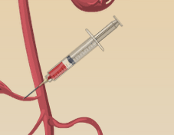

Question: What is inside blood?

- Observe: Look at the Microscopic view of blood sample. Sketch what you see in the space at right. (If you like, you could also click the camera icon to take a Gizmo snapshot, and then paste your snapshot into a blank word-processing document.)

Find and label the following objects in your sketch:

- Red blood cells (small, round cells that carry oxygen)
- White blood cells (large, irregular cells that fight disease)
- Platelets (tiny fragments that help to stop bleeding when you are cut)

- Collect data: Blood carries many vital substances. Four of these are listed above the Microscopic view. Oxygen and sugar are needed by all body cells. Carbon dioxide and urea are waste products. What are the concentrations of each substance in this sample?

Oxygen: _________ Carbon dioxide: _________ Sugar: _________ Urea: _________

- Investigate: Take samples of blood from all over the body. Try to determine where sugar enters the blood, and where it is removed.

  - Where does sugar enter the blood? ______________________________________

  - How can you tell where sugar enters the blood? ____________________________

___________________________________________________________________

  - Where is sugar removed from the blood? __________________________________

  - How can you tell? ____________________________________________________

___________________________________________________________________

- Investigate: Take blood samples to determine where urea enters the blood and is removed.

  - Where does urea enter the blood? _______________________________________

  - Where is urea removed from the blood? ___________________________________

