Name: Date:

Student Exploration: City Tour (Coordinates)

Vocabulary: coordinates, horizontal axis, ordered pair, origin, vertical axis

Prior Knowledge Questions (Do these BEFORE using the Gizmo.)
The two historical maps below show sections of famous cities.

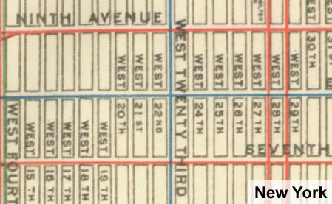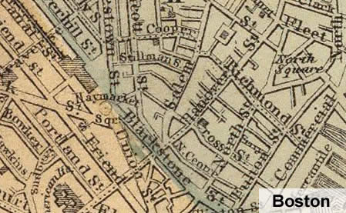

- Based on the maps, which city would be easier to find your way in? ___________________

- Why? ____________________________________________________________________

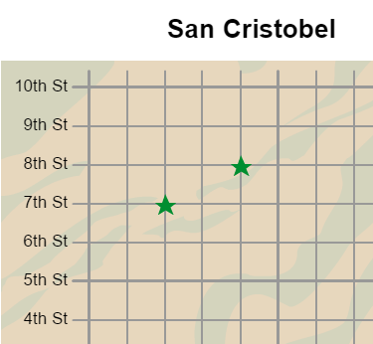
Gizmo Warm-up
In the City Tour Gizmo, you are a tourist visiting (fictional) cities all over the world. The tour begins in San Cristobel.

- Check that Move using arrows is selected. You should be at your hotel ( ). Click the right arrow 3 times to ride your bike 3 blocks east. Then click the up arrow 5 times to ride your bike 5 blocks north.

  - What avenue are you on now? __________

  - What street are you on now? __________

  - Click Visit here. What did you find at this location? __________________________

- Click Resume travel, and select Move from my location. Use this method to get to the landmark on 7th Avenue and 3rd Street. Click Visit here.

What did you find? ____________________________ (Click Resume travel when done.)

Activity A:  Visiting San Cristobel | Get the Gizmo ready:  - Click Return to hotel.  - Check that San Cristobel is selected. (If not, click Previous city until your reach San Cristobel.)

Welcome to San Cristobel, a sparkling jewel on the Caribbean Sea. The map of San Cristobel shows avenues on the horizontal axis and streets on the vertical axis. You will start at your hotel, which is located at the origin of the grid (where the horizontal and vertical axes cross).

- Using any method, move to one of the landmarks labeled by a green star.

  - What is your location? _________________________________________________

  - Click Visit here. Which landmark are you visiting? ___________________________

- Click Resume travel. Turn on Show my address. Coordinates name a location. For a flat surface or graph, coordinates of a point are written as an ordered pair such as “(2, 3).”

  - What are the coordinates of your current location? __________

  - What does the first number tell you? ______________________________________

  - What does the second number tell you? ___________________________________

  - What is the difference between the points (2, 3) and (3, 2)? ____________________

___________________________________________________________________

- Select Move using arrows. Turn on Places to visit and visit all four locations on this list. Also visit the five spots marked by green stars on the map. (Click Visit here at each place!)

- A friend of yours wants to visit San Cristobel. List three landmarks you would recommend visiting. Also give the location and coordinates of each place. (An example is given.)

Landmark | Location | Coordinates
Shipwreck | 10th Avenue and 6th Street | (10, 6)

- What is an advantage of using coordinates to describe a location? ____________________

_________________________________________________________________________
Activity B:  Scavenger hunt | Get the Gizmo ready:  - Click Next city.

You’ve signed up for a scavenger hunt! To answer these questions, visit all the landmarks (the Places to visit plus the green stars) in Snowden, Saltuna, Morivec, and Randomaria. (Note: The Randomarians are tricky—they switch the locations of their landmarks each time you visit!)

Use either method of moving. Click Next city or Previous city to go from one city to another. Find the answer to each question, name the landmark, and list the coordinates. Happy travels!

- In Saltuna, when was the ancient Anasazi village deserted? _________________________

Landmark: __________________ Coordinates: _________

- Who built soup kitchens and orphanages in Morivec? ______________________________

Landmark: __________________ Coordinates: _________

- How do they produce meat in Randomaria? ______________________________________

Landmark: __________________ Coordinates: _________

- What can you find on the Chapman’s front lawn in Snowden? ________________________

Landmark: __________________ Coordinates: _________

- Why did they build a city wall around Morivec? ____________________________________

Landmark: __________________ Coordinates: _________

- Where can you travel if you go to the Randomaria spaceport? ________________________

Landmark: __________________ Coordinates: _________

- Challenge: Where could you go to hear throat singing? _____________________________

City: _______________ Landmark: __________________ Coordinates: _________

- Challenge: Who was shot by Sheriff’s deputies in 1846? ____________________________

City: _______________ Landmark: __________________ Coordinates: _________

