Vocabulary: Cladograms

Vocabulary

- Adaptation – a change that results in an organism being better suited to its environment.

- Amino acid – an organic molecule containing a carboxyl and an amino group.
- Amino acids combine in a long chain to form proteins.
- Amnion – a membrane that contains the developing embryo of a mammal, bird or reptile.

- Artiodactyla – an order of even-toed hoofed mammals.
- Sheep, goats, pigs and camels are part of the Artiodactyla group.

- Bipedal – an animal that uses two legs for walking.
  - Humans, birds, and some other animals are bipedal.

- Clade – a group of organisms believed to have evolved from the same common ancestor.
- A clade includes all of the descendants of the common ancestor.
- A group like dinosaurs is not a true clade because it does not include birds, which evolved from dinosaurs.

- Cladistics – a method of classification of species based on their morphological or molecular similarity.

- Cladogram – a branching diagram that shows the hypothesized relationship between organisms.
- The organisms to compare are listed at the top of the cladogram.
- The nodes of the cladogram represent common ancestors and the branches represent divergent evolution.
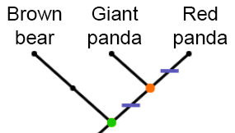
- In the cladogram at right, the brown bear, giant panda, and red panda all share a common ancestor at the green node. Then, the ancestors of the brown bear diverged from the ancestors of both the giant panda and red panda. The giant panda and red panda share a common ancestor at the orange node.

- Convergent evolution – the independent evolution of similar traits in more than one lineage.
- Wing development in birds and bats is an example of convergent evolution.

- Evolution – change in the inherited traits of a population of organisms that occurs over many generations.

- Flower – a specialized, often colorful plant structure that contains the plant’s reproductive organs.
  - After pollination, flowers develop into fruits and seeds.

- Mammary glands – the milk-producing structures in female mammals.

- Molecular – relating to molecules, a group of atoms bonded together that represent the smallest unit of a chemical compound.

- Morphological – relating to the physical structure of organisms.

- Multicellular – having more than one cell.

- Parsimony – a principle that states that the simplest explanation that fits all evidence is most often true.
- When building a cladogram, the most parsimonious cladogram is the one that requires the fewest evolutionary changes.
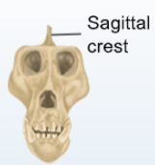
- Phloem – the vascular tissue in plants that conducts sugar and other metabolites down from the leaves to the roots.

- Sagittal crest – a bony ridge on the top of some mammal skulls to which jaw muscles are attached.
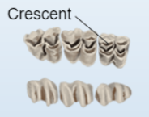
- Animals with sagittal crests, such as gorillas, usually have very strong jaw muscles.

- Selenodont teeth – molars that have crescent-shaped ridges on the grinding surface.
- Ruminant animals, such as cows and deer, often have selenodont teeth.

- SNP – a single-nucleotide polymorphism (SNP) is a difference in a nucleotide in a specific location that varies among individuals.
- SNPs are mutations that often don’t have negative effects, so they remain in a population.
- For example, a cow may have a guanine nucleotide at the 100th position of chromosome 2, whereas a deer may have an adenine at the same position. If that location is not inside an essential genetic element, the amino acid change will not have a negative effect on the deer.
- Similarities and differences in SNPs between species gives clues about their evolutionary relatedness.

- Xylem – the vascular tissue of plants that transports water and nutrients up from the roots to the rest of the plant.

