Name: Date:

**Student Exploration:** **Classifying Quadrilaterals**

**Vocabulary:** isosceles, kite, parallelogram, quadrilateral, rectangle, rhombus, square, trapezoid

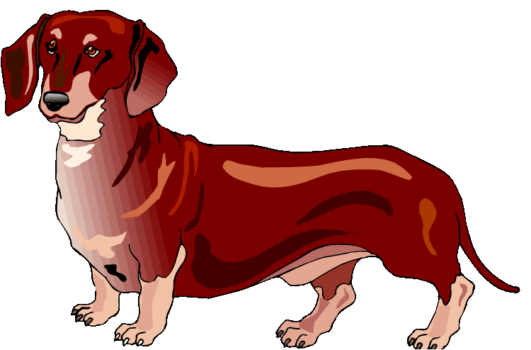

**Prior Knowledge Questions** (Do these BEFORE using the Gizmo.)

1. Kim’s family just adopted a Dachshund. They already have a German Shepherd.
2. How are the two animals the same?

1. How are the two animals different?

1. Michael has a turtle and a hamster. What do these animals have in common with Kim’s animals?

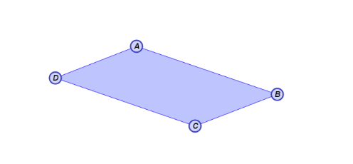**Gizmo Warm-up**

In the *Classifying Quadrilaterals* Gizmo, you can manipulate a variety of dynamic polygons, and name them based on the conditions you put on them.

1. With **Quadrilateral** and **None** selected, drag the vertices to create several **quadrilaterals**. What seems to always be true about a quadrilateral? (Fill in the blanks below.)

A quadrilateral is a with sides.

1. 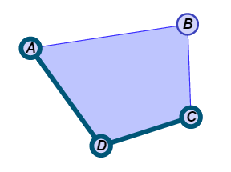You can select **Show angle measure tool** to open a Gizmo protractor, and **Show ruler** to open a Gizmo ruler. Attach the “donuts” to points, as shown to the right.

Create a variety of quadrilaterals. Use the Gizmo protractor to measure all angles of each quadrilateral.

What is the sum of the angle measures of a quadrilateral?

|  |  |  |
| --- | --- | --- |
| **Activity A:**  **Classifying by traits** | Get the Gizmo ready:   * Be sure **Quadrilateral** is selected. | 176SE_Kye3 |

1. Under **Condition**, choose **One pair of opposite sides parallel**. Drag the vertices to see a variety of these figures.
2. Create a quadrilateral of your choice. Sketch your quadrilateral in the space to the right.
3. Name the pair of opposite, parallel sides.
4. Turn on **Show name of shape**. What is this shape called?
5. Select **Trapezoid**. Drag the vertices to experiment with the figure. What seems to always be true about a **trapezoid**? (Fill in the blanks below.)

A trapezoid is a with

1. Select **Isosceles trapezoid**. Create a variety of these figures by dragging the vertices. Sketch one of them in the space to the right.
2. When is a trapezoid **isosceles**?
3. Which pairs of angles of this isosceles trapezoid appear to be congruent?

Use the Gizmo protractors to verify this.

1. Select **Quadrilateral** and **Two pairs of opposite sides parallel**. Be sure **Show name of shape** is checked.
2. Drag the vertices around to see a variety of these figures. Sketch an example in the space to the right.
3. Name the two pairs of parallel sides.
4. What is the shape you drew above called?
5. Select **Parallelogram** and drag the figure’s vertices. What defines a **parallelogram**?

A parallelogram is a with

1. How do you think the lengths of the parallel sides of a parallelogram compare?

Use the Gizmo rulers to check.

**(Activity A continued on next page)**

**Activity A (continued from previous page)**

1. Be sure **Parallelogram** and **Show name of shape** are still selected.
   1. Under **Condition**, select **All sides are ≅**. Look at a variety of these figures by dragging the vertices. Sketch one figure you create to the right. What is the name of this type of figure?

* 1. Select **Rhombus** and experiment with this figure. What is a **rhombus**?

A rhombus is a with

* 1. Select **Parallelogram**. Then choose **All angles are 90°** from the **Condition** menu and drag the vertices. Sketch it to the right. What is this type of figure called?

* 1. Select **Rectangle**, and vary the given figure. Describe a **rectangle** below.

A rectangle is a with

* 1. Select **Parallelogram** and **All angles are 90° and all sides are ≅** from the dropdowns. Vary the figure. Sketch an example of it to the right. What is the name of this shape?

* 1. Keep manipulating this figure in the Gizmo. What defines a **square**?

A square is a with

1. With **Show name of shape** still checked, select **Quadrilateral**.
2. Under **Condition**, select **Two pairs of adjacent sides ≅**. Drag the vertices around. Sketch your shape in the space to the right. What is the name of this quadrilateral?

1. Vary the figure by dragging its vertices. What is always true about a **kite**?

A kite is a with

|  |  |  |
| --- | --- | --- |
| **Activity B:**  **Using quadrilaterals** | Get the Gizmo ready:   * Be sure **Quadrilateral** is selected, and the **Condition** chosen is **None**. * Turn on **Show name of shape**. | 176SE_Kye11 |

1. Fill in the first blank with *always*, *sometimes*, or *never* to form a true statement. Then explain your answer, and check each one in the Gizmo.
2. A rhombus is a rectangle.

Explain:

1. A parallelogram is a square.

Explain:

1. A square is a rectangle.

Explain:

1. Find the value of *x* for each quadrilateral. Show all of your work.

**2*x* + 7**

**6*x* – 1**

**3*x* + 1**

**5*x* – 3**

1. Each side of a square is (*x* + 5) units long. The perimeter of the square is 52 units.