Vocabulary: Coastal Winds and Clouds

Vocabulary

- Condensation – change from a gas to a liquid.
  - Condensation of water occurs when water vapor is cooled.
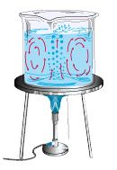
Convection currents
  - Condensation forms clouds, mist, and fog.

- Convection – transfer of heat through movement of a fluid.

- Convection current – the circular motion of a fluid (such as air) in which hot material rises while cold material sinks.
  - Hot fluid rises because it is less dense than cold fluid.
  - As hot fluid rises, cold fluid rushes in to occupy the space.

- Land breeze – a wind that blows from the land to the sea.
  - A land breeze is also known as an offshore breeze.

- Sea breeze – a wind that blows from the sea to the land.
  - A sea breeze is also known as an onshore breeze.

