Name: Date:

**Student Exploration:** **Comparing and   
Ordering Decimals**

**Vocabulary:** compound inequality, decimal, decimal point, equivalent, hundredth, inequality, tenth

**Prior Knowledge Questions** (Do these BEFORE using the Gizmo.)

For these questions, assume that are 3 tennis balls in a can, and 4 cans (12 balls) in a box.

1. Jake has 10 tennis balls. Juan has 3 cans of tennis balls. Julia has 1 box of tennis balls.

Who has the most tennis balls? ____________________________

1. Jake puts his 10 tennis balls into cans. How many cans does he use?

How many balls will be left over?

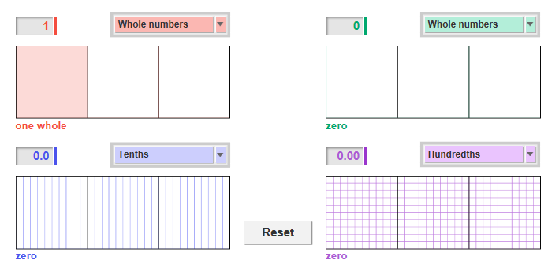**Gizmo Warm-up**

In the *Comparing and Ordering Decimals* Gizmo, you can compare and order decimals from 0 to 3, using area models.

A **decimal** is a number written in a standard, base-10 system. It usually contains a **decimal point** which separates the ones place from **tenths**, **hundredths**, etc.

1. With the red model set to **Whole numbers,** shade one whole. You can shade a model by clicking in it or by typing a number in the text field (in this case, 1) and hitting **Enter**.
2. Click **Reset**. Change to **Tenths**. Shade one whole again. How many tenths are in one whole? What decimal is shown?
3. Click **Reset**. Change to **Hundredths**. Shade one whole again. How many hundredths are in one whole? What decimal is shown?
4. **Equivalent** decimals are equal in value. Are the decimals in question 1 equivalent?

How do you know?

|  |  |  |
| --- | --- | --- |
| **Activity A:**  **Ordering from least to greatest** | Get the Gizmo ready:   * Click **Reset**. * Set the red model to **Whole numbers**. * Set the green model to **Tenths**. * Set the blue and purple models to **Hundredths**. | 208SE2 |

In this activity, you will be shading grid models to represent decimals. You can then use the shaded region of the models to compare decimals. A larger shaded region means a greater number.

1. Model the numbers 3, 0.3, 0.03, and 0.33 in the Gizmo by clicking to shade them as shown below.

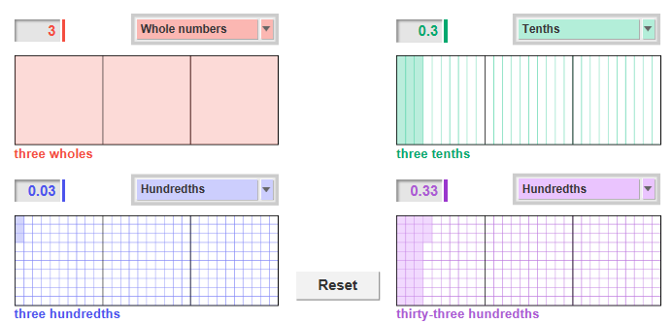

1. Which number is the least? How do the area models show this?
2. Which number is the greatest? How do the area models show this?
3. Write the four numbers in order from least to greatest.

__________ __________ __________ __________

1. Check your answer by turning on **Show number line** and **Compare numbers**. How does the number line show you the correct order of these four numbers?

**(Activity A continued on next page)**

**Activity A (continued from previous page)**

1. Click **Reset**. Change the red model to **Hundredths** and the blue model to **Tenths**. Shade 0.68 on the red model, 1.8 on green, 0.8 on blue, and 1.86 on purple.
   1. Write the four decimals in order from least to greatest.

__________ __________ __________ __________

* 1. How did you use the models and number line to order the decimals?

1. The red model currently represents 0.68, and the blue model represents 0.8.

* 1. Which model has more parts shaded?
  2. Which model has more area shaded?
  3. Which number is greater, 0.68 or 0.8? ______
  4. Which shows the greater number, more parts or more area shaded?

Explain.

1. Write each set of numbers in order from least to greatest. Use less than (<) or equals (=) signs between the numbers. Then check your answers in the Gizmo. (Note: The last three cannot be modeled in the Gizmo.)
   1. 2.3, 1.63, 3, 0.36
   2. 1.50, 2.15, 1.25, 0.9
   3. 0.1, 1.0, 1, 0.10
   4. 0.6, 0.65, 0.60, 0.56
   5. 2.28, 1.2, 2.1, 2.2
   6. 0.02, 0.2, 2, 2.02
   7. 6.9, 9.6, 6.09, 9.06
   8. 4.45, 5.5, 5.45, 4.54
   9. 7.76, 6.77, 7.7, 6.7

|  |  |  |
| --- | --- | --- |
| **Activity B:**  **Finding the decimal between** | Get the Gizmo ready:   * Click **Reset**. | 208SE4 |

1. You are going to use the Gizmo to find a decimal of the form __ . __ __. Should you use the **Tenths** or **Hundredths** setting to do this? Explain.
   1. Use the red model to find the least decimal containing the digits 0, 1, and 2.

______ . ______ ______

* 1. Use the green model to find the greatest decimal containing the digits 0, 1, and 2.

______ . ______ ______

* 1. Now use the blue and purple models find two different decimals containing the digits 0, 1, and 2 between the least and greatest decimals.

______ . ______ ______ ______ . ______ ______

Turn on **Show number line** and **Compare numbers** to check your answers.

* 1. Write the four decimals in order from least to greatest.

1. Use the Gizmo to model (shade) a decimal between 1 and 2.

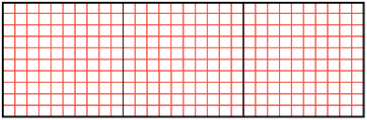

1. Write your decimal in the blank below.

Also shade it on the grid to the right.

1 < < 2

1. The inequality above is called a **compound inequality** because it shows two inequalities combined into one. Write the two inequalities that have been combined.

_______ < _______ and _______ < _______

1. How do the area models show you that your decimal is between 1 and 2?

**(Activity B continued on next page)**

**Activity B (continued from previous page)**

1. Use the Gizmo to help you find a decimal between 1.6 and 1.7.
   1. Is there a decimal with one decimal place that is between 1.6 and 1.7?

How do you know?

* 1. Write your decimal in the blank to the right. 1.6 < ___________ < 1.7





1.6 1.7

* 1. If you zoom in on the number line, you would see that there are many numbers between 1.6 and 1.7. Plot your decimal on the zoomed number line here:
  2. How does the number line show you that your decimal is between 1.6 and 1.7?



1. Now try to find a decimal between 1.63 and 1.64.
   * 1. How many decimal places will your decimal have?
     2. Plot your decimal on the number line to the right. Then write a compound inequality below.



1.63 1.64



1.6 1.7

___________________________________

1. Find a decimal between each pair of numbers. Then write a compound inequality using all three values. (Note: The last two cannot be modeled in the Gizmo.)
2. 2 and 3
3. 0.8 and 0.9
4. 0 and 0.1
5. 2.4 and 2.5
6. 50.87 and 50.88
7. 4256.03 and 4256.04