Name: Date:

Student Exploration: Compound Inequalities

Vocabulary: boundary point, compound inequality, inequality, intersection (of sets),
union (of sets), solution

Prior Knowledge Questions (Do these BEFORE using the Gizmo.)
Marla is selling tickets to a play. Discounts are available for people who are younger than 6, or 60 or older.

- An inequality compares two quantities that are not equal. Use <, ≤, >, or ≥ to write two inequalities for the ages that get discounted ticket prices. Use the variable a for age.

- Describe the ages of the people who do not get discounted ticket prices.

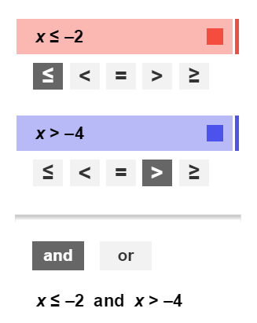
Gizmo Warm-up
You can combine the inequalities for the ages that get discounts to form a compound inequality. In the Compound Inequalities Gizmo, you will graph the individual inequalities to find the solution of the compound inequality.
In the Gizmo, drag the point on the top (red) number line to –2. Be sure the button is selected under the top inequality on the left. The inequality shown and graphed on top should be x ≤ –2.

- The red solid point shown on the top number line is the boundary point of the graph. Is the boundary point part of the solution of x ≤ –2?

- Is the solution of x ≤ –2 in the shaded or unshaded part of the number line?

- The inequality graphed on the bottom (blue) number line should be x > –4. Why is the boundary point of this graph open?

Activity A:  Compound inequalities involving and | Get the Gizmo ready:  - Set the top (red) inequality to x > –1.  - Set the bottom (blue) inequality to x ≤ 3.  - Be sure the and button is selected and Show solution is turned off. | 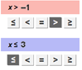
x | Is x > –1? | Is x ≤ 3?
–2
–1
0
1
2
3
4

- The top (red) inequality should be x > –1 and the bottom (blue) inequality should be x ≤ 3.

  - Fill in the table for the values of x shown.

  - What values make both x > –1 and x ≤ 3 true?

  - Look at the graphs shown in the Gizmo. How can you use the graphs to determine the values that make the compound inequality x > –1 and x ≤ 3 true?

  - Select Show solution. Write the algebraic solution of x > –1 and x ≤ 3 in the blank, and sketch the graph of the solution on the number line.

  - When two inequalities are joined by and, the solution is the intersection of the two inequalities. Does an intersection include only values that make both inequalities true, or values that make at least one of the inequalities true?

- Turn off Show solution. Graph the inequalities x ≤ –2 and x > 1 in the Gizmo.

- Do the graphs have any points in common?

- What do you think is the solution of the compound inequality x ≤ –2 and x > 1?

Select Show solution to check your answer.

- In the Gizmo, flip the sign in x > 1 so the inequality becomes x < 1. How does this change the solution?

(Activity A continued on next page)
Activity A (continued from previous page)

- In the Gizmo, experiment with more inequalities joined by and.

- In general, when will a compound inequality that contains and have a solution between two real numbers?

- In general, when will a compound inequality that contains and have no solution?

- In general, when will the solution of a compound inequality that contains and have a graph that is just a single ray?

- For the following compound inequalities, graph each inequality individually on the first two number lines. Then graph the solution of the compound inequality on the bottom number line and write the solution. Check your answer in the Gizmo.

- x > 4 and x < 7

Solution:

- x ≤ 5 and x > –1

Solution:

- x ≥ 2 and x < 0

Solution:

- x ≥ –6 and x > –2

Solution:

Activity B:  Compound inequalities involving or | Get the Gizmo ready:  - Set the top (red) inequality to x ≤ –2.  - Set the bottom (blue) inequality to x > 1.  - Select the or button.  - Be sure Show solution is turned off. | 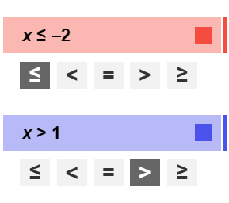

- The top (red) inequality should be x ≤ –2 and the bottom (blue) inequality should be x > 1.
x | Is x ≤ –2? | Is x > 1?
–3
–2
–1
0
1
2
3

- Fill in the table for the values of x shown.

- What values make either x ≤ –2 or x > 1 true?

- Look at the graphs shown in the Gizmo. How can you use the graphs to determine the values that make the compound inequality x ≤ –2 or
x > 1 true?

- Select Show solution. Write the algebraic solution of x ≤ –2 or x > 1 in the blank, and sketch the graph of the solution on the number line.

- When two inequalities are joined by or, the solution is the union of the two inequalities. Does a union include only values that make both inequalities true, or values that make at least one of the inequalities true?

- Consider the compound inequality x > –3 or x ≤ 5. (Do not graph it in the Gizmo yet.)

- Sketch the graphs of both inequalities on the number line to the right.
- Are there any values on the number line that are not shaded?

- Graph x > –3 or x ≤ 5 in the Gizmo. Be sure Show solution is selected. What is the solution of this inequality?

(Activity B continued on next page)
Activity B (continued from previous page)

- In the Gizmo, flip the sign in x ≤ 5 so the compound inequality becomes x > –3 or x ≥ 5. How does this change the solution?

- In the Gizmo, experiment with more inequalities joined by or.

- In general, when will a compound inequality that contains or have a solution of all real numbers?

- In general, when will the solution of a compound inequality that contains or have a graph that is just a single ray?

- For the following compound inequalities, graph each inequality individually on the first two number lines. Then graph the solution of the compound inequality on the bottom number line and write the solution. Check your answer in the Gizmo.

- x > 4 or x < –7

Solution:

- x ≤ –2 or x > –1

Solution:
- x < 5 or x ≤ –3

Solution:

- x ≥ –1 or x ≤ 6

Solution:

