Name: Date:

Student Exploration: Conditional Statements

Vocabulary: conclusion, conditional statement, converse, hypothesis

Prior Knowledge Questions (Do these BEFORE using the Gizmo.)
Consider the true statement, “If it’s snowing, then it’s cold outside.”

- Suppose it’s snowing. Does that mean it’s cold outside? Explain.

- Suppose it’s cold outside. Does that mean it’s snowing? Explain.

Gizmo Overview
In the Conditional Statements Gizmo, you will use word tiles to practice writing conditional statements (if-then statements) and identifying the parts of conditional statements. You will also determine whether conditionals and other related statements are true or false.

Here’s how the Gizmo looks at first:

At the top, click the tabs to select a “mode”: STANDARD (words) or SYMBOLIC (with symbols).
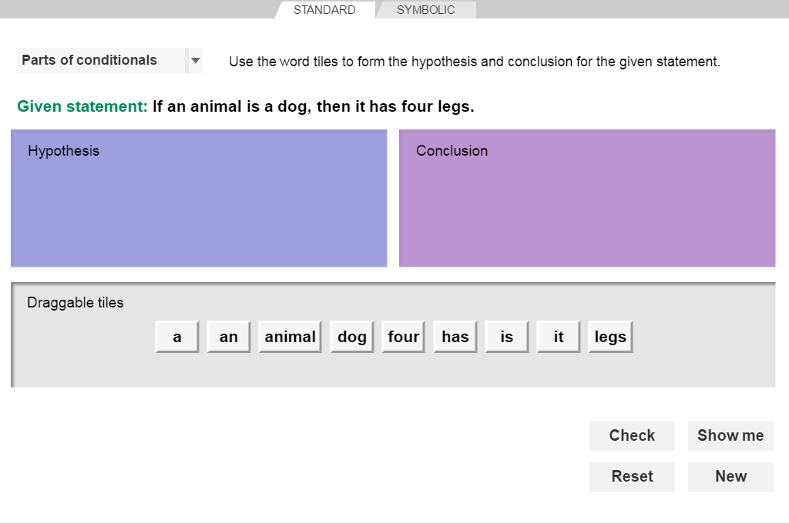
You can choose four different problem types from this dropdown menu:
- Parts of conditionals
- Writing conditionals
- Writing converses
- Truth values
Click Show me for the answer.
Here are the word tiles. Your job is to place them in the correct order in the bins above.
Click Check to check your answer.

(Note that the bins will be different depending on which problem type you have selected.)
Click New to try a new problem.
Click Reset to start over.

Activity A:  Conditionals | Get the Gizmo ready:  - Be sure the STANDARD tab is selected.  - Select Parts of conditionals in the dropdown list. | 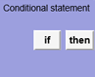

In a conditional statement, the hypothesis is the “if” part, and the conclusion is the “then” part.

- You should see the statement to the right at the top of the Gizmo.

- What is the hypothesis in this statement?

Form the hypothesis in the Gizmo by dragging word tiles into the Hypothesis bin. Use the small black arrows to help you place the tiles in the correct order.

- What is the conclusion in this statement?

Form the conclusion by dragging word tiles into the Conclusion bin. Click Check to see if your answers are correct. If not, make some changes and click Check again.

- With Parts of conditionals still selected, click the SYMBOLIC tab. You should see the statement shown to the right.

  - The symbolic statement p → q is read, “If p then q.” Which letter do you think stands for the hypothesis? Which one stands for the conclusion?
  - Drag the word tiles into the bins to form p and q. Then click Check to see if your answers are correct. What are p and q?

p:

q:

  - Compare your answers for this statement on the SYMBOLIC tab to your answers on the STANDARD tab. What do you notice?

- Click New. Work through more Parts of conditionals problems in the Gizmo, in both STANDARD and SYMBOLIC form.

(Activity A continued on next page)
Activity A (continued from previous page)

- At the top left corner of the Gizmo, select Writing conditionals.

- Click the STANDARD tab. You should see the statement shown to the right.

If you had to write this statement as an if-then sentence, how would you do it? (You can add some words, such as “object.”) Fill in the blanks below with your sentence.

If an object , then it

In the Gizmo, drag the word tiles into the Conditional statement bin to form that sentence. Click Check to verify your answer.

- Click the SYMBOLIC tab. Will the conditional for this statement be the same as the one for the STANDARD tab? Explain.

Drag the word tiles into the bin to form the conditional.

- Click New. Work through another problem from the Writing conditionals menu in the Gizmo.

  - What statement did you get?

  - What conditional statement is equivalent to that statement?

Click Check to verify your answer.

  - Click New. Continue working through Writing conditionals problems in the Gizmo.

- Write a conditional statement that means the same thing as each statement given below.

- A dog barks.

- A camera takes pictures.

- A square has four sides.

- A bicycle has pedals.

- A pine tree has needles.

- Half of 4 is 2.

Activity B:  Converses and truth values | Get the Gizmo ready:  - Click on the STANDARD tab.  - Select Writing converses from the dropdown. | 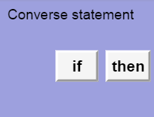

- You should see, “If a number is 7, then it is an integer,” at the top of the Gizmo.

  - What are the hypothesis and conclusion of the given statement?

Hypothesis: Conclusion:

  - The converse of a conditional is formed by switching the hypothesis and conclusion. What is the converse of the given statement?

Drag the tiles into the bin to form the converse. Click Check to verify your answer.

- With Writing converses chosen, select the SYMBOLIC tab. You should see the statement, “p → q, p: a number is 7, q: a number is an integer”. (Note: “p → q” means, “If p, then q.”)

- Write the converse of p → q in symbolic form here: →

- Drag the tiles into the bin to form the converse in words. What is the converse?

- Click New. Work through more Writing converses problems in the Gizmo.

- Choose Truth value from the dropdown menu. Click on the STANDARD tab.

- The given statement in the Gizmo is, “If you are in California, then you are in Los Angeles.” Is this statement true or false? Explain.

- The converse is, “If you are in Los Angeles, then you are in California.” Is this statement true or false? Explain.

Choose the truth values for both statements from the Select truth value dropdown menus in the Gizmo. Then click Check to verify your answers.
(Activity B continued on next page)
Activity B (continued from previous page)

- With Truth value still chosen, click the SYMBOLIC tab. You should see the information below at the top of the Gizmo.

Are the truth values of p → q and q → p the same as the conditional and converse on the STANDARD tab? Explain.

Choose the correct answers from the Select truth value dropdown menus and click Check.

- Give an example of a conditional statement that is true and has a true converse.

- Give an example of a conditional statement that is false and has a true converse.

- Click New. Work through more Truth values problems in the Gizmo.

- State the truth value of each conditional statement. Then write its converse and state the truth value of the converse.

- Conditional: If an object is an oven, then it heats food. Truth value:

Converse: Truth value:

- Conditional: If a figure is a pentagon, then it has five sides. Truth value:

Converse: Truth value:

- Conditional: If an object is a stop sign, then it is blue. Truth value:

Converse: Truth value:

- Conditional: If an animal is a kangaroo, then it hops. Truth value:

Converse: Truth value:

- Conditional: If a woman has children, then she is a mother. Truth value:

Converse: Truth value:

