Name: ______________________________________ Date: ________________________

Student Exploration: Conduction and Convection

Vocabulary: conduction, conductor, convection, insulator

Prior Knowledge Questions (Do these BEFORE using the Gizmo.)

- Two pots have been sitting on the stove for a while. One pot has a copper handle and the other has a wooden handle. Which handle would you rather touch? Why?

_________________________________________________________________________

_________________________________________________________________________

- One of the pots is filled with soup. The soup at the bottom of the pot is warmed by the stove burner, but how does the soup at the top get hot?

_________________________________________________________________________

_________________________________________________________________________

Gizmo Warm-up
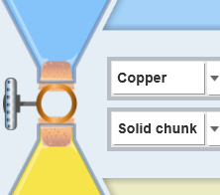
The Conduction and Convection Gizmo shows two flasks of colored water, one blue and one yellow. Select Copper and Solid chunk from the dropdown lists. (This means the two flasks are separated by a solid piece of copper, and the two liquids cannot touch each other.)

- Use the sliders to make one flask hotter than the other. Click Play ( ). What happens? __________________
_____________________________________________

- Select the DATA tab and look at the graph. What do the blue curve and the yellow curve represent?

  - The blue curve represents ______________________________________________

  - The yellow curve represents ____________________________________________

- What is the final temperature of the top flask? ____________ Bottom flask? ____________

Activity A:  Conduction | Get the Gizmo ready:  - Click Reset ( ).  - Set the Initial temperature of the top flask to 95 °C and the bottom flask to 5 °C. | 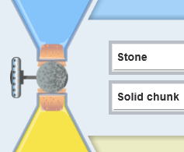

Question: Conduction is the transfer of heat from one object to another by direct contact. Which materials conduct heat most easily?

- Observe: Run the Gizmo twice – once with a Solid chunk of Copper separating the liquids, and once with a Solid chunk of Stone. Watch how quickly the temperatures of the liquids change in both cases. (Note: This solid chunk keeps the liquids from mixing.)

- Form hypothesis: A conductor allows heat to flow easily, while an insulator resists heat flow. In general, what kinds of materials do you think are good conductors?

_________________________________________________________________________

- Predict: Of the six substances in the Gizmo, which ones will allow the fastest temperature change in the two flasks? ____________________________________________________

- Experiment: Experiment with all six Solid chunks. For each, click Fast forward ( ) and then, after about 500 seconds, Pause ( ). Record the temperature of each flask.

Connection | Initial temp. (top flask) | Initial temp. (bottom flask) | 500 sec. temp. (top flask) | 500 sec. temp. (bottom flask)
Solid copper | 95 °C | 5 °C
Solid gold | 95 °C | 5 °C
Solid lead | 95 °C | 5 °C
Solid stone | 95 °C | 5 °C
Solid glass | 95 °C | 5 °C
Solid rubber | 95 °C | 5 °C

- Analyze: What substances conducted heat the best? _______________________________

How do you know? _________________________________________________________

- Draw conclusions: What do the best conductors have in common? ____________________
_________________________________________________________________________
Activity B:  Convection | Get the Gizmo ready:  - Click Reset.  - Select Glass and Hollow pipe in the dropdowns. | 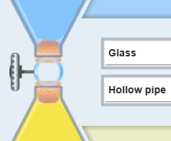

Question: Convection is the transfer of heat by the movement of matter. In what situations does convection work best?

- Observe: The Hollow pipe allows the water in each flask to move around and mix. Try several experiments with different temperatures in the top and bottom flasks.

  - Describe what you see: ________________________________________________

___________________________________________________________________

  - How does the color show when convection (movement of hot water) is taking place? ___________________________________________________________________

- Form hypothesis: Why do you think the water mixes quickly in some cases, while other times the water mixes slowly? _________________________________________________
_________________________________________________________________________

- Experiment: Predict the results of each experiment by writing “fast” or “slow” in the predictions column. Test your predictions on the Gizmo, and record the actual results.

Initial temperature (top flask) | Initial temperature (bottom flask) | Mixing speed (predictions) | Mixing speed (actual results)
95 °C | 5 °C
5 °C | 95 °C

- Analyze: How do the positions of the hot and cold water affect the speed of convection?

_________________________________________________________________________

_________________________________________________________________________

- Draw conclusions: Does hot water tend to rise or sink? Explain. ______________________

_________________________________________________________________________

_________________________________________________________________________

Activity C:  Conduction vs. convection | Get the Gizmo ready:  - Set the Initial temperatures of the top flask to 30 °C and the bottom flask to 70 °C.  - Select Gold from the dropdown list. | 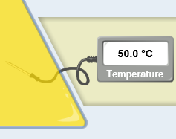

Question: Which works more quickly, conduction or convection?

- Observe: Experiment with a Hollow pipe of Gold and a Solid chunk of Gold separating the flasks. Compare how quickly heat is exchanged.

- Form hypothesis: Heat can be transferred by conduction or convection.
  - Which process do you think is quicker? ____________________________________
  - Why do you think this is so? ____________________________________________
___________________________________________________________________

- Experiment: For each of the situations below, record the temperatures after 100 seconds.

Connection | Initial temp. (top flask) | Initial temp. (bottom flask) | 100 sec. temp. (top flask) | 100 sec. temp. (bottom flask)
Solid gold | 30 °C | 70 °C
Hollow gold | 30 °C | 70 °C
Solid gold | 70 °C | 30 °C
Hollow gold | 70 °C | 30 °C

- Draw conclusions: Does convection always work more quickly than conduction? Explain why or why not. ____________________________________________________________
_________________________________________________________________________

- Extend your thinking: You may have noticed that there was a big difference in the results of the two hollow pipe experiments, but very little difference in the solid chunk experiments.

Why do you think this was the case? ___________________________________________

_________________________________________________________________________

_________________________________________________________________________

