Name: Date:

**Student Exploration: Congruence in Right Triangles**

**Vocabulary:** congruent, corresponding angles (of a polygon), corresponding sides, hypotenuse, legs (of a right triangle), right triangle, similar

**Prior Knowledge Questions** (Do these BEFORE using the Gizmo.)

Look at the pairs of triangles below. Some **corresponding sides** (matching sides) are marked congruent and some **corresponding angles** (matching angles) are marked congruent.

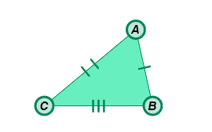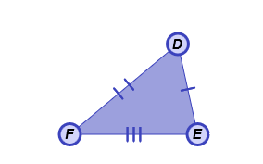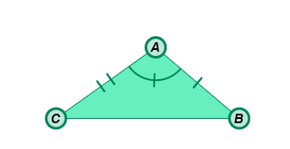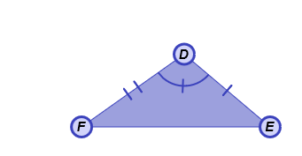

1. If all three pairs of corresponding sides of two triangles are the same length, the triangles are **congruent** (same size and shape) by Side-Side-Side (SSS).

Which pair of triangles is congruent by SSS?

1. If two pairs of corresponding sides and the corresponding angles between them are the same size, the triangles are congruent by Side-Angle-Side (SAS).

Which pair of triangles is congruent by SAS?

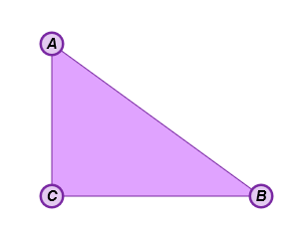**Gizmo Warm-up**

In the *Congruence in Right Triangles* Gizmo, you can place conditions on a pair of **right triangles**. Then you can manipulate the triangles to see if the conditions guarantee congruency.

1. In the triangle to the right, label the right angle, the two **legs** (the sides that form the right angle) and the **hypotenuse** (the side opposite the right angle).
2. With **None** selected from the **Condition** menu, drag vertices *B*, *C*, *E*, and *F* to form a variety of triangles. Which angles are congruent in all of the triangles you created?
3. Select **Show ruler** to open the Gizmo rulers. Measure one side of each triangle by attaching the ruler’s “donuts” to the endpoints. Then manipulate the vertices.

Are the triangles always congruent?

|  |  |  |
| --- | --- | --- |
| **Activity A:**  **What guarantees congruence?** | Get the Gizmo ready:   * Under **Condition**, select **One leg congruent**. | 179SE1 |

1. When **One leg congruent** is selected under **Condition**,  and  are congruent. Do you think this condition guarantees that the two triangles are always congruent?

Explain.

1. cameraDrag the vertices until the triangles are clearly *not* congruent. (You can use the measurement tools below the triangles to check this.) Click the camera ( ) at upper right to create a Screenshot. Open a blank word-processing document, and paste the image into it. Label the image “One leg congruent (L).” You will turn in this document with this worksheet.
2. For each condition listed below, write “yes” or “no” in the second column to predict whether you think the condition guarantees congruency for right triangles.

|  |  |  |
| --- | --- | --- |
| **Condition** | **Guarantee congruency?**  **(Your prediction)** | **Guarantee congruency?**  **(Actual answer)** |
| One leg congruent (L) |  |  |
| Both legs congruent (LL) |  |  |
| Hypotenuse congruent (H) |  |  |
| Hypotenuse and one leg congruent (HL) |  |  |
| One acute angle congruent (A) |  |  |
| One acute angle and one leg congruent (LA) |  |  |
| One acute angle and hypotenuse congruent (HA) |  |  |

1. In the Gizmo, choose each condition listed above, and try to create right triangles that are *not* congruent. In the third column, write “yes” if you made all congruent right triangles, or “no” if you were able to make non-congruent right triangles. Paste a Screenshot of any non-congruent right triangles in your document, labeled with the condition.

**(Activity A continued on next page)**

**Activity A (continued from previous page)**

1. Which conditions guarantee congruence of right triangles?
2. Under **Condition**, select **One acute angle congruent** (A). Two congruent shapes are the same shape and size. Two **similar** shapes are the same shape, but not necessarily the same size. Drag vertices *C* and *F* to form a variety of right triangles.
3. What is true about the right triangles when the condition is A?

1. Why is A for right triangles the same as AAA for any triangle?

1. The Pythagorean Theorem states that, for a right triangle with leg lengths *a* and *b* and hypotenuse length *c*, *a*2 + *b*2 = *c*2. Under **Condition**, select **Hypotenuse and one leg congruent** (HL).
2. If you know the lengths of the hypotenuse and one leg, how can you find the length of the other leg?
3. How is HL equivalent to SSS?

1. Just as HL is a special case of SSS, the conditions that guarantee congruence in right triangles are special cases of the conditions that guarantee congruence in any triangle.

* **SSS (Side-Side-Side):** All three pairs of sides are congruent.
* **SAS (Side-Angle-Side):** Two pairs of sides and the included angles are congruent.
* **ASA (Angle-Side-Angle):** Two pairs of angles and their included sides are congruent.
* **AAS (Angle-Angle-Side):** Two pairs of angles and a pair of non-included sides are congruent.

Fill in the following table to show how the general conditions listed above match up with the right triangle conditions. (Note: There are two possible general conditions for LL and LA.)

|  |  |
| --- | --- |
| **Right triangle condition** | **General condition** |
| LL (Leg-Leg) |  |
| LA (Leg-Angle) |  |
| HA (Hypotenuse-Angle) |  |

|  |  |  |
| --- | --- | --- |
| **Activity B:**  **Proving congruence** | Get the Gizmo ready:   * Under **Condition**, select **None**. | 179SE2 |

1. In the right triangles to the right, you know that  ≅ .



1. Can you tell from the given information if the triangles are congruent? Explain.

1. What other information do you need to prove that the triangles are congruent by LL?

Check your answer in the Gizmo.

1. Is Δ*ABC* ≅ Δ*DEF* if  ≅ ? Explain.



1. In the right triangles shown, you know that ∠*B* ≅ ∠*E*.
2. What other information do you need to prove the right triangles congruent by LA?
3. What other information do you need to prove that the right triangles are congruent by HA?
4. Is Δ*ABC* ≅ Δ*DEF* if ∠*C* ≅ ∠*F*? Explain.

1. The triangles to the right have the congruent parts as marked.



1. Are the triangles congruent? Explain.

1. What other pairs of corresponding sides and angles are congruent?