Name: Date:

Student Exploration: Convection Cells

Vocabulary: convection, convection cell, density, global conveyor belt, mantle, mid-ocean ridge, subduction zone, vector, viscosity

Prior Knowledge Questions (Do these BEFORE using the Gizmo.)
You place a pot of soup on the stove. As the soup warms you notice some areas where soup is rising up and other areas where soup is sinking down.

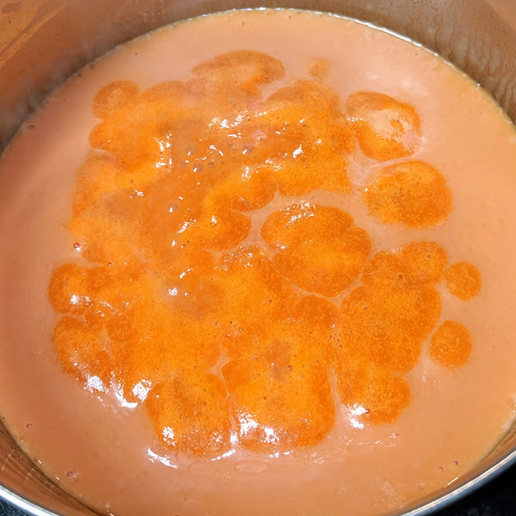
- Why do you think some of the soup is rising up?

- Why do you think some of the soup is sinking down?

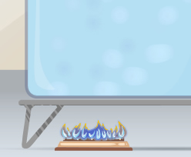
Gizmo Warm-up
When fluids (gases or liquids) are heated, they tend to move. This motion is called convection. In the Convection Cells Gizmo, you will observe and experiment with convection both in a laboratory setting and in several real-world examples.

To begin, note the laboratory setup on the MODEL tab. A beaker of liquid is placed above a gas burner. Click Play (). The burner is now heating the fluid.

- What do you notice?

- Drag the eyedropper into the beaker just above the burner and let go to release a drop of orange liquid into the beaker. What do you notice about the path of the drop?

Activity A:  Convection | Get the Gizmo ready:  - Click Reset (), and set Burner A to High. | 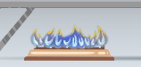

Question: What causes convection cells to form?

- Hypothesize: Click Play, add a drop, and watch the motion of the liquid. Why do you think convection tends to occur in heated fluids?

- Observe: Click Clear drop. Under Show, select Temperature. The temperature scale runs from red (hot) to dark blue (colder).

- Where is the hottest liquid located?

- Where is the coldest liquid located?

- Add a drop. Does the hottest liquid tend to rise or sink?

- Does the coldest liquid tend to rise or sink?

- Observe: Click Clear drop, and then add a new drop to the liquid. Turn on Show micro view of drop. This view shows 21 molecules in the drop. Pay attention to how fast the molecules move and how much space they occupy as the drop moves around the beaker. (Note: If the drop gets stuck, add a new drop to the beaker.)

- In which part of the beaker do the liquid molecules move fastest?

- In which part are the liquid molecules most spread out?

- Explore: Click Clear drop and drag the probe () into the beaker. Density is defined as the mass per unit volume. It is a measure of how tightly the particles of a substance are packed. Move the probe to different parts of the beaker, observing the temperature and density.

- What relationship do you observe between the temperature and density?

- Why do you think this is so?

(Activity A continued on next page)
Activity A (continued from previous page)

- Explain: In a liquid, objects denser than the liquid (such as rocks) tend to sink, while objects less dense than the liquid (such as inflatable rafts) tend to rise. How does this relate to the observed motions of the liquid in the beaker?

Convection occurs because heated fluids become less dense, causing them to rise. Cooled fluids become denser, causing them to sink.

- Observe: Click Reset. Select Motion and turn on Show velocity vectors. Click Play. The vectors (arrows) show the speed and direction of the liquid at each point in the beaker.

- What is the general pattern of motion?

This circulation is known as a convection cell. In a convection cell, hotter fluid rises while cooler fluid sinks.

- Why do you think the liquid in the bottom of the beaker moves to the left, while liquid at the top of the beaker moves to the right?

In the convection cell, liquid moves horizontally because it is pushed by other liquid. The liquid at the top of the beaker moves to the right because it is pushed by the rising liquid on the left. The liquid at the bottom of the container is pushed to the left by the downward-moving liquid on the right. The whole beaker is a closed system, so liquid motion in one part of the beaker must be offset by liquid motion elsewhere.

- Summarize: In your own words, describe what causes convection to happen and what causes convection cells to form.

Activity B:  Factors that affect convection | Get the Gizmo ready:  - Click Reset. Set Burner A to High.  - Turn on Advanced features. | 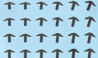

Question: What factors affect the characteristics of convection cells?

- Predict: For each of the configurations below, predict what the convection cell (or cells) will look like. Draw a sketch with arrows showing the motion of the liquid in each diagram. (Note there are two burners in the right-hand image.)

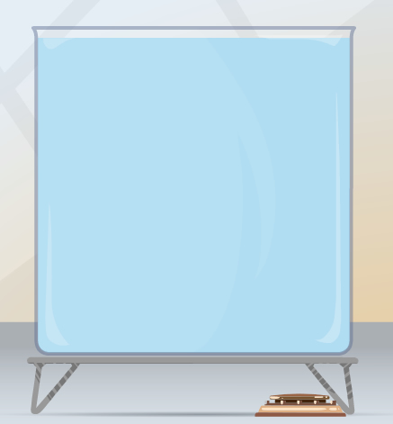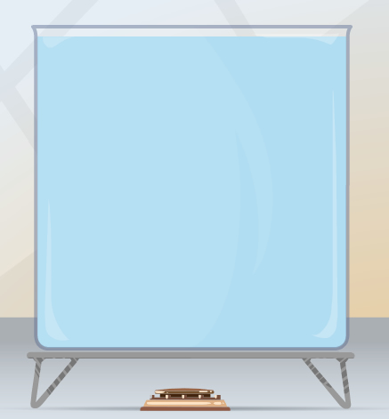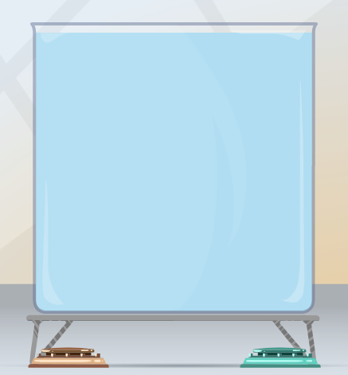

- Test: Use the Gizmo to model each scenario by dragging the burner left or right. In each case, set the burner to High. For the two-burner simulation, turn on Advanced features and select Add a second burner. For best results, set the Viscosity to 0.0 m²/s. Turn on Show velocity vectors and sketch the results, then explain why the liquid moves as it does.

(Activity B continued on next page)
Activity B (continued from previous page)

- Experiment: Click Reset. Turn off the second burner and move burner A to the left side of the beaker. Experiment with the four burner settings to determine how the amount of heat affects the speed of the liquid.

What did you find?

- Explain: Why doesn’t a convection cell form when the burner is turned off?

- Experiment: The viscosity of a liquid is its resistance to flow. Ketchup and honey, for example, have a greater viscosity than water. Experiment with different Liquid viscosity values to determine how viscosity affects the speed of the liquid in the convection cell.

Describe your findings:

- Explain: Move burner A as far as it can go to the left and set it to High. Set the Liquid viscosity to 0.2 m²/s. Turn on Burner B and set it to Medium. Move this burner as far to the left as possible, next to Burner A. Select Show temperature and click Play. In this setting, you should get a large contrast between the hottest and coolest parts of the beaker.

  - Use the eyedropper to add a drop and turn on Show micro view of drop. How does the speed of the molecules in the drop change as the drop goes around?

  - How does this affect the size and density of the drop?

  - What causes the drop to move around the container?

Activity C:  Real-world convection | Get the Gizmo ready:  - Select the EXAMPLES tab.  - Check that Mantle is selected. | 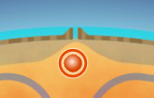

Introduction: The convection you observe in the lab (or in a pot of soup on the stove) also occurs on much larger scales. In this activity, you will learn about four types of convection cells that form on Earth.

Question: Where does convection occur on Earth?

- Observe: Earth’s mantle is a zone of semi-molten rock, or magma, found between the solid crust that makes up Earth’s surface and the molten rock in Earth’s outer core. Read about mantle convection, then click Play to observe convection cells in the mantle.

What is the general pattern of magma circulation in the mantle?

- Describe: Click the central orange dot to learn more about mid-ocean ridges.

- What occurs along a mid-ocean ridge?

- Click the right-hand dot to learn about a subduction zone. What occurs at subduction zones?

- The country of Japan is located along a subduction zone between the Philippine Plate and the Eurasian Plate. What natural disasters might be common in Japan?

- Observe: Select Ocean. The global conveyor belt is a vast, slow-moving convection cell that connects Earth’s oceans. Click each of the orange dots to read about what causes water to move up and down in the global conveyor belt.

- What two reasons cause water to move downward in the North Sea?

- What causes water to rise near the equator?

(Activity C continued on next page)
Activity C (continued from previous page)

- Infer: Why might a zone of upwelling be a good place to fish?

- Observe: Select Coast and read about and observe convection cells that occur in the air around coastlines. Select each orange dot and see what happens during the day and night.

- If you are standing on a beach, why might you feel an ocean breeze during the day?

- If you are starting a sea voyage in a sailing ship, why would it be a good idea to leave shore at night?

- What causes the direction of the wind to change from day to night?

- Observe: Select Atmosphere. The atmosphere contains three large-scale convection cells. Click Play to observe these cells, and then select each orange dot to learn more.

- What causes air to rise near the equator?

- What causes air to sink near the latitude 30° N (and 30° S)?

- Why are climates generally wet near the equator, and generally dry around the latitudes 30° N and 30° S?

- Think and discuss: In activity B, you learned that higher-viscosity fluids tend to form slower-moving convection cells than low-viscosity fluids. How does this relate to the speed of convection in Earth’s mantle, oceans, and atmosphere? Record your answer on the back of this sheet. If possible, discuss with your classmates and teacher.

