Vocabulary: Coral Reefs 2 – Biotic Factors

Vocabulary

- Biotic factor – the living components that affect an ecosystem.
  - Examples of biotic factors include disease-causing bacteria, invasive species, and humans.
  - Abiotic factors are the nonliving components of an ecosystem. Examples include temperature, salinity, and pH.
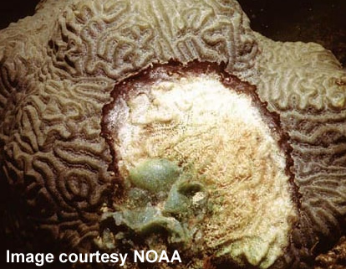
Black band disease on brain coral

- Black band disease – a disease characterized by a narrow band of microorganisms that gradually spreads across a coral, completely destroying coral tissue as it moves.
  - Black band disease mainly affects massive corals such as star corals and brain corals.
  - Corals that are stressed by high water temperatures or other factors are more likely to become infected with black band disease.

- Invasive species – an introduced species that is harmful to native species.
  - Introduced species are organisms that do not naturally occur in a given region.
  - Not all introduced species are invasive species. Only species that have harmful effects are considered invasive.
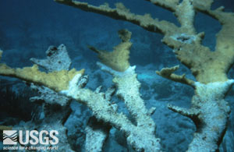
White band disease on elkhorn coral
- White band disease – a coral disease that generally proceeds from the base of the colony up toward the branch tips, destroying coral tissue as it goes.
  - White band disease affects two branched coral species in the Caribbean: staghorn coral and elkhorn coral.
  - The cause of white band disease has not been identified yet.

