Name: Date:

Student Exploration: Coriolis Effect

Vocabulary: Coriolis effect, deflect, frame of reference, high-pressure system, low-pressure system, tropical cyclone, velocity
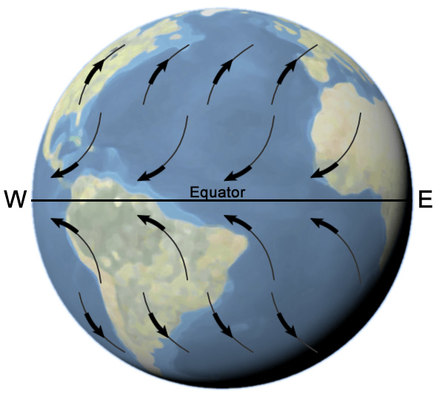

Prior Knowledge Questions (Do these BEFORE using the Gizmo.)
The diagram shows the prevailing winds on Earth’s surface. The arrows show the most common wind directions at different latitudes.

- Look at the winds blowing toward the equator. In which direction are these winds bent, or deflected?

- Look at the winds blowing toward the north and south poles.

In which direction are these winds deflected?

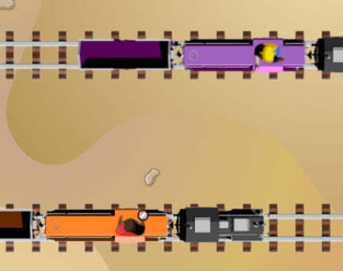
Gizmo Warm-up
The deflection of winds on Earth’s surface is called the Coriolis effect. You will learn what causes this effect by playing catch. Meet Willie and June, who live near the train station. One of their favorite things to do is climb on top of the trains and play catch. (Don’t try this at home!)

In the Coriolis Effect Gizmo, you can see Willie and June playing catch. Willie is the thrower and June is the catcher. Set the Catcher speed to Slow.

- Click Play (), and then Throw when the thrower and catcher are lined up. What happens?

- Click Reset () and turn on Show ball path. Click Play and Throw. Does the ball go straight across in the direction it is thrown, or at a slant?

- How do you think the motion of Willie’s train affects his throw?

Activity A:  Trains | Get the Gizmo ready:  - Check that the TRAINS tab is selected. | 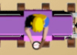

Question: How does a moving train affect the path of a thrown ball?

- Explore: Try playing catch with the Gizmo. Use different combinations of Catcher speed, Thrower speed, and Throw speed.

- What is the path of the ball when the thrower and catcher are not moving?

- How does the speed of the thrower’s train affect the path of the ball?

- Observe: Set the Catcher speed and Thrower speed to zero. Turn on Show velocity arrows. The velocity of the ball describes its speed and direction. Click Play and Throw. Try throwing with each different throw speed: Slow, Medium, and Fast. How does the length of the yellow arrow relate to the speed of the throw?

- Observe: Set the Thrower speed to Slow and the Throw speed to Slow. Notice the thrower has a red arrow showing his sideways speed. Click Play, click Throw, and then click Pause. Notice there are now three arrows coming from the ball.

- What do you think the blue arrow represents?

- What do you think the red arrow represents?

- What do you think the yellow arrow represents?

- Experiment: Try different combinations of thrower speed and throw speed.

- How does the throw speed (blue arrow) affect the ball velocity (yellow arrow)?

- How does the thrower velocity (red arrow) affect the ball velocity (yellow arrow)?

(Activity A continued on next page)
Activity A (continued from previous page)

- Explain: The velocity of the ball (yellow arrow) is found by combining the velocity of the thrower (red arrow) and the velocity of the throw (blue arrow). How does this explain the speed and direction of the ball after it is thrown?

- Observe: Willie has a drone that is programmed to hover over his head and make a video. Next to Frame of reference, select Thrower. Check that the thrower speed is not zero.

Turn on Show ball path and click Play. What do you notice?

Frame of reference is the part of a scene that is assumed to be stationary. For example, a passenger on a train might use the train as a frame of reference while moving to their seat. From this viewpoint, it looks like the outside landscape is moving rather than the train.

- Observe: With Willie’s speed set to Medium, compare the path of the ball when the frame of reference is the thrower to when the frame of reference is the ground.

- What does the ball’s path look like when the frame of reference is the ground?

- What does the ball’s path look like when the frame of reference is the thrower?

- Is there any frame of reference in which the ball’s path is curved?

- Think and discuss: The Coriolis effect causes winds to be deflected (bent) on Earth. Winds moving away from the equator are deflected east. Winds moving toward the equator are deflected west.

From what you have seen so far, what do you think causes the Coriolis effect? (Don’t worry if you haven’t figured it out yet, just record your ideas.)

Activity B:  Merry-go-round | Get the Gizmo ready:  - Select the MERRY-GO-ROUND tab. | 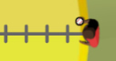

Question: How does a rotating merry-go-round affect the path of a thrown ball?

- Explore: Willie and June also live near a playground. When they visit the playground, they like to play catch on a large merry-go-round. (Luckily, neither of them gets very dizzy!)

Play catch on the merry-go-round. Vary the rotation speed, throw speed, and spin direction. You can even change Willie and June’s positions. Summarize your findings below.

- Observe: Set the Spin direction to Counterclockwise and the Rotation speed to zero. Turn on Show ball path. Click Throw and Play.

- What is the path of the ball?

- Set the Rotation speed to Slow. Click Play and Throw. What is the path of the ball now?
- Does the ball move in a curve or a straight line?

- Explain: Turn on Show velocity arrows. Check that the Rotation speed is Slow.

- Click Play and Throw. Why is the ball deflected (bent) to the thrower’s right?

- Repeat the experiment with the Spin direction set to Clockwise. Why is the ball deflected to the thrower’s left?

- How is this similar to how the ball is deflected when thrown from a moving train?

(Activity B continued on next page)
Activity B (continued from previous page)

- Experiment: Turn on Show ball path. Try a few different combinations of spin direction, rotation speed, and throw speed.

In all of these situations, is the path of the ball straight or curved?

The ball is on this path because, after it is released, there are no forces to deflect the ball. (We are ignoring the effects of gravity here.)

- Observe: Willie decides to use his drone to take a video. Once again, the drone is programmed to hover over his head as he is moving around in a circle. To show this, for Frame of reference choose Merry-go-round. Set the Spin direction to Clockwise and the Rotation speed to Slow.

- Click Play. What do you notice?

Because the drone is hovering over Willie’s head, Willie and June appear to be standing still while the ground rotates below them.

- Click Throw. What do you notice about the path of the ball?

- Do you think the path of the ball is really curved, or does it appear curved because the drone is circling above the merry-go-round?
As you saw before, the ball is really moving in a straight line. But from the perspective of Willie and June, who are rotating, the ball’s path appears curved. You will see why this is important in the next activity.

- Think and discuss: How do you think the path of the ball on the merry-go-round is related to the path of winds on Earth? (Hint: Think about how the winds would move if you looked down on the North Pole.)

Activity C:  Earth | Get the Gizmo ready:  - Select the EARTH tab. | 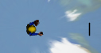

Question: How does Earth’s rotation affect the path of a thrown ball?

- Predict: Willie and June have magically grown larger and are now playing catch on Earth! Willie stands at the equator, while June stands on the North Pole.

- How is this situation similar to when Willie and June were standing on the merry-go-round?

- Earth’s rotation is counterclockwise. What do you think will happen when Willie throws the ball?

- Test: Change the Perspective to Equator. Turn on Show ball path. Click Throw and Play, and then click Pause.

- Did the ball go to the North Pole, or was it deflected?

- Was the ball deflected to the west (left) or east (right)?

- From this view, does the path of the ball appear straight or curved?

(Note: The ball’s path does curve because of Earth’s gravity, but this is not caused by the Coriolis effect.)

- Click Reset and observe throws with different speeds.. How does the path of the ball relate to Earth’s rotation?

- Explain: Based on what you have learned so far, why was the ball deflected from its path to the North Pole?

How do you think this relates to the deflection of winds by the Coriolis effect?

(Activity C continued on next page)
Activity C (continued from previous page)

- Observe: Click Reset. A satellite has been programmed to hover over Willie’s head as he throws the ball. The video from the satellite makes it look as though Earth is standing still while the stars are whirling around. For Frame of reference, select Earth.

Click Play and Throw, then Pause. What do you notice about the path of the ball now?

Just like with the merry-go-round, if you use a frame of reference where the rotating thrower and catcher look like they aren’t moving, the path of the ball appears to be curved.

- Predict: Click Reset. With the Equator as the perspective, drag Willie and June so that Willie (the thrower) is on the North Pole and June (the catcher) is at the equator.

What do you think will happen this time?

- Observe: Click Play, Throw, and Pause. In which direction is the ball’s path deflected (bent) this time? (Remember that west is left and east is right.)

- Make a rule: Experiment with different positions of Willie and June in the Northern and Southern Hemispheres. (You can drag either character all the way to the South Pole if you like.) In each case, write a rule stating if the path of the ball is deflected (bent) east or west.

- If Willie throws the ball away from the equator, the ball is deflected to the

- If Willie throws the ball toward the equator, the ball is deflected to the

- Think and discuss: The Coriolis effect is the deflection of winds across Earth’s surface, as shown in the image. Based on what you have observed with Willie and June, why does the Coriolis effect occur?

Activity D:  Wind | Get the Gizmo ready:  - Select the WIND tab.

Introduction: Near the equator, air is hot and tends to rise. As a result, winds blow toward the equator. At other latitudes, winds tend to blow toward the poles. Because Earth is rotating, the path of these winds is deflected by the Coriolis effect.

Question: How does Earth’s rotation affect the path of winds?

- Predict: On the WIND tab, check that Global winds is selected. Remember that Earth rotates from west (left) to east (right).

As winds blow away from the equator, in which direction will they be deflected?

As winds blow toward the equator, in which direction will they be deflected?

- Observe: Click Play, and wait for the animation to finish. Read the text description.

- What happens to winds blowing away from the equator?

- What are these winds called?

Note: For some reason, winds are named for the direction they blow from, not the direction they blow to. So a “west wind” is blowing from west to east. Confusing!

- Click Next and Play. What happens to winds blowing toward the equator, and what are they called?
- Click Next. What ocean current is caused by these winds?

- Predict: Select High-pressure system. In a high-pressure system, cool air sinks and then moves away from the center of the system.

What do you think will happen to the wind as it blows away from the center, and why?

- Test: Click Play. What happens to the wind moving away from the center of the high-pressure system?
Click Next to view wind patterns in the Southern Hemisphere. How is this pattern different?

(Activity D continued on next page)
Activity D (continued from previous page)

- Predict: Select Low-pressure system. In a low-pressure system, warm air rises. Cooler air moves in toward the center of the system.

What do you think will happen to the wind as it blows toward the center, and why?

- Test: Click Play. What happens to the wind moving toward the center of the low-pressure system?
Click Next to view wind patterns in the Southern Hemisphere. How is this pattern different?

- Predict: Select Tropical cyclone. A tropical cyclone is an extreme low-pressure system that forms over warm tropical oceans. Because of the very low pressure, strong winds blow toward the center of the system.

What do you think will happen to the wind as it blows toward the center, and why?

- Test: Click Play.

- What happens to the wind moving toward the center of the tropical cyclone?

- What are the names for storms that form in a tropical cyclone?

- Click Next to view wind patterns in the Southern Hemisphere. How is this pattern different?

- Think and discuss: In all of these weather systems, it appears that the winds are moving in a circular pattern. What is actually happening? (Hint: Think about the path of Willie and June’s ball both on the merry-go-round and on Earth.)

