Vocabulary: Coriolis Effect

Vocabulary

- Coriolis effect – a deflection of objects moving across a rotating body.
  - The Coriolis effect explains the deflection of winds as they move across Earth’s surface.

- Deflect – change direction, or bend.

- Frame of reference – the background or object that is assumed to be stationary when analyzing motion.
  - In our day-to-day lives, we usually assume Earth’s surface is stationary.
  - A passenger on a moving train might use the train as a frame of reference as they walk to their seat.

- High-pressure system – a weather system in which air pressure is higher than in the surrounding areas.
  - In a high-pressure system, cool, dry air moves downward and then spreads out across Earth’s surface.
  - High-pressure systems usually bring cool, sunny weather.

- Low-pressure system – a weather system in which air pressure is lower than in the surrounding areas.
  - In a low-pressure system, warm, moist air moves upward. Air from surrounding areas moves inward to fill the space.
  - Low-pressure systems usually bring warm, humid, and cloudy weather.

- Tropical cyclone – a large, rotating storm system with high winds and heavy rains.
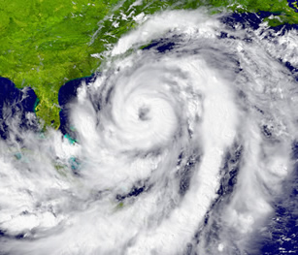

A large hurricane
  - A tropical cyclone forms over warm oceans. Hot, moist air rises rapidly, forming an extreme low-pressure system. Air rushes in to fill the space, and is bent by the Coriolis effect. The result is a rotating tropical cyclone.
  - Depending on the location and wind speed, tropical cyclones may be called hurricanes, typhoons, or tropical storms.

- Velocity – a quantity that represents the speed and direction of a moving object.
  - Velocity is often represented by arrows, or vectors.
    - The length of the vector shows the speed of the object.
    - The direction of the vector shows the direction of the motion.

