Name: Date:

Student Exploration: Correlation

Vocabulary: correlation, correlation coefficient, least-squares fit line, scatter plot

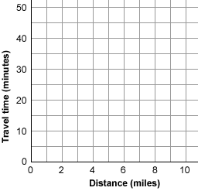
Prior Knowledge Questions (Do these BEFORE using the Gizmo.)
Mr. Bryant asks his students how far they live from school, and their travel time to get to school. He plots a point for each student’s distance in miles (x) and travel time in minutes (y) to create a scatter plot of his data.

- Suppose Mr. Bryant’s student Elena lives 3 miles from school and it takes her 15 minutes to get to school.

What point will Mr. Bryant plot for Elena? ( , )

- How do you think increased distance will affect travel time?

- Sketch points in the grid above to illustrate what you think the data might look like.

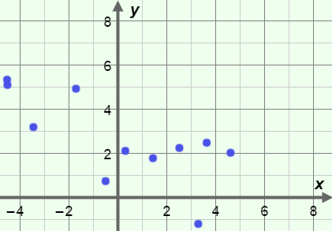
Gizmo Warm-up
When one variable is related to another, the two variables are said to be correlated. In many cases, variables that are correlated have a roughly linear relationship, where the scatter plot approximates a line. You can explore linear correlation with the Correlation Gizmo.

The variable r is called the correlation coefficient. Move the r slider back and forth and observe the scatter plot.

- How would you describe the scatter plot when r is close to 1?

- How does the scatter plot look when r is near –1?

- Describe the graph when r is near 0.

Activity:  Correlation and lines of best fit | Get the Gizmo ready:  - Set r to 1.00. (To quickly set a slider to a specific value, type the value into the text box to the right of the slider, and hit Enter.) | 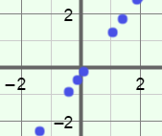

- In a data set with a strong linear correlation, the points in the scatter plot approximate a line. Turn on Show least-squares fit line. The least-squares fit line is the “best-fit” line, or the line that most closely “fits” the shape of the data.

- When r = 1, how are the points in the scatter plot related to the least-squares fit line?

- Slowly decrease r. How does this affect where the points are in relation to the line?

- With Show least-squares fit line still selected, set r to 0.90. The points should be close to the line, but not right on it. Below Generate new data set with: click Same r several times.

- Do all the least-squares fit lines for these scatter plots have the same slope?

- Do all the least-squares fit lines have the same y-intercept?

- What do all the least-squares fit lines have in common?

A positive r indicates a positive correlation: as x increases, y also tends to increase.

- Set r to –0.90. Click Same r several times. What do the least-squares fit lines for these scatter plots have in common?
A negative r indicates a negative correlation: as x increases, y tends to decrease.

- Set r to 0.00. Click Same r several times.

- Do all the least-squares fit lines for these scatter plots have the same slope?

- Do all the least-squares fit lines have the same y-intercept?

- What do all the least-squares fit lines have in common?

When r = 0, there is no correlation in the data. This means that the value of y does not seem to be at all related to the value of x.

(Activity continued on next page)
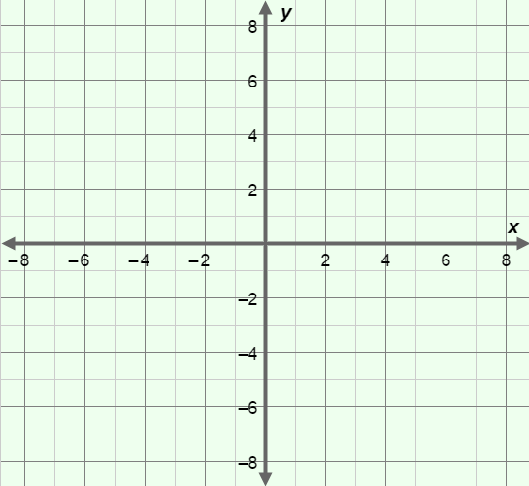
Activity (continued from previous page)

- Turn off Show least-squares fit line. Click New r, and sketch the scatter plot to the right.

What is the value of r?

Turn on Fit a line. Use the slope (m) and y-intercept (b) sliders to estimate the line that fits this data set best. Sketch your line and record its equation below.

Equation of estimated line:

Check your estimate by turning on Show least-squares fit line. Record the equation for the actual least-squares fit line.

Least-squares fit line equation: Was your estimate close?

- Turn off Show least-squares fit line. Click New r several times. For each data set, try to fit the red line to the data, and then check it by turning on Show least-squares fit line.

How does the value of r relate to how easy it is to estimate the least-squares fit line?

- Three scatter plots are shown below. Use them to answer the questions below the graphs.

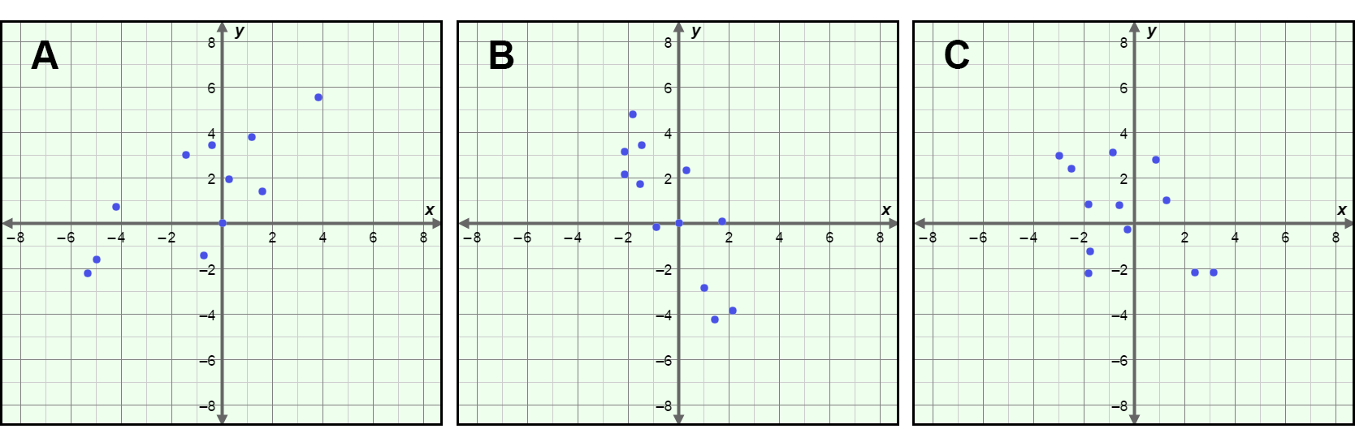

- For one of the three scatter plots, r = –0.83. Which one do you think it is?

Explain.

- Which graph has a least-squares fit line with the equation y = 0.6x + 1.75?

Explain.

