Name: _____________________________ Date: ________________________

Student Exploration: Density

Vocabulary: density, mass, matter, volume

Prior Knowledge Questions (Do these BEFORE using the Gizmo.)

- List three objects that you think would sink in water, and three objects you think would float.

Sink: _____________________________________________________________________

Float: ____________________________________________________________________

- Why do you think some things float and some things sink? __________________________

_________________________________________________________________________

_________________________________________________________________________

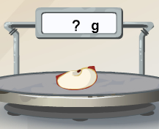

Gizmo Warm-up

- In the Gizmo, drag the apple onto the Scale. The scale measures mass. Mass is the amount of matter, or “stuff,” in an object.

What is the apple’s mass? ________ (Note: “g” stands for grams.)

- An object’s volume is the amount of space it takes up. The volume of an object can be measuring by using a graduated cylinder. Observe the graduated cylinder and the blue text showing the volume of water inside the cylinder.

  - What is the starting volume of water in the graduated cylinder? _________

  - Place the apple into the cylinder. What is the volume in the cylinder now? _________

The water rises in the cylinder because it is displaced, or pushed upward, by the apple. The amount of displaced water is equal to the volume of the apple.

  - What is the volume of the apple? _________ (Use the Object volume to check.)

Note: Milliliters (mL) are used for liquid volumes, while cubic centimeters (cm³) are used for solids. One mL is the same volume as one cm³. The apple’s volume is measured in cm³.

Activity A:  Sink or float? | Get the Gizmo ready:  - Replace all objects on the shelf.  - Be sure the liquid in the beaker is Water. | 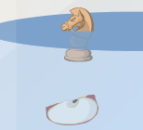

Question: How do mass and volume affect sinking and floating?

- Predict: Which objects do you think will float in water? Which do you think will sink? Record your predictions below in the first column of the table.

Object | Prediction  (sink or float?) | Mass  (g) | Volume  (cm³) | Result  (sink or float?)
Ping pong ball
Golf ball
Apple
Chess piece
Penny
Rock

- Experiment: Use the Gizmo to find the mass and volume of each object and whether it floats or sinks. Record your results in the table.

- Analyze results: Look at the data in your table.

- Can you use mass alone to predict whether an object will sink or float? Explain.

___________________________________________________________________

- Can you use volume alone to predict whether an object will sink or float? Explain.

___________________________________________________________________

- Draw conclusion: Can you use mass and volume to predict whether an object will sink or float in water? Explain your thinking.

_________________________________________________________________________

_________________________________________________________________________

- Apply: Measure the mass and volume of the toy soldier: Mass ________ Volume ________

Will it float or sink? ________________ Use the Gizmo to test your prediction.

Activity B:  Calculating density | Get the Gizmo ready:  - Replace the objects on the shelves.  - Be sure the liquid in the beaker is Water. | 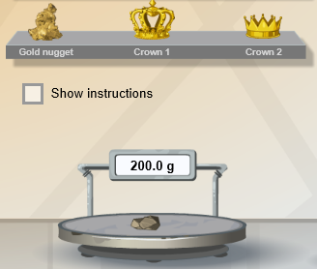

Question: How does density tell you whether an object will sink or float?

- Calculate: Density is the amount of mass contained in a given volume. To find the density of an object, divide its mass by its volume. Density is recorded in units of grams per cubic centimeter (g/cm³).

What is the density of an object with a mass of 100 g and a volume of 50 cm³? __________

- Record data: In the Gizmo, find mass and volume of the objects listed below. Then calculate each object’s density and record it. Finally, test whether each one sinks or floats in water.

Object | Density  (g/cm³) | Sink or Float?
Chess piece
Rock
Toy soldier
Apple

- Draw conclusion: The density of water is 1.0 g/mL, or 1.0 g/cm³. Look at the data in your table. How can you use the density of an object to predict whether it will sink or float?

_________________________________________________________________________

_________________________________________________________________________

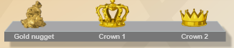
- Apply: In the Gizmo, either Crown 1 or Crown 2 is solid gold (but not both). Find the density of the gold nugget and of each crown. (Hint: You will probably need a calculator to do this.)

  - Density of the gold nugget: _____________________________________________

  - Density of Crown 1: ___________________________________________________

  - Density of Crown 2: ___________________________________________________

  - Which crown is pure gold? ______________________________________________

Activity C:  Egg-speriment | Get the Gizmo ready:  - Replace all the objects on the shelf. | 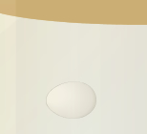

Question: How does an object behave in different liquids?

- Observe: Use the Gizmo to explore whether the egg sinks or floats in different liquids. Record what you find in the table below.

Liquid | Water | Oil | Gasoline | Seawater | Corn Syrup
Sink or Float?

- Draw conclusion: Which liquids are denser than the egg? Which are less dense? Explain your reasoning.

________________________________________________________________________

________________________________________________________________________

________________________________________________________________________

________________________________________________________________________

- Extend your thinking: Observe the egg in each liquid again.

- In which liquid does the egg float the highest? ______________________________

- In which liquid does the egg sink the fastest? _______________________________

- Which liquid do you think is the densest? Least dense? Explain. ________________

___________________________________________________________________

___________________________________________________________________

- Challenge yourself: Using the objects in the Gizmo to help you, list the liquids from densest to least dense. Discuss your answer with your teacher and classmates. (Hint: Compare where objects float within each liquid.)

________________________________________________________________________

________________________________________________________________________

