Name: ______________________________________ Date: ________________________

Student Exploration: Determining Density via Water Displacement

Vocabulary: Archimedes’ principle, density, displacement, mass, volume

Prior Knowledge Questions (Do these BEFORE using the Gizmo.)
A ship floats by an iceberg as shown.

- Based on the picture, which object is denser, the iceberg or the ship?

______________________________

- How do you know? _________________________________________________________

_________________________________________________________________________

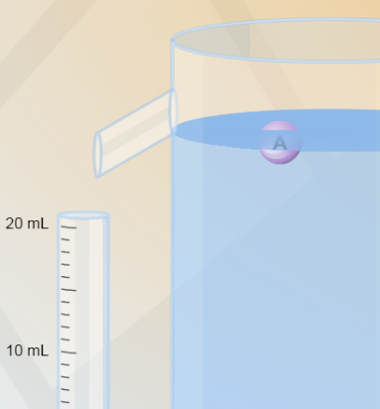
Gizmo Warm-up
Have you ever gotten into a bath and noticed the water level rise? Have you added potatoes to a full pot of water and had water spill over the sides? If so, you have witnessed a phenomenon called displacement, in which water or another fluid is pushed out of the way when a solid object is submerged in the fluid.

The Determining Density via Water Displacement Gizmo allows you to calculate the density, or mass per unit volume, of an object using nothing but a graduated cylinder and a container of water.

- Place object A into the water. Does it float or sink? _____________________

- Click Reset. Add each object to the water, one at a time. (Click Reset after each trial.)

Which objects float? __________________ Which objects sink? __________________

- Which object do you think is densest? ____________ Least dense? ____________

Explain: __________________________________________________________________

Activity:  Finding density | Get the Gizmo ready:  - Click Reset.

Introduction: Over 2,000 years ago, the Greek mathematician Archimedes discovered that an object in water is pushed up by a force equal to the weight of the displaced water. This law, called Archimedes’ principle, has two consequences:
- If an object floats, its mass is equal to the mass of the displaced water.
- If an object sinks, its volume is equal to the volume of the displaced water.

Question: How do you find the density of an object without using a balance?

- Measure: Drop object A into the water. Notice the water displaced into the graduated cylinder to the left of the container. The unit of volume is the milliliter (mL).

    - How much water is displaced by object A? ____________________

    - Water has a density of 1 gram per milliliter (1 g/mL). Based on its density, what is the mass of the displaced water? ____________________
    - Use Archimedes’ principle to determine the mass of object A: __________________

- Measure: The volumes of solid objects are measured in cubic centimeters (cm³). One cubic centimeter is exactly the same volume as one milliliter. Click Reset. Notice that object F has the same volume as object A. Drag object F into the water.

    - Does object F float or sink? ____________________

    - How much water is displaced by object F, in mL? ____________________

    - What is the volume of object F, in cm³? ____________________

    - What is the volume of object A? ____________________

- Calculate: The density of an object is equal to its mass divided by its volume: D = m ÷ V. The density of solids is measured in grams per cubic centimeter (g/cm³).

What is the density of object A? ____________________

- Analyze: Click Reset and drop object A back into the water. About what percentage of object A is under the water? How is this percentage related to the density of object A?

_________________________________________________________________________

_________________________________________________________________________
(Activity continued on next page)
Activity (continued from previous page)

- Gather data: Click Reset. Find how much water is displaced by objects B, C, D, and E. Record your measurements below. Include units.

Object | Volume of displaced water | Floats or sinks?
B
E

Object | Volume of displaced water | Floats or sinks?
C
D

- Calculate: Use your data to find the mass, volume, and density of the two floating objects, C and E. Recall that the mass of a floating object is equal to the mass of displaced water, and the volume of a sinking object is equal to the volume of displaced water. Assume objects B and E have the same volume, as do objects C and D.

Object C: Mass: ________ Volume: ________ Density: ________

Object E: Mass: ________ Volume: ________ Density: ________

- Analyze: Drag objects C and E into the water. Estimate the percentage of these objects that are submerged below the waterline. List these estimates below:

Object C: ____________________ Object E: ____________________

How do these estimates relate to the densities you calculated above? _________________

_________________________________________________________________________

- Think and discuss: Why can’t you use this Gizmo to measure the densities of objects B, D, and F? If possible, discuss your answer with your classmates and teacher.

_________________________________________________________________________

_________________________________________________________________________

_________________________________________________________________________

- Challenge: What can you say about the densities of objects B, D, and F? Is there a way to compare the relative densities of these three objects? Explain.

_________________________________________________________________________

_________________________________________________________________________

_________________________________________________________________________

