Name: ______________________________________ Date: ________________________

Student Exploration: Determining a Spring Constant

Vocabulary: displacement, equilibrium, Hooke’s law, restoring force, slope, spring, spring constant, weight

Prior Knowledge Questions (Do these BEFORE using the Gizmo.)
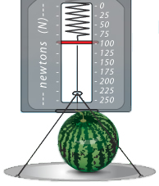
- At the grocery store, you put a watermelon on a produce scale. This causes the spring to stretch as shown. How far will the spring stretch if you add another watermelon of equal mass?

___________________________________________________

- What property allows springs to be used in scales? __________

___________________________________________________

___________________________________________________

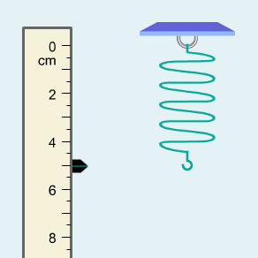
Gizmo Warm-up
When you put a grapefruit on a grocer’s scale, the scale may bounce up and down a bit, but eventually it settles into an equilibrium state. At this point, the force pulling the spring down is equal to the restoring force pulling the spring up. You can explore these forces in the Determining a Spring Constant Gizmo.

To begin, check that Spring 1 is chosen and nothing is hanging from the spring.

- What is the level of the bottom of the spring? ________

- Place the pan on the bottom of the spring. The pan has a mass of 20 grams. Wait for the spring to stop moving. At this point it has reached equilibrium.

- What is the level of the spring now? ________

- How much did the spring stretch? ________ This is the displacement of the spring.

- Place mass C (20 grams) on the pan. What is the level of the spring? ________

What is the total displacement of the spring from its original position? ________

Activity:  The spring constant | Get the Gizmo ready:  - Remove all weights from Spring 1.  - Select the TABLE tab.

Question: How is the displacement of a spring related to the weight it bears?

- Predict: In this activity, you will create a graph of the displacement vs. the weight on the spring. What do you think this graph will look like?

_________________________________________________________________________

_________________________________________________________________________

- Calculate: Place the 20-g pan on the spring.

- Convert the mass of the pan in grams to kilograms by dividing by 1,000.

What is the mass of the pan in kg? ____________________

- To find the weight of the pan, multiply the mass (in kg) by gravitational acceleration, 9.81 m/s². (Note: The units for weight are kg·m/s², or newtons (N)).

What is the weight of the pan in newtons? ____________________

- Gather data: Select the TABLE tab. Remove the 20-g pan from the spring. Record the force, position, and displacement (stretch) for each mass listed below. Click Record data each time the spring reaches equilibrium. (Note: You will have to figure out which combination of objects adds up to each of the listed masses.)

Mass (g) | Mass (kg) | Force (N) | Position (cm) | Displacement (cm)
0 g
20 g
40 g
80 g
100 g

- Analyze: What patterns do you notice in your data? (Hint: What happens to the displacement when the weight is doubled?)

_________________________________________________________________________

_________________________________________________________________________

(Activity continued on next page)
Activity (continued from previous page)

- Interpret: Select the GRAPH tab. What do you notice? ______________________________

_________________________________________________________________________

- Measure: Turn on Show line. The slope of the line (rise divided by run) is given by the value of k. Adjust the k slider until the line is aligned with all four points on your graph.

What is the slope of the line? ____________________

- Calculate: On your data table on the previous page, multiply each displacement value by the slope of the line recorded above. What do you notice? ______________________________
_________________________________________________________________________

- Infer: The slope of the line is a measure of the stiffness of the spring. The greater the slope, the stiffer the spring because it indicates more force is required to stretch the spring a given amount. The slope of the line is called the spring constant and given the symbol k.

Based on your data, create an equation that relates the force on the spring (F), the displacement (x), and the spring constant (k).

F =

This relationship is known as Hooke’s law. Usually, Hooke’s law is written for the restoring force (F_{R}) rather than the force on the spring. Because the spring is in equilibrium, the restoring force is equal to the negative of the force that is pulling the spring.

- Apply: How far will Spring 1 stretch with a mass of 70 grams? ____________________

Use the Gizmo to check your answer. Show your work below.

- Practice: Find the spring constant for each of the other springs in the Gizmo. Show your work on a separate sheet of paper.

Spring 2: k = ____________________

Spring 3: k = ____________________

Spring 4: k = ____________________

