Name: ______________________________________ Date: ________________________

Student Exploration: Dichotomous Keys

Vocabulary: dichotomous key, genus, organism, scientific name, species, traits

Prior Knowledge Question (Do this BEFORE using the Gizmo.)
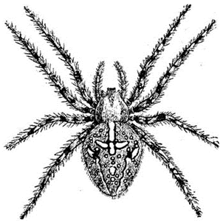
Jerome is walking through a park when he sees the spider shown at left. How could Jerome find out what type of spider it is?

_________________________________________________________

_________________________________________________________

_________________________________________________________

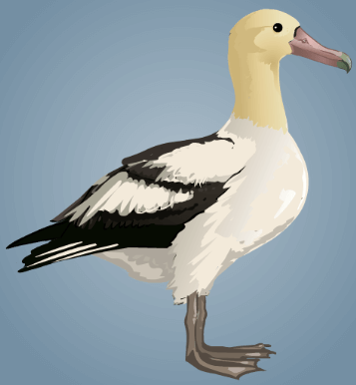
Gizmo Warm-up
In the field, scientists often have to identify an unfamiliar organism (living thing). A reliable way to identify organisms is to use a dichotomous key. A dichotomous key is a series of paired statements or questions that lead to the identification of an organism.

The Dichotomous Keys Gizmo allows you to use five different dichotomous keys to identify a variety of organisms. To begin, make sure California Albatrosses and Organism A are selected.

- Read the two statements at lower right. Which of the two statements most closely matches the characteristics of the bird pictured?

_________________________________________________________________________

- Select that statement and click Next. Continue until you have correctly identified the albatross. If you change your mind about a choice, you can click the Back button. If you incorrectly identify the albatross, you can click the Start Over button and try again.

  - What is the name of the albatross? _______________________________________

  - The scientific name is shown in italics. Scientific names have two parts: the genus name and the species name. What is the scientific name of this albatross?

___________________________________________________________________

Activity A:  Use a dichotomous key | Get the Gizmo ready:  - Make sure the California Albatrosses key is selected.  - Select Organism B.

Introduction: As you saw on the previous page, a dichotomous key can help you identify an organism using its characteristics, or traits. The keys in this Gizmo use only physical traits, such as feather color, to identify organisms. In some cases, behavioral traits are used in dichotomous keys. For example, some frog species can be identified by their croaks.

Goal: Use a dichotomous key to identify albatross species found in California.

- Compare: Take a close look at organism B.

- How does organism B differ from organism A? ______________________________

___________________________________________________________________

- What physical traits do you think can be used to help identify organism B? ________

___________________________________________________________________

- Identify: Use the Gizmo to identify organism B. Then, identify the other albatrosses included in the California Albatrosses key. Complete the table below.

California Albatrosses
Organism | Common name | Scientific name
A | Short-tailed albatross | Phoebastria albatrus
B
C
D
E
F

- Think and discuss: What do you think are some limitations of dichotomous keys?

_________________________________________________________________________

_________________________________________________________________________

_________________________________________________________________________

Activity B:  Identification practice | Get the Gizmo ready:  - Select the Canadian Rockies Buttercups key.  - Select Organism A.

Introduction: Dichotomous keys are written for small, specific groups of organisms. For example, each dichotomous key in this Gizmo is used to identify six to eight related species found within a geographic region.

Goal: Identify a variety of organisms using dichotomous keys.

- Practice: Use the Gizmo’s dichotomous key to identify all the buttercups.

Canadian Rockies Buttercups
Organism | Common name | Scientific name
A
B
C
D
E
F

- Analyze: Which traits were used to identify the flowers, and which of these traits did you think were most useful? ______________________________________________________
_________________________________________________________________________

- Practice: Select the Texas Venomous Snakes key. Use the Gizmo’s dichotomous key to identify all the snakes.

Texas Venomous Snakes
Organism | Common name | Scientific name
A
B
C
D
E
F
G

(Activity B continued on next page)
Activity B (continued from previous page)

- Reflect: Why is it important to be able to tell a scarlet kingsnake apart from a coral snake?
_________________________________________________________________________
_________________________________________________________________________

- Practice: Select the Virginia Evergreens key. Use the Gizmo’s dichotomous key to identify all the trees.

Virginia Evergreens
Organism | Common name | Scientific name
A
B
C
D
E
F
G
H

- Practice: Select the Florida Cartilaginous Fishes key. Use the Gizmo’s dichotomous key to identify all the fishes.

Florida Cartilaginous Fishes
Organism | Common name | Scientific name
A
B
C
D
E
F
G
H

Activity C:  Make your own dichotomous key | Get the Gizmo ready:  - Select the California Albatrosses key.

Goal: Make a dichotomous key.

- Observe: Now that you’ve learned how to use a dichotomous key, you get to practice making your own. We’ll start with four organisms you’ve already seen:

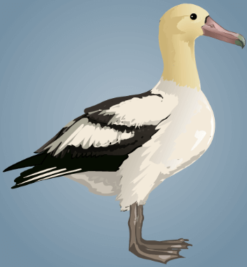 | 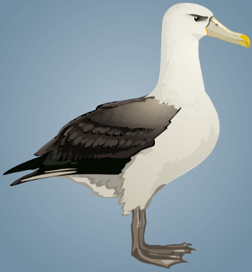 | 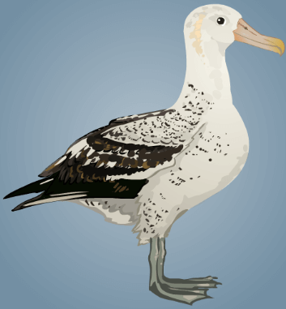 | 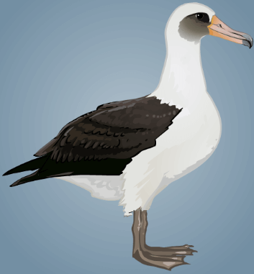
Short-tailed albatross | Shy albatross | Wandering albatross | Laysan albatross

- What is one trait that could be used to separate these albatrosses into two groups of two birds each? (Hint: Look at the colors and patterns on their plumage and beaks.)

___________________________________________________________________

- Use this trait to write statement set #1 in the table below. The statements should be mutually exclusive. In other words, either the albatross has that trait or it doesn’t.

- Observe the albatrosses described by statement #1a. Identify one trait that could be used to differentiate these organisms and use it to write statement set #2. Repeat this step for the albatrosses described by statement #1b.

Set | Statements | Identity of Organism
1 | a. | Go to #2
 | b. | Go to #3
2 | a.
 | b.
3 | a.
 | b.

- Practice: Choose another key on the Gizmo. Take screen shots of all the organisms included in that key and place them in a separate document. Make a new dichotomous key that could be used to identify these organisms. Turn the key in with this worksheet.

