Name: ______________________________________ Date: ________________________

Student Exploration: Diffusion

Vocabulary: absolute zero, controlled experiment, diffusion, dynamic equilibrium, Kelvin scale, kinetic energy

Prior Knowledge Question (Do this BEFORE using the Gizmo.)
Have you ever smelled microwave popcorn? The oddly enticing scent can fill a whole house.

How do you think the smell of popcorn spreads through the air? _________________________

____________________________________________________________________________

____________________________________________________________________________

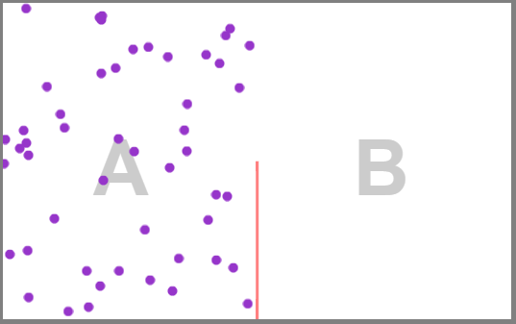
Gizmo Warm-up
Smells are carried by tiny particles that move through the air. The Diffusion Gizmo shows gas particles in a chamber that is divided into two regions by a partial wall. Click Play () and observe.

- Describe the motion of the gas particles. _______

________________________________________

- Over time, what is happening? ________________________________________________

This process, in which particles move from an area of high concentration (region A) to an area of low concentration (region B), is called diffusion.

- Select the BAR CHART tab, and observe the chart for a few minutes. After the first 30 seconds or so, how much do the numbers of particles in each region change?

_________________________________________________________________________

When the numbers don’t change much, the particles are said to be in dynamic equilibrium.

- Click Pause (), and select the GRAPH tab. What does the graph tell you about the number of particles in region A? _______________________________________________
_________________________________________________________________________

Activity A:  Temperature and diffusion | Get the Gizmo ready:  - Click Reset ().  - Set the Wall to 100%. | 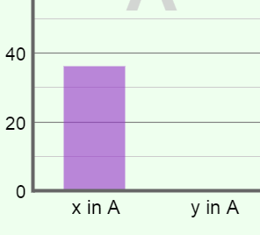

Introduction: In this Gizmo, temperature is measured on the Kelvin scale. On this scale, 0 K represents absolute zero, the coldest possible temperature. Water freezes at 273.15 K (0 °C), and water boils at 373.15 K (100 °C).

Question: How does temperature affect the rate of diffusion?

- Observe: Set the temperature (Temp.) to 100 K, and press Play. Observe the motion of particles. Click Reset. Then set the temperature to 600 K, click Play, and observe.

How does the temperature of the gas relate to the motion of the particles? ______________

_________________________________________________________________________

The temperature of a gas is a measure of the average kinetic energy of a set of particles. Kinetic energy (KE) depends on the velocity and mass of the particles (KE = mv² / 2).

- Form hypothesis: How do you think temperature will affect the rate of diffusion? __________

_________________________________________________________________________

- Experiment: Click Reset. Set the Wall to 50%, x in A to 100, y in B to 0, Temp. to 100 K, and Particle mass to 15 amu (atomic mass units). Select the TABLE tab. Press Play.

Click Pause when x in A first reaches 55% or below. Record this Time to reach equilibrium in the left table below.

Repeat four more times at 100 K, and then run five trials with the temperature set to 600 K.

Temp = 100 K experiment

Trial | Time to reach equilibrium
1
2
3
4
5

Temp = 600 K experiment

Trial | Time to reach equilibrium
1
2
3
4
5

(Activity A continued on next page)
Activity A (continued from previous page)

- Calculate: Find the average time to reach equilibrium for each experiment:

    - Average time to reach equilibrium at 100 K: ________________________________

    - Average time to reach equilibrium at 600 K: ________________________________

- Draw conclusions: Compare the average times to reach equilibrium for each temperature.

    - How did temperature affect the rate of diffusion? ____________________________

___________________________________________________________________

___________________________________________________________________

    - Why do you think this was the case? ______________________________________

___________________________________________________________________

___________________________________________________________________

- Extend your thinking: Why do you think the experimental results were different for each trial?

_________________________________________________________________________

_________________________________________________________________________

_________________________________________________________________________

_________________________________________________________________________

- On your own: In our lives, we rarely experience temperatures that are above 373 K (100 °C) or below 273 K (0 °C). Investigate how much diffusion rates differ between these two temperatures. Describe the results of your experiments below.

_________________________________________________________________________

_________________________________________________________________________

_________________________________________________________________________

_________________________________________________________________________

_________________________________________________________________________

_________________________________________________________________________

Activity B:  Rates of diffusion | Get the Gizmo ready:  - Click Reset.

Introduction: The Diffusion Gizmo allows you to manipulate five variables: the Wall, the number of x particles in region A, the number of y particles in region B, the temperature, and the Particle mass.

Question: How do factors other than temperature affect the rate of diffusion?

- Choose a variable: Pick a variable to investigate. Which one did you choose? ___________

- Form hypothesis: How do you think this variable will affect rates of diffusion? ____________

_________________________________________________________________________

_________________________________________________________________________

- Set up experiment: In a controlled experiment, only one variable is manipulated, or changed. Set up your experiment so that there is just one difference between set-up A and set-up B. List the Gizmo settings you will use for each set-up below.

Set-up A
Wall _______________
x in A _______________
y in B _______________
Temp. _______________
Particle mass _______________
Set-up B
Wall _______________
x in A _______________
y in B _______________
Temp. _______________
Particle mass _______________

- Gather data: Use the Gizmo to fill in each table. As before, the “time to reach equilibrium” is the time it takes for the number of x particles in region A to reach 55% or lower.

Set-up A

Trial | Time to reach equilibrium
1
2
3
4
5
Set-up B

Trial | Time to reach equilibrium
1
2
3
4
5

(Activity B continued on next page)
Activity B (continued from previous page)

- Calculate: Find the average time to reach equilibrium for each experiment:

    - Average time to reach equilibrium for set-up A: ____________

    - Average time to reach equilibrium for set-up B: ____________

- Draw conclusions: Compare the average times to reach equilibrium for each set-up.

- How did the variable you investigated affect the rate of diffusion? _______________

___________________________________________________________________

___________________________________________________________________

- Why do you think this was the case? ______________________________________

___________________________________________________________________

___________________________________________________________________

___________________________________________________________________

- On your own: Investigate the remaining variables. Record all experimental results in your notes. Summarize your findings in the space below.

_________________________________________________________________________

_________________________________________________________________________

_________________________________________________________________________

_________________________________________________________________________

_________________________________________________________________________

_________________________________________________________________________

_________________________________________________________________________

