Vocabulary: Digestive System

Vocabulary

- Absorption – the taking in of one substance by another.
  - In the digestive system, absorption refers to the passage of nutrients and water through the walls of the small and large intestines.

- Amino acid – an organic molecule containing a carboxyl and an amino group.
  - Amino acids combine in long folded chains to form proteins.
  - Proteins must be broken down into amino acids before they can be absorbed.

- Carbohydrate – organic molecules containing hydrogen, carbon, and oxygen.
  - Carbohydrates are a major source of energy in the diet.

- Chemical digestion – chemical breakdown of nutrients through the action of enzymes and other substances.

- Chyme – a thick liquid of partially digested food produced by the stomach.

- Complex carbohydrate – a long carbohydrate molecule formed by chains of sugars.
  - Complex carbohydrates are also called polysaccharides.
  - Examples of complex carbohydrates are starch, glycogen, and cellulose (fiber).

- Digestion – the breakdown of food into simpler components that can be absorbed and used by the body.

- Digestive system – a group of organs that work together to break down and absorb nutrients from food, as well as eliminate the resulting wastes.

- Elimination – the process by which wastes are removed from the body.

- Enzyme – a molecule, usually a protein, which catalyzes a chemical reaction.
  - Digestive enzymes break down nutrients into simpler chemicals.

- Fat – organic molecule consisting of three fatty acids attached to a glycerol “backbone.”
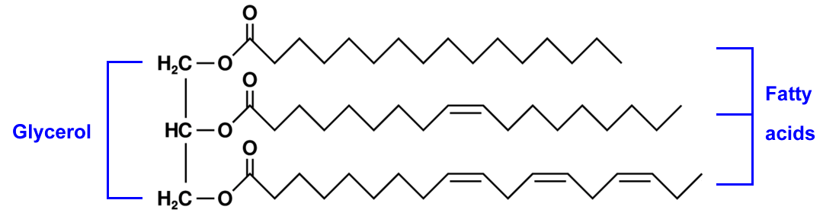
  - Fats are used to maintain healthy skin and hair, as insulation against cold weather, as an essential component of cells, and as a source of energy.
- Fatty acid – a component of a fat molecule, along with glycerol.
  - Fats must be broken down into fatty acids and monoglycerides before absorption.

- Fiber – plant material in food that is difficult to digest.
  - Fiber helps food move smoothly through the digestive system.
  - Fiber is classified as soluble and insoluble.
  - Soluble fiber is digested by bacteria in the large intestine. The resulting Calories are absorbed through the walls of the large intestine.
  - Insoluble fiber passes through the digestive system without breaking down.

- Food calorie – a unit used to measure the energy in foods.
  - The food calorie (Cal) is equal to 1,000 gram calories (cal).
  - Food calories are known as kilocalories (kcal) in many parts of the world.

- Mechanical digestion – physical breakdown of foods.
  - Examples of mechanical digestion include chewing in the mouth, churning in the stomach, and emulsification of fats by bile.

- Monoglyceride – a molecule that results from the breakdown of fats, consisting of a fatty acid attached to the glycerol backbone.

- Nutrient – a substance that is used by the body for energy, growth, or other processes essential to life.

- Peristalsis – wavelike muscle contractions that push food through the digestive system.

- Protein – an organic molecule consisting of a long chain of amino acids folded into a particular shape.
  - Proteins are essential building blocks of muscles, skin, bone, hair, and most other body structures.
  - Enzymes are proteins that help digest foods.

- Starch – a common complex carbohydrate used as a source of energy.

- Sugar – a simple carbohydrate that may be a monosaccharide or a disaccharide.
  - Monosaccharides consist of single carbohydrate units.
    - Glucose and fructose are examples of monosaccharides.
  - Disaccharides consist of two linked carbohydrate units.
    - Sucrose and lactose are examples of disaccharides.

- Villus – tiny, finger-like projection in the wall of the small intestine.
  - Nutrients and water are absorbed through the thin walls of the villi.

