Vocabulary: Dilations

Vocabulary
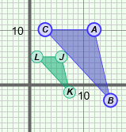
- Dilation – an enlargement or reduction of a figure.
  - In the figure shown to the right, the preimage, ΔABC, has been dilated by a scale factor of 0.5 to get the image, ΔJKL.
  - A dilation preserves shape, but not necessarily size, so the preimage and image are similar.

- Image – a figure that has been transformed, compared to the original figure (the preimage).
  - Transformations include resizing, reflecting, rotating, or translating a figure.

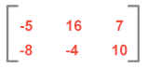
- Matrix – a rectangular array of numbers and/or variables.
  - The matrix shown to the right has 2 rows and 3 columns, so it is a 2 × 3 matrix.
  - Each number or variable in a matrix is called an element.

- Preimage – the original figure, before being transformed.
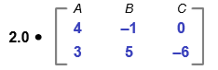
- Scalar – a constant number that a matrix is multiplied by.
- The matrix shown to the right is being multiplied by the scalar 2.
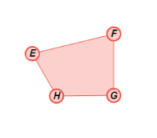
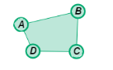
- Scale factor – the ratio of the lengths of the corresponding sides of two similar figures.
  - For example, the sides of EFGH are twice as long as the sides of ABCD, so the ratio of the lengths of each pair of corresponding sides is 2.
  - All dilations can be described by a scale factor.

- Transformation – a change in the size, shape, direction, or position of a figure.
- Transformations that don’t change the size or shape of images are isometric, and include reflections, rotations, and translations.
- Other transformations such as dilating (resizing) are not isometric.

