Name: Date:

**Student Exploration:** **Direct and Inverse Variation**

**Vocabulary:** constant of proportionality, direct variation, inverse variation

**Prior Knowledge Questions** (Do these BEFORE using the Gizmo.)

1. Michelle makes $10 an hour babysitting.
2. How much will she make in 2 hours? in 4 hours?
3. How does doubling the babysitting time affect the amount Michelle makes?

1. A car moving at a speed of 30 miles per hour (mph) will travel 30 miles in one hour.
2. How long will it take to cover 30 miles at a speed of 60 mph?
3. How does doubling the speed affect the time?

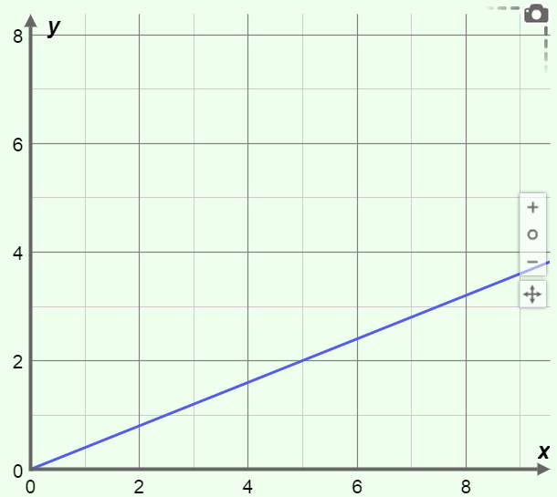

**Gizmo Warm-up**

Earning a certain amount of money per hour is an example of **direct variation** because as the hours increase, the pay increases by a constant factor. The travel time example – where doubling speed causes the time to be cut in half – is an example of **inverse variation**. Situations like these can be modeled in the *Direct and Inverse Variation* Gizmo.

1. On the **CONTROLS** tab, check that **Direct variation** is turned on. Drag the line on the graph. What changes about the line? What stays the same?

1. Drag the ***k*** slider in the Gizmo. How does the graph change as *k* increases?

|  |  |  |
| --- | --- | --- |
| **Activity A:**  **Direct variation** | Get the Gizmo ready:   * Check that **Direct variation** is turned on and **Inverse variation** is turned off. | 129SE2 |

|  |  |  |
| --- | --- | --- |
| ***x*** | ***y*** |  |
| 0.5 |  |  |
| 1 |  |  |
| 1.5 |  |  |
| 2 |  |  |
| 2.5 |  |  |
| 3 |  |  |

1. On the **CONTROLS** tab, set ***k*** to 2.0 to graph *y* = 2*x*. (To quickly set a value, type it in the text field to the right of the slider and hit **Enter**.)
   1. Substitute the *x*-values shown in the table to the right into the equation to find several points on the line.

To check your work, select the **TABLE** tab in the Gizmo. Compare your *y*-values with the ***y*direct**column in the Gizmo table.

* 1. Calculate the values of  in the last column of your table. What is true about the ratio of the variables in a direct variation?

* 1. Select the **CONTROLS** tab. How much does *y* change when *x* increases by 1?

* 1. How does the change you described above relate to the slope of the line *y* = 2*x*?

* 1. In the direct variation equation *y* = *kx*, *k* is the **constant of proportionality**. Look at the last column of your table and your answers to the questions above.

What three things are equal to the value of *k*?

1. In the Gizmo, use different values for *k* in the general equation *y* = *kx*. Study the resulting graph and table to see what happens to the *y*-value for the following changes in the *x*-value.
2. If the *x*-value is multiplied by 3, what happens to *y*?
3. If the *x*-value is multiplied by 5, what happens to *y*?
4. If the *x*-value is divided by 2, what happens to *y*?
5. If the *x*-value is divided by 4, what happens to *y*?

**(Activity A continued on next page)**

**Activity A (continued from previous page)**

1. If *y* varies directly as *x*, then *y* = *kx* for some value *k*.
   * 1. Suppose *y* varies directly as *x* and *y* = 20 when *x* = 5. What is the constant of proportionality, *k*, in this situation? Explain how you found *k*.
     2. In the Gizmo, set ***k*** to the value you found above. Find four other (*x*, *y*) pairs that occur in this direct variation function.

( , ) ( , ) ( , ) ( , )

1. Suppose you’re exchanging money from one form of currency to another, where $1.00 in currency A equals $1.70 in currency B.
2. If *x* = amount of currency A and *y* = amount of currency B, write an equation to model this currency conversion.
3. Graph your equation in the Gizmo. Select the **TABLE** tab. How can you use the table to check if your equation is correct?
4. How much is $8.00 in currency A equal to in currency B? Explain how you found your answer.
5. How much is $17 in currency B equal to in currency A? Explain how you found your answer.
6. Write an equation to solve each problem. Then solve the problem. Check your answers in the Gizmo.
7. If *y* varies directly as *x*, and *y* = 12 when *x* = 2, find *x* when *y* = 30.

equation: If *x* = then *y* = 30.

1. Joe gets paid by the hour. If he earns $54 for working 6 hours, how much will he earn when he works 15 hours?

equation: If Joe works 15 hours, he will make

|  |  |  |
| --- | --- | --- |
| **Activity B:**  **Inverse variation** | Get the Gizmo ready:   * On the **CONTROLS** tab, turn off **Direct variation**. * Turn on **Inverse variation**. | 129SE3 |

|  |  |  |
| --- | --- | --- |
| ***x*** | ***y*** | ***xy*** |
| 1 |  |  |
| 2 |  |  |
| 3 |  |  |
| 4 |  |  |
| 5 |  |  |
| 6 |  |  |
| 7 |  |  |
| 8 |  |  |

1. With the **CONTROLS** tab selected, set ***k*** to 2.0 to graph *y* = .
   1. Substitute the *x*-values shown in the table to the right into the equation to find several points on the graph.

To check your work, select the **TABLE** tab. Set **MIN** to 1.00, **MAX** to 8.00, and **STEP** to 1.00. Compare your *y*-values with the ***y*inverse** column of the Gizmo table.

* 1. Calculate the product *xy* in the last column of your table. What is true about this product in an inverse variation?

* 1. In the inverse variation equation, *k* is the constant of proportionality. What do you notice about the value of *k* for this equation and the values in the last column of your table?

* 1. Look at the ***x*** and ***y*inverse** columns in the Gizmo table. Find the difference in the values of *y* between the following pairs of *x*-values:

*x* = 1 and *x* = 2 *x* = 3 and *x* = 4 *x* = 5 and *x* = 6

* 1. How do the differences above relate to the shape of the graph?

1. In the Gizmo, use different values for *k* in the general equation *y* = . Study the resulting graph and table to see what happens to the *y*-value for the following changes in the *x*-value.
2. If the *x*-value is multiplied by 3, what happens to *y*?
3. If the *x*-value is multiplied by 5, what happens to *y*?
4. If the *x*-value is divided by 2, what happens to *y*?
5. If the *x*-value is divided by 4, what happens to *y*?

**(Activity B continued on next page)**

**Activity B (continued from previous page)**

1. If *y* varies inversely as *x*, then *y* = . Suppose *y* varies inversely as *x* and *y* = 4 when *x* = 6.
2. What is the constant of proportionality, *k*, in this situation?
3. Explain how you found *k*.
4. On the **CONTROLS** tab, set ***k*** to this value by entering it in the text box and hitting **Enter**. How can the graph show you if this equation is correct?
5. For anything in motion, distance traveled, *d*, is equal to the average speed (average rate), *r*, multiplied by the time traveled, *t*. This is often abbreviated as *d* = *rt*.

=

1. Suppose you need to drive 75 miles. In the boxes to the right, solve *d* = *rt* for time, and use 75 for *d*. This should give you an equation that shows that time varies inversely with rate.
2. Graph your equation in the Gizmo. (Click the **–** button to the right of the graph to zoom out.) Select the **TABLE** tab. How can the table show you if your equation is correct?
3. How fast would you need to drive to make the trip in 2.5 hours?

Explain how you found your answer.

1. Daniel’s baseball team raised $90 to buy new baseballs. The team needs to know how many baseballs they can buy, based on how much each one costs.

=

1. Write an equation to model this situation. (Hint: Your equation should show that the number of baseballs the team can afford varies inversely with the price of each baseball.)
2. What does each variable in your equation represent?

1. How many baseballs can the team buy if each baseball costs $2.50?

Check your answer in the Gizmo.