Name: ______________________________________ Date: ________________________

Student Exploration: Disease Spread

Vocabulary: contagious, disease, epidemic, infect, infectious disease, pathogen

Prior Knowledge Questions (Do these BEFORE using the Gizmo.)

- Why do you think it is important to cover your mouth when you cough?

- Why should you always wash your hands before you eat?

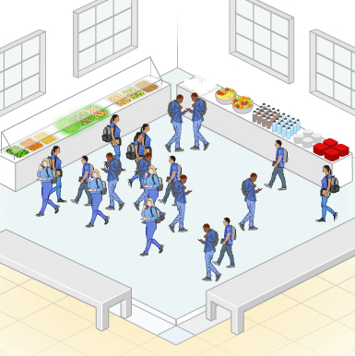

Gizmo Warm-up
When a person has a disease, his or her normal body functions are disrupted. Some diseases, such as diabetes and most cancers, are not spread from one person to another. But other diseases, such as the flu and strep throat, can be spread. These diseases are known as infectious diseases. Infectious diseases are caused by viruses, bacteria, and other agents known as pathogens.

In the Disease Spread Gizmo, you will be able to observe how various pathogens can spread through a group of students in a school. Click Play () and observe.

- Describe what happens on the SIMULATION pane:

- Look at the color key on the bottom right of the Gizmo. What is happening when a person changes color?

Activity A:  Person-to-person transmission | Get the Gizmo ready:  - Click Reset ().  - On the CONTROLS tab, select Person to person.  - Set the Number of people to 10. | 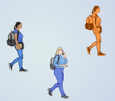

Question: What factors affect how quickly a pathogen spreads from person to person?

- Predict: Some pathogens are spread directly from one person to another. This can happen when people come into direct contact or share items, such as drinking glasses. What do you think might affect how quickly a pathogen is spread from person to person?

- Identify: Select the TABLE tab. (You will want the table tab open to answer question C.)

    - What does the orange person represent?

    - Click Play, and observe the simulation for a while. What must happen for the disease to spread from one person to another?
    - How long did it take to infect all ten people?

- Experiment: Click Reset. Change the Number of people to 20. Click Play and record how long it takes to infect 10 people. Repeat this four times for a total of 5 trials, then calculate the mean time. Repeat the experiment when there are 30 people and 40 people in the room.

Number of people | Time to infect 10 people, 5 trials (h) | Mean time (h)
20
30
40

- Interpret: Study the data you collected. What trend do you see in the data, and how would you explain it?

(Activity A continued on next page)
Activity A (continued from previous page)

- Experiment: Not all pathogens are equally contagious, or likely to spread. The probability of transmission is the chances that a contact between two people will result in transfer of the disease. Click Reset and set the Number of people to 20. Set the Probability of transmission to 20%. Record data for transmission probabilities of 20%, 50%, and 80%.

Transmission probability | Time to infect 10 people, 5 trials (h) | Mean time (h)
20%
50%
80%

- Interpret: Study the data in the table. What trend do you see, and how would you explain it?

- Experiment: For certain pathogens, mask-wearing can greatly reduce the probability of transmission. Click Reset, select Students wearing masks, and set the Probability of transmission (without masks) to 50%. Check that the Number of students is still 20.

Run five trials with masks and find the mean time to infect 10 people.

Probability (without masks) | Time to infect 10 people, 5 trials (h) | Mean time (h)
50%

- Compare: Compare the mean time to infect ten people with masks to the mean time to infect ten people without masks. (Use the 50% line from the table in question 5.)

How do these times compare?

- Infer: Why do you think masks have this effect on the rate at which a person-to-person disease spreads?

- Think and discuss: Suppose you were a public health official. Based on the data you have collected, how would you slow the spread of a person-to-person disease?

Activity B:  Foodborne transmission | Get the Gizmo ready:  - Click Reset. Select Foodbourne.  - Set the Number of people to 10 and the Probability of transmission to 100%. | 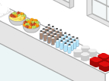

Introduction: Many types of food, especially meat or fresh produce, can be infected with pathogens. A foodbourne disease is spread when people eat or drink infected food or water. One way to avoid these diseases is to boil drinking water and thoroughly cook meats.

Question: How do foodborne pathogens spread?

- Predict: How do you expect the spread of a foodborne disease to be similar to and different from the spread of a person-to-person disease?

- Observe: Click Play and closely watch the students moving around the cafeteria.

  - What does each student do before becoming infected?

  - How are foodborne pathogens transmitted?

  - If a student in the simulation never eats or drinks anything, is it possible for them to become sick with the foodborne disease? Explain.

- Experiment: Click Reset. Check that the Number of people is 10 and set the Probability of transmission to 50%. Click Play and record how long it takes to infect 10 people. Repeat four times, then calculate the mean. Repeat the experiment for 25 and 40 people.

Number of people | Time to infect 10 people, 5 trials (h) | Mean time (h)
10
25
40

- Interpret: What trend do you see in your data? Why do you think this is the case?

(Activity B continued on next page)
Activity B (continued from previous page)

- Experiment: Set the Number of people to 20. Using the same method, find the mean time for each transmission probability.

Transmission probability | Time to infect 10 people, 5 trials (h) | Mean time (h)
20%
50%
80%

- Interpret: Study the data in the table. What trend do you see, and how would you explain it?

- Experiment: Click Reset. Select Students wearing masks and set the Probability of transmission (without masks) to 50%. Check that the Number of students is still 20. Using the same method as before, collect data to see the effect of masks.

Probability (without masks) | Time to infect 10 people, 5 trials (h) | Mean time (h)
50%

- Compare: Compare the mean time to infect ten people with masks to the mean time to infect ten people without masks. (Use the 50% line from the table in question 5.)

How do these times compare?

- Infer: Why do masks have no effect on the rate at which a foodborne disease spreads?

- Compare: How is the spread of a foodborne disease similar to the spread of a person-to-person disease? How are they different?

